Text 10
Sporting Activities Unique to Spain
The Running of the Bulls and Bullfighting

TOPICS Online Magazine - ©1997-2006 topics mag@yahoo.com
Published by Sandy and Thomas Peters
http://www.topics-mag.com/internatl/customs/spain-bullfighting.htm
Copyright 2002
Video: Anti-Bullfighting: - http://www.sharkonline.org/?P=0000000423
Video of Running with the bulls: http://www.sanfermin2.com/2001/video_new.php?lang=eng
Newspaper Review: - http://topics.nytimes.com/top/reference/timestopics/subjects/b/bullfighting/index.html?s=closest&&query=REVIEWS&field=des&match=exact

Photograph of Bull-fighting Bull gores Bullfighter
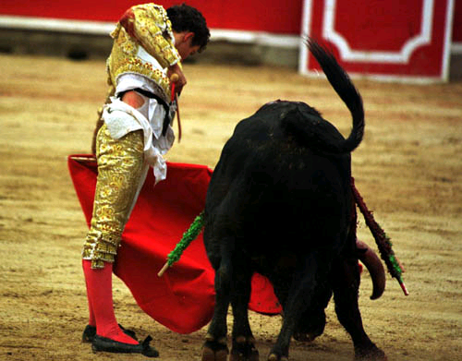 | 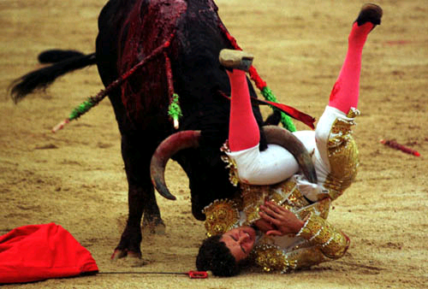
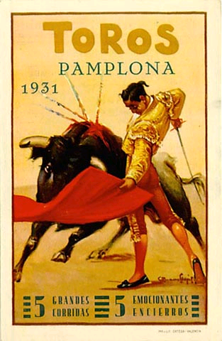 | 
Poster: Bull-fighting Print: Picador by Picasso

SANFERMIN.COM
© Kukuxumusu S.L. All rights reserved

Description: -

In Spain, they practiced one of the worlds most brutal and unusual sports. A bullfighter enters an arena to do battle with a real live bull. There has been much

protest against this inhumane treatment of animals, and yet it continues. As you shall see based on the anti-bullfighting video, it is a brutal and unfair sport that pits the bull against several participants and not just one on one, man versus beast.

The Spaniards defend the sport on account of their tradition. It is a long tradition that is evidenced in the paintings of Goya painted in 1812-14

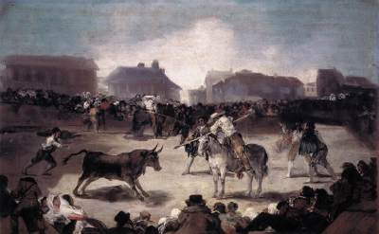

Oil on panel, 45 x 72 cm
Museo de la Real Academia de San Fernando, Madrid

The Spaniards defend it “as a time-honored ritual that conflates religious and esthetic ideals with a lofty code of machismo.” (Stephen Holden; NY Times, August 31, 1994)
However, brutal it may seem, sometimes the bull triumphs over his human tormentor. The photo at the top of this page attests to that.
http://www.spanish-living.com/regional/sports/sports-spain/sports-spain_bullfighting.php

The website above gives a balanced view of bullfighting.

Task
Based on the two opposing views, write a short essay expressing your personal opinion of bullfighting. Be objective and weigh the pros and con of the sport as tradition to be preserved or barbaric cruelty to be banned.

The Running of the Bulls

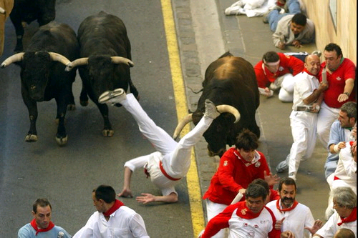

Description: -
The actual date of the beginning of this festival cannot be ascertained, however, it involves the celebration of San Fermin and the carrying of his effigy in procession. It is a mixture of secular and religious celebration that seems to have lost its religious direction. A one-mile stretch of cobbled road in Pamplona, Spain is walled off and the participants dressed in white top and black pants tied with a red sash run ahead of a herd of ferocious bulls while trying to avoid being trampled and gored.

Task

From the images seen of the Running of the Bulls and your reading about the festival, write a paragraph expressing your opinion of the sport. Should it be banned or preserved as tradition dictates. Bear in mind that it has a long history in Spain. Do you think that humane concerns for animals should interfere with a people’s tradition? Nowhere else in the world practices such a sport. However, it is a huge tourist attraction that brings in much money to the economy of the town. Compare this to the treatment of racehorses that receive injuries in a race. How far can the argument go?

