Text 11
Native costumes – Flamenco
Videos of Flamenco dance: - http://www.flamenco-world.com/video/videos_dance.htm
Photographs of dancers: - http://www.topics-mag.com/internatl/customs/sevillana-dance.htm
Photos of various parts of costume: -http://www.esflamenco.com/product/en31926022.html

Flamenco Costume
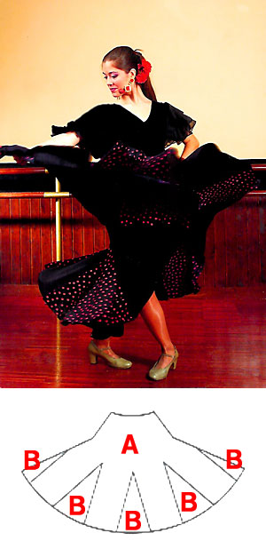 | 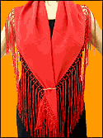 | 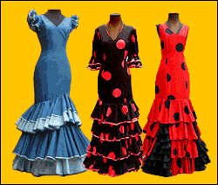
Shoes | 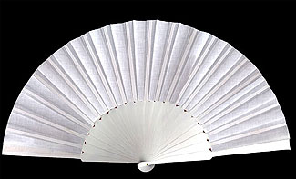 | 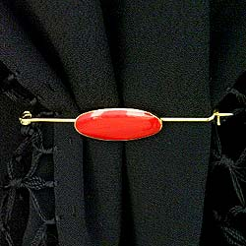
Castanets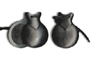 | 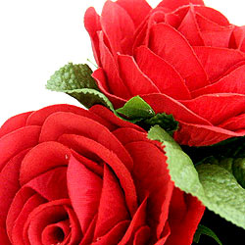 | 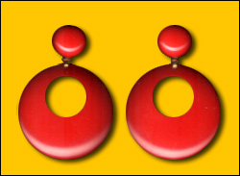

Website about Flamenco © 1999 El Raks Sai'd: - http://www.nagwa.com/flamenco.html

Description: -
Flamenco is a form of dance associated with the Andalusia in Spain.
It draws its rich heritage from the numerous ethnic groups that lived in
Andalusia. “Jews, Gypsies, Arabs, Berbers and Moors lived separately in their ghettos or districts; others, with a higher material standard, lived in palaces. Integration between the immigrants and the native population was, however, unavoidable, and since that time the Andalusian people have been an indistinguishable union of these races”. (El Raks Sai'd, 1999) However, in spite of all the cultures that have amalgamated to create it, it is uniquely Spanish.

Task
View several of the videos available on the attached site and create a piece of artwork, whether collage, drawing or painting depicting a scene of a Flamenco dance. What are the musical instruments that you hear or see in those films? Include all in your artwork.

