Text 12
Comparing the reaction of two Spanish artists to War in Spain
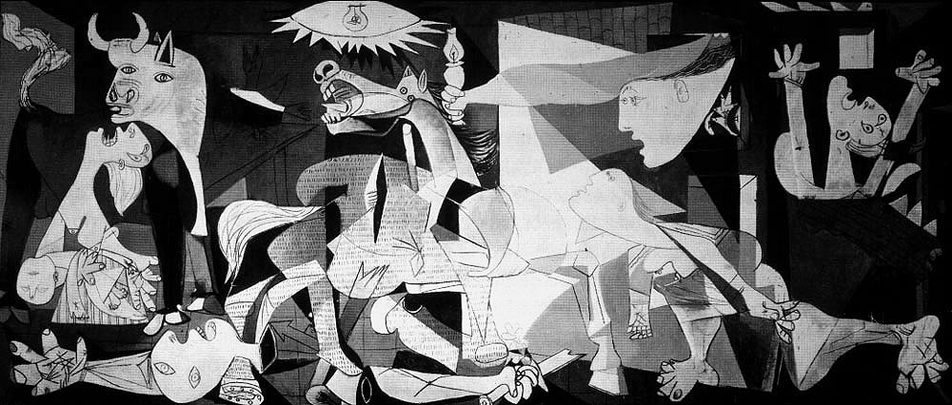
Guernica by Pablo Picasso

Picasso: Guernica: -http://www.mala.bc.ca/~lanes/english/hemngway/picasso/guernica.htm

Description: -
Picasso had been commissioned to execute a painting for the Spanish Republic for the 1936 World Fair. He was suddenly filled with rage and inspiration on May 27, 1937, when news arrived about the carpet-bombing of a defenseless little town of Guernica, in the Basque region. He completed this huge painting in six (6) weeks, motivated by the anger that he felt towards Generalissimo Franco who had ordered the German Luftwaffe to carry out this raid. Hundreds of men, women and children were killed and it caused a worldwide outcry against the excesses of modern war.

Dalí
Copyright © 2006 Answers Corporation: - http://www.answers.com/topic/soft-construction-with-boiled-beans

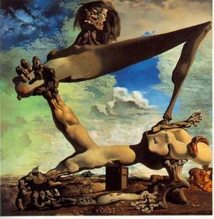
Dalí: Soft Construction with Boiled Beans: Premonition of the Spanish Civil War. (1936) .
-

Description: -
Salvador Dalí was the most famous Surrealist painter. He reacted to the Spanish Civil War by portraying an already dismembered woman in the act of tearing herself apart. The grimacing figure epitomizes the degree of pain that the country suffers when Civil War breaks out
Audio guide: - http://www.philamuseum.org/collections/permanent/51315.html

Goya
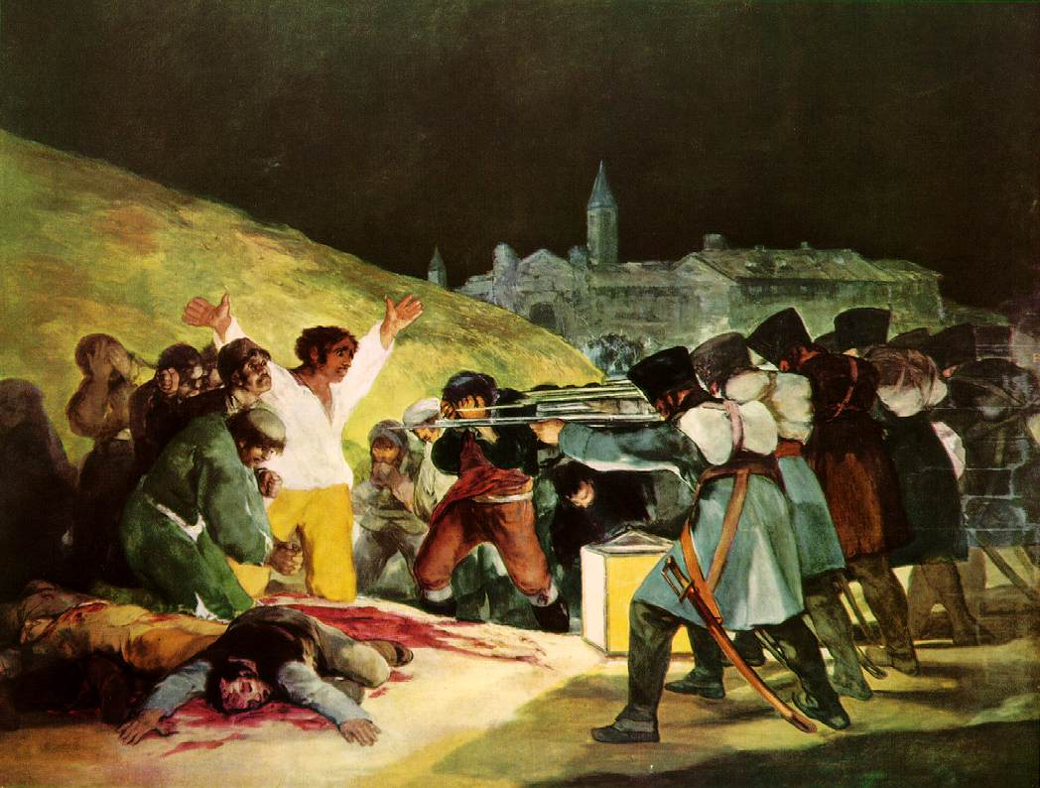
Goya: Third of May

Description: -
Goya claims to have seen some of the atrocities that the Napoleonic soldier committed against the peasants of Madrid on the Third of May 1808. This was Goya’s response to the bloody slaughter of Spanish peasants by Napoleon’s troops, who retaliated for the revolt of the day before May 2. Goya portrays faceless soldiers who are executing a civilian in a pose like the crucifixion. He takes a stab at the church, whose darkness appears as complicity in the murderous act.

WEB SITE COPYRIGHT©1997-2006 ERIK E. WEEMS: - http://www.eeweems.com/goya/3rd_of_may.html

Task

In a short essay, compare and contrast the way in which these three Spanish artists dealt with war in their homeland. How did they express their anger and outrage? Did they seek to blame others? How do these artists use a gruesome image to portray the truth of the horrors of war?

