Text 3
Map of Language distribution in Spain

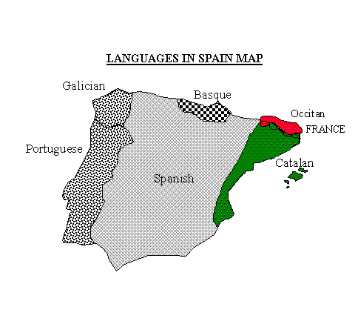
Marta Ribas (1994) http://www.june29.com/HLP/lang/Catalan/webcat3.html
Description:
This text indicates the language distribution throughout Spain. It indicates the dominant Castilian language that has become known throughout the world as Spanish. It reflects the Latin based origin that puts it in the realm of romance languages. In Spain what is known as Castellano has been the language that Spain has exported throughout its colonial realm and is the language spoken in nineteen different counties of the world.

Task
Find a map of Spain that shows the location of its major cities. Compare the linguistic map with their location. Locate two (2) cities in each linguistic region. Then determine what language you would have to learn in order to be able to fit comfortably into society in each city. Find five cities in which a Mexican or any Hispanic from the Western Hemisphere would a feel at home?

