Text 4.

Origin and Similarities with other romance languages

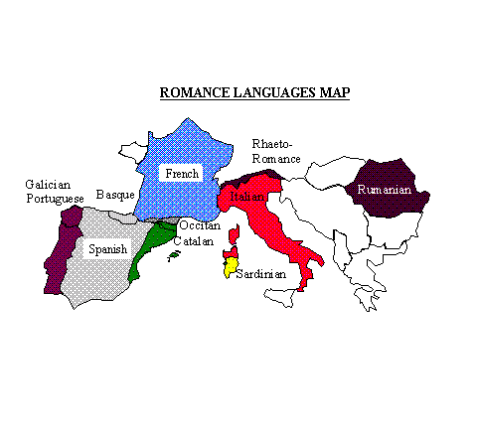
Marta Ribas (1994) http://www.june29.com/HLP/lang/Catalan/webcat2.html
Description: -
A glimpse of the map above will show the countries that speak a language that belongs to the group called Romance Languages. These are languages that reflect a clear derivation from Latin. The countries where these languages are spoken fell under the influence of the Roman Empire and reflect the input of the Roman language- Latin. You shall now observe the similarities in the similar sentences written in three of these languages and you shall see how pervasive Latin was and the effect of the Roman Empire on Western European languages.

Romance Languages
Spanish French Italian
Yo soy americano. | Je suis americain. | Io sono americano.
Yo amo mi patria. | J’aime ma patrie. | Io amo la mia patria.
Ellos leen cinco lenguas | Ils lisent cinq langues | Loro leggono cinque lingue
María me ha dado el libro | Marie m’a donné le livre | Maria me ha dato il libro

Latin
1)Sum americanum
(2)Amo mia patria.
(3) Legerunt quinque linguae
(4)Maria libro datit meum

Task
Create a list of ten (10) countries other than those on the map above in which Latin has influenced the language that they speak and name the language.
(Hint:- Think of colonial expansion.)

