Text 7.

Spanish Literature

http://en.wikipedia.org/wiki/Lazarillo_de_Tormes
D.Miguel Pérez Rosado. Ph. D. in Hispanic Philology.
http://www.spanisharts.com/books/literature/i_celestin.htm

Novel

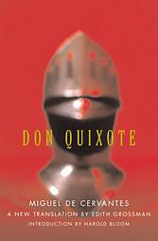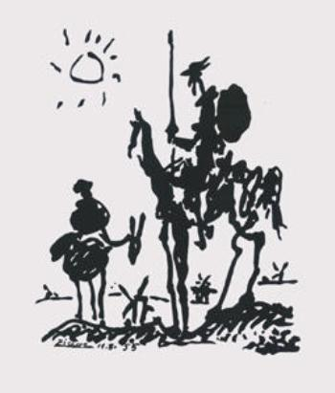
Don Quixote de la Mancha, Don Quixote and Sancho Panza
Miguel de Cervantes Saavedra Print by Pablo Picasso

Description: -
Spanish literature is as lively as that of English. There are as many Spanish classics as there are in English. One can compare the literary impact of Miguel de Cervantes on the Spanish language to that of William Shakespeare on English. One of Cervantes’ most famous classics is the story of The Adventures of Don Quixote, the famous Spanish knight who is so delusional about traditional Spanish quest for honor that he begins to see windmills as giants and decides to attack them in defense of his land.

Lazarillo de Tomes

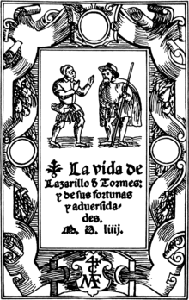 | 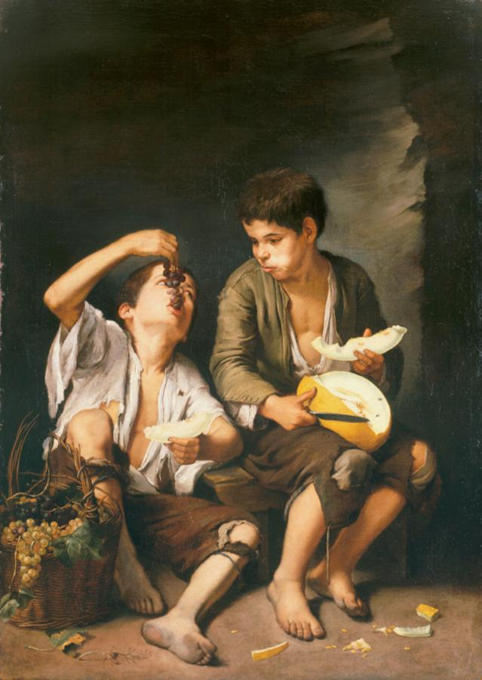
The novel of Lazarillo de Tomes Boys Eating Fruit (Grape and Melon
Eaters) by Bartolomé Esteban Murillo
Description : -
There is also Lazarillo de Tomes who lives by his wits. He is the typical street rogue who swindles and cheats his way through life. This is the advent of the Picaresque novel, a literary genre that extended its influence on the writings of Huckleberry Finn by Mark Twain and Oliver Twist by Charles Dickens. This genre of writing did not only influence other writers, but numerous Spanish painting took the liberty to thwart the authority of the church, which had so much influence on the life of Spaniards threw its repressive use of the Spanish Inquisition.

The Tragicomedy of Calisto and Melibea
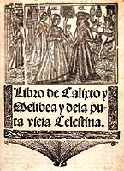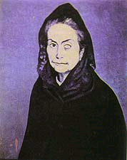
Book: Calisto and Melibea Painting: Celestina seen by Picasso in 1904
Anonymous
Description: -
There is another type of literary device introduced to world literature that has not only influenced writing, but painting also. That is the character of “La Celestina.” from the writings of Fernando de Rojas’. This story
dates from 1499 and was published anonymously. We now know that Fernando de Rojas wrote it. These were times when the Spanish Inquisition was very strict literature and the arts in general. This accounts for its anonymous publication. The story deals with a man who is enamored with a
young woman but has difficulty approaching her. So he enlists the assistant of Celestina, a procuress (go-between), at the urging of his servants in order to get his lady. However, the greed of the procuress and Calisto’s servants who had agreed to split the profits for their services caused them to murder Celestina. Calisto dies tragically climbing a ladder to Melibea’s house and in turn, the grief stricken Melibea commits suicide.
The ending of this story appears quite similar to that of Shakespeare’s “Romeo and Juliette” and may have been an influence on the latter.
These three (3) stories are giant contributions to world literature by Spanish authors who have influenced great classics of world literature and art.

Task
Using your visual skills, write a paragraph or two describing the image in Murillo and Picasso’s paintings. Let your own prejudices about street-life influence what you think about the characters in these two paintings. In what occupation do you think they are engaged and what do you think about their lifestyles?

