
Antelope Valley Libertarian
April, 2000

Supper Club News
Thanks to everyone who attended March’s Supper Club! We hope you found David Abber and interesting guest. This month (April) we have no guest planned. Instead we will re-hash the recent elections and what we did right and what we can do better. Please come and help our candidates do even better in November!
April’s Supper Club will be held at 7 p.m. April 20th. As usual, we’ll be at the Greenhouse Café in the A.V. Mall.
1233 West Avenue P
Palmdale
661-272-8866
We look forward to seeing you there. ✓

Financial Update
It has been nearly a year since Region 68 reactivated and we still have not received our funding from the state. It has been agreed that we will complain to the national party about this treatment. We have done everything in our power to receive our back dues, but with no success. ✓

Thank You!

Upcoming Events
- April 20, 6:30 p.m. - April Business Meeting and election of officers, Greenhouse Café
- April 20, 7:00 p.m. – Supper Club, Election Discussion, Greenhouse Café
- April 22, 9:00 am – Adopt-a-Highway Cleanup. Meet off the southbound Aqua Dulce off-ramp.
- May 18, 6:30 p.m. - May Business Meeting, Greenhouse Café
- May 18, 7:00 p.m. – Supper Club, no guest scheduled yet, Greenhouse Cafe
Many thanks to Bill Holmes, John Gibson, the entire Bashem family, Christopher Swearengin, Clyde Dotson, Chuck Tedeschi, Dorothea Taylor, Doc Ellis, and David Matherly for helping keep Highway 14 clean! All these people participated in our first adopt-a-highway cleanup in March. They deserve a big round of thanks!
For more information on Adopt-a-Highway, please refer to the article on page 4. ✓

Elections of Officers
This April’s Business meeting we will be holding an election of officers. Each position is for the following year. If you wish to be a party officer, please attend! The following positions are up for election: Chair, Vice-Chair, Secretary, and Treasurer. Please attend and help pick our next officers! ✓

Table of Contents
- Members in the news page 2
- Win the Safe Census Lotto! page 2
- How Does Uncle Sam (Tentatively) Plan to Spend Your Federal Tax Dollar in FY 2001? page 2
- Palmdale’s Teetering Edge page 4
- Adopt-a-Highway Update page 4
- Explaining Civil Society Simply page 4
- Some Quick Notes page 5
- Prop 26 is Not Dead page 5
- Newsletter Deadline and Contact Information page 6

Members in the News
- The Bakersfield Californian: “17th District Candidates won’t have competition until November” by Debby Badillo Feb. 22, 2000 page B3
- The Antelope Valley Press: “Tuesday’s Primary no Threat to Knight’s Job” by Thomas Francis March 5, 2000 page A6
- The Antelope Valley Press: “Knight to Face Same 3 in Fall” by Thomas Francis March 8, 2000 page A3
- Victorville Daily Press: “Everyone wins State Senate Primary” by Emily Sachs March 8, 2000 page A1
- The Rosamond Tribune: Title unknown, by Lee R. Thomas Issue 1
If you notice a Libertarian in the news let us know! We like to see what coverage we get. Newsletter contact information can be found on page 6. ✓

Win the Safe Census Lotto!
Have you noticed how the Census is being portrayed? Two things stand out:
- The census is being advertised as a sort of tax money lotto. Only by filling out the census can you guarantee your community will get the tax money due it. Get that? Free money just for filling out the census! Never mind that it was our money in the first place confiscated by the government.
- The census is perfectly safe and private. Never mind that the primary asset used in rounding up Japanese American in the 1940’s was the Bureau of the Census. Don’t worry, that would never happen again. They’d never let anyone know your private information. Then why ask?
What is not being shouted loudly to the public is that if you don’t fill out the census you could be put in jail. That’s right, fill out your lotto form or go to jail.
But don’t worry! If you’re a white middle class American you can fail to fill out your census, because they don’t really want to count you anyway. In the minds of the Census Bureau you’re over counted anyway. The important people to count are the poor and the minorities. And they’re trying to help out these communities by using the one-drop law.
What’s the one drop law? Back in the days of Jim Crow, if you had one drop of black blood in you, you were black. Now, through an edict passed down from the Clinton Administration, the one-drop law is back in place. If you mark down anything but white/Caucasian on your census, then you are a minority. Since they’re allowing you to check multiple boxes to cover all multi-ethnic possibilities, your great-great-great-great-grandmother could have been half Indian, thereby making you one too! All it takes is one drop!
Notice that for the Asians, there are now several boxes to mark. We couldn’t hurt their feelings by lumping the Japanese and Koreans in the same category. But we’re comfortable lumping Greeks and Englishman, Hungarian and French men in the same category – if you’re white, it doesn’t matter what your ethnicity is.
If this wasn’t bad enough, we come to statistical sampling. Although the Supreme Court has declared sampling invalid for the Census, they’re still going forward with it. The administration’s view is that they must count everyone for district re-apportionment, but for the tax money lotto, guessing is okay. So they’re going to “estimate” the last 20% of the census count. Want to bet how that’s going to be skewed? No need to ask – they publicly state that sampling will occur because minorities are undercounted. Guess who gets the shaft again!
What can we do? Practice Civil Disobedience. I can’t tell you not to fill out your census, or even not to answer all the questions. That’s illegal, and could get you jail time or a fine. But when you do fill it out, be creative. Race? Human. ✓

How Does Uncle Sam (Tentatively) Plan to Spend Your Federal Tax Dollar in FY 2001?
Courtesy of the Tax Foundation
How will your federal tax dollars be spent in fiscal 2001? According to the latest federal budget, the typical tax dollar will be divvied up far differently than in past decades.
The graph below shows how the FY 2001 federal budget dollar likely will be spent.
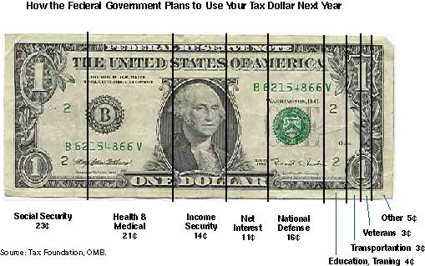
(Notes: "Income Security" includes General Retirement and Disability, Federal Employee Retirement and Disability, Unemployment Compensation, Food and Nutrition Assistance, Supplemental Security Income, Family and Other Support Assistance, Earned Income Tax Credit, Offsetting Receipts, and Housing Assistance.
"Other" includes Energy, Natural Resources and Environment, Commerce and Housing Credit, Community and Regional Development, International Affairs, General Science, Space and Technology, Agriculture, Administration of Justice, General Government, Allowances and Undistributed Offsetting Receipts.)
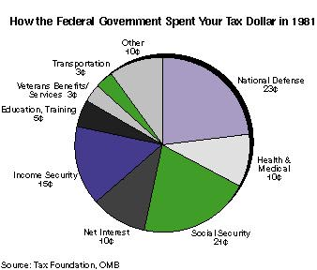
As a comparison with previous budgets demonstrates (see charts below), major changes have occurred over the years. The biggest changes in the last four decades can be found in how much Uncle Sam spends on health-related programs and on national defense. In fiscal 1961, the federal government spent only 1¢ out of every tax dollar on health, and even after Medicare and Medicaid had been enacted, that cost had risen to 6¢ on the dollar in 1971 and 10¢ on the dollar in 1981. Those are small slices of the national pie compared to the 21¢ that is planned for 2001.
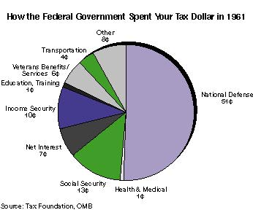
On the other hand, the portion of federal spending devoted to national defense has fallen from 51¢ out of every tax dollar in FY 1961, to 23¢ in FY 1981, to 16¢ in FY 2001.
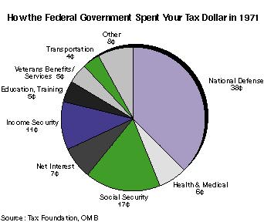
Net interest payments on the federal debt are projected to fall significantly in FY 2001 compared to ten years ago, from almost 15¢ on a dollar in 1991 to slightly more than 11¢ in the coming fiscal year. That's not as low as twenty and thirty years ago, but if the currently projected surpluses are used to buy back debt as projected in the President's budget, interest payments will continue declining.

Social Security outlays have climbed slightly over the past two decades, from a little less than 21¢ out of every federal tax dollar in fiscal 1981 to 23¢ today.

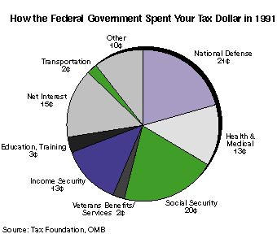
The FY 2001 budget shows how relatively minor a role discretionary spending -- such as defense, education, agriculture, and transportation -- has assumed over the past few decades. Mandatory spending, including net interest and entitlements, now represents about 70¢ out of every federal tax dollar, while discretionary outlays represent only about 30¢. In contrast, back in FY 1961, the portions were reversed: discretionary spending represented roughly 70¢ out of every federal tax dollar -- 51¢ of which went to national defense -- while entitlements and net interest payments took up about 30¢. ✓

Palmdale’s Teetering Edge
You may know that two of Palmdale’s five city councilmen have resigned. They are to be replaced in the November general election. What you may not know is how close the city is to not having that election.
If one more councilman resigns then Palmdale no longer has an effective government and becomes a ward of the state. The state legislature has effective control. No elections can be held, as that requires a valid government.
But why expect this to happen? Councilman Penner was a reluctant candidate originally and a strong backer of George Runner. If he resigns then Runner has a real chance of merging Lancaster and Palmdale. After all, with no city government, why not merge Palmdale with the local effective government?
Already there are some things that can’t come to a vote in Palmdale, as they require a 4/5 vote. Lose one more person and Palmdale loses everything. ✓

Adopt-a-Highway Update
AVLP’s first ever Adopt-a-Highway cleanup was held on March 18. It was a success! Thanks to all who came out and made it work.
We collected over 40 bags of trash! Good work!
We also made the front page of the Signal, and had write-ups in both the Antelope Valley Press and the Daily News.
Part of our responsibility is to do this monthly! So if you missed our first time, you can come on April 22, which is Earth Day. Help make the Highway a cleaner place!
We will be meeting on the Aqua Dulce Southbound Ramp at 9:00am. Wear tough shoes and dress sensibly. We look forward to seeing you there! ✓

Explaining Civil Society Simply
John R. Gibson
I would like to get feedback from the readers of this newsletter on some ideas I have for campaign literature, but first a personal anecdote. While I was in college I worked as a co-op student for NASA. I remember once being assigned the task of drawing a plot from a table of X and Y coordinates. Another high school graduate was supposed to help; however, I ended up doing the work myself because my “help” didn’t understand the concept of plots. Being young and naïve I was incredulous that they couldn’t do what I considered a simple task. Looking back I have attempted to be more understanding. After all I was a top student in high school and an engineering student in college.
I was reminded of this old incident recently while looking at the small Nolan Charts I was handing out to average Americans that I meet. (They fit nicely in a pocket) Could a generation raised on computer games, Internet and channel surfing (short attention span) be intimidated by hand plotting? Here is another method I have been considering…
Who Ya Gonna Call?
Liberal - Trust me. I’m from the government and I would like to do some social engineering.
Conservative – Trust me. I speak for God and I’m on a moral Crusade.
Libertarian – Trust in yourself and remember, “it’s a free country.”

The Pursuit of Happiness
Liberal – We should make you decisions for you because we are intellectually superior.
Conservative – We should make your decisions for you because we are morally superior.
Libertarian – You should decide. There is no substitute for personal responsibility and individual freedom.

Freedom of Speech
Liberal – I believe in freedom of speech, unless someone wishes to say something hateful or politically incorrect.
Conservative – I believe in freedom of speech, unless someone wishes to say something immoral or un-American.
Libertarian – I believe in freedom of speech, period. If someone says something I consider wring, I will tell him so. “The answer to bad speech is good speech.”

Gun Rights
Liberal – Only police should own guns (a.k.a. Police State.) Guns are bad and people are good (or victims.)
Conservative – Support the NRA when the polls are right. Guns are good, but people are bad.
Libertarian – It’s none of the government’s business what I own. Remember the 2nd Amendment. Guns are just guns and you have a natural right to defend yourself.

The Bottom Line
Liberal – We will spend your money* on ourselves and our favorite special interest groups; welfare, unions, etc.
Conservative – We will spend your money on ourselves and our favorite special interest groups; DoD, Big Business, etc.
Libertarian – You should spend you own money and choose investments and charities you believe in.
*For you beginners, this means Taxes.
John Gibson is running for State Senate district 17 (Antelope Valley). ✓

Some Quick Notes

Greg Bashem
Hi Everyone,
We will be cleaning the 14 Freeway on Earth Day April 22 at 0900 meet at the Aqua Dulce Southbound ramp. The first cleanup went well we got write ups in the Signal Front page with a Picture and small articles in the Daily News and AV Press.
Over 40 bags of trash picked by Bill Holmes; John Gibson; Greg, Tammy, and Shawna Bashem; Christopher Swearengin; Clyde Dotson; Chuck Tedeshi; Dorthea Taylor; Doc Ellis; and David Matherly. A BIG THANK YOU TO ALL.
My campaign is going to kick in for Assembly in July. I have been chosen as a delegate to the National Convention in July - to be held in Anaheim.
David Abber's race for Mayor is down to the wire. Hope we did enough but we are learning with each race tried.
Mayor Jim Ledford is scheduled for the June Supper club guest.
Sorry this is so chaotic, but I hope after this Abber thing we can take a breath. Newspaper articles, press releases, photo ops, meeting people, phone calls, signs, over 2000 leaflets, buttons, TV reports, and call in shows! We have set him up now lets WIN!!!!! ✓

Prop 26 is Not Dead!
When Prop 26 was defeated in March Libertarians breathed a sigh of relief. But our complacency has come too soon.
There is a movement to bring back Prop 26 in November. It would change the voting requirements for school bonds from 2/3 to only 55%. This is just as bad as Prop 26!
"What part of 'no' don’t they understand?" asked Mark Hinkle, state chair. "To submit the exact same measure and simply change the threshold by a mere 5% is sheer arrogance, a waste of time, and a slap in the face to California voters."
The California Teachers Association and Silicon Valley businessman Reed Hastings, who pumped $25 million into the failed Prop 26 campaign, are also masterminding "Son of Prop. 26." There is only a few weeks left to qualify for November, and 5 million dollars has been poured into a petition drive. If you see this do not sign!
The Libertarian Party of California joined with the Howard Jarvis Taxpayers Association in opposing Proposition 26. The Jarvis Association even launched a special website for the No on 26 campaign, http://www.SaveOurHomes.com.

Newsletter Deadline
The deadline for newsletter submissions is May 1. If you have anything you want included in May’s Newsletter, please contact Deanna Peugeot at: dpeugeot@avlp.org or
Antelope Valley Libertarian Party
P.O. Box 3475
Quartz Hill CA 93586-3475
661- 943-5649 (fax)

We’re interested in running a monthly column on how you got involved with the Libertarians. Please send us your story!

You know what to do! Don’t sign the petition! And in November, vote NO! We don’t need our property taxes raised. ✓

Antelope Valley Libertarian Party
P.O. Box 3475
Quartz Hill CA 93586-3475

«First_Name» «Last_Name»
«Primary_Address_Line_1»
«Primary_Address_Line_2»
«City» «StateProv» «ZipPostal_Code»

