A Simple Double Acting Vacuum Cylinder

I have read with interest the discussions and views imparted by their authors on the many aspects of braking on our 5" gauge railways in the April issue of the GVN. Now without wanting to get involved in the virtues of the "fail safe" or continuous systems over the simple vacuum brakes, I would just like to say that I think the most important requirement is that the brakes work.

Having a number of passenger carrying cars in use, over half of them fitted with bogeys containing the shoes and linkages for simple caliper brakes, I have been uncertain as to which system I should adopt in the long run and still be able to retain some compatibility with the general trend. The uncertainty is created because this general trend does not appear to be clearly defined as yet.

My braked carriages all have mechanical linkages with hand levers but they had not as yet been fitted with a device for operating all brakes from a single source, e.g. vacuum. Being inherently lazy I was hoping that someone would come up with such a suitable system that could be cheaply and easily constructed out of readily available parts. As this design has not being forthcoming I was forced to seriously look into it myself.

Most of the designs for vacuum cylinders that I have seen require castings and, or large flat annular rings which I find tedious to machine with lots of holes and extensive intricate welding which I also find difficult to do repeatedly.

I have been working with pneumatically controlled machinery for some time and have had a fair bit to do with air operated cylinders which basically consist of a steel tube with a piston sealed with "O" rings clamped between two end plates with four bolts. One end plate is fitted with an "O" ring sealed gland through which the piston rod passes. Now using large "O" ring sealed pistons tends to create too much loss due to friction when used on vacuum so I thought why not do away with the piston and replace it with a diaphragm.

I had a look through my junk box and found enough scrap steel to make a prototype cylinder essentially as in the drawing. The only thing I did not have was the car inner tube. A request at the local tyre shop quickly gave me an ample supply of old inner tubes.

The design shown is adaptable to any conveniently available tubing and can be used for simple or fail safe braking. The most important dimension is the size of the diaphragm retaining washers. Their diameter needs to be as large as possible and a good rule of thumb is to make them about 9 or 10 mm less than the inner diameter of the tube.

A cylinder of the dimensions shown will pull a measured 32 lb over a 20 mm stroke using the vacuum created by one of those 12v automotive tyre pumps converted to vacuum operation. Now assuming that a practical travel for the brake shoes is 4 mm total in an equalized caliper on each bogey and the brakes on each bogey are also linked by equalized rods, levers can be made to convert the 20 mm stroke into a 4 mm operating range. This in fact will give a total braking force of (32 x 4 x 20 / 4lb) 640 lb, enough to lock the wheels with a fully loaded carriage if applied continuously.

A second cylinder was made as per the drawing fig 1 and these two cyliinders were fitted to the two braked cars of my four car train. The manual control was left as was and the cylinders operated on the other side of the equalizing lever with a sliding coupling. The bogeys were modified to fit a stop on the release position and return springs added to pull the brakes off against this stop. The first test applied the brakes very solidly but when I shut off the motor the brakes failed to release , my vacuum seals were too good! This was overcome by making a rotary vacuum control valve which was also arranged to turn the vacuum pump on at the full on position. The brakes now worked smoothly and the real test of applying them coming down the hill at 8 kph with a load without the pull of the locomotive was able to bring the train to a stop in its own length.

A third cylinder was made from 2" water pipe, small enough to fit directly on the bogey. This cylinder pulled 26 lb under the same test and as it is direct acting the shoe travel can be reduced to .5 mm or so giving a possible brake force of something like 1000 lb on the bogey. Indeed enough to bend the operating mechanism if used unwisely! This cylinder has hot yet been fitted but I expect it to work as designed if ever required.

A fourth cylinder was made as per fig 2 using the 2 ‘ water pipe. This is intended as a twin double acting cylinder for mounting on a passenger carriage with direct pull rods and without the centre equalising linkage and mechanical override. This was eventually fitted to one of my two spare carriages and worked well.

At a much later date three more cylinders basically similar to fig 2 but without the sealed end compartments and using 3" diam. Pipe. Two of these cylinders were fitted to the previously un-braked carriages of my four car set along with brake shoes and linkage to the un-braked bogies. The four car set now has all wheels braked and when applied they can bring the train to a halt against the pull of the locomotive in a train length and even less if I shut down the loco.

Operationally I do not normally use any braking on my train other than the engine and drive gear of the locomotive which is extremely effective. For this to fail my drive chains must break (this has happened once) but if this happens I have the vacuum brakes and if the vacuum fails I still have effective mechanical brakes. In any case my theory is that if you need to apply the brakes you must have wasted too much energy reaching a speed that requires slowing down.

figure 1 Basic double acting cylinder

figure 2 Basic twin double acting cylinder.
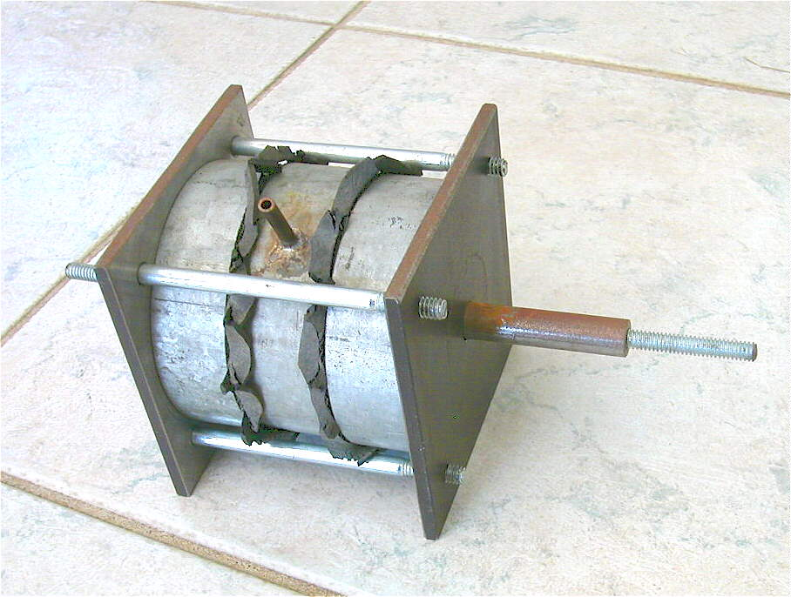
Fig 3 Picture of the large double pull cylinder
Construction of cylinder components
Note:- I used a mixture of imperial and metric components and tools and the sizes quoted are what was actually done. All sizes can be changed as required to the nearest metric or imperial units to suit the available material.
The end plates are all similar and are cut from off cuts of mild steel 80 mm by 6 mm bar stock obtained from the scrap bin at the local steel fabricator. The rubber sheet is salvaged from old truck or car inner tubes obtained without cost from a tyre dealer who is usually only too happy to oblige. The 16g sheet metal for the large washers is cut from steel salvaged or purchased from a sheet metal shop. The rest of the parts come from the hardware store. The principle tools used were a band saw to cut the pipe, steel bar and blanks for the washers, a drill press and a small lathe.
The first job is to cut off suitable sections of water pipe to be clamped in the lathe, trued up and finished to the sizes shown in the respective drawings. Make sure that the end surfaces are smooth and free of sharp edges that could cut into the rubber diaphragm. Each cylinder section has a hole drilled as shown and a short section of copper tube soft soldered into it using a heavy duty soldering iron or carefully applied flame.
After cutting off the end plates and de-burring them a 1/4” hole was drilled in the centre. The plate was then bolted to a simple mandrel made from a piece of 1” round bar and a 1/4” bolt and clamped in the lathe three jaw chuck. and a 1.5 mm step turned down on one side to make a neat fit to the inner diameter of the cylinder section. At the same time the turning tool was used to make a shallow score on the turned surface of one end plate marking the radius for the clamping bolts. This end plate was then
carefully marked out and drilled with 13/64” holes to be later tapped for 1/4” whitworth bolts. The plate was then used as a template to drill pilot holes in all the other end plates. The ends used for the clamping bolt heads were then opened out to 1/4” clearance and the others tapped 1/4” whitworth.
End plates can be of two types, with glands or sealed guides. If a gland is required the centre hole is opened out to 3/8” and tapped 1/8” BSP using a guide to ensure that it is perfectly perpendicular to the plate. The hole is tapped deep enough to give a deep penetration of the of the union. The union is then screwed home to give an airtight seal. The plate is then put back onto the lathe, held by the hexagonal part of the union, making sure that it runs true and the union bored out to 1/4” clearance and any excess protrusion into the cylinder area faced off. The ferrule from the union can be discarded but a small washer will be required to retain the “O” rings. This is made from a 1/4” flat washer, the outside turned or filed down till it will fit inside the ferrule nut.
If the end is of the sealed type the hole in the end plate is drilled out to 1/2”. A piece of 15 mm rod is turned to the outside dimensions shown and either welded or silver soldered to the end plate. The end plate is then clamped in the lathe by this rod, ensuring again that it runs true and the centre hole drilled to the required depth.
Construction of diaphragm
The diaphragm consists of four parts, the washers, the diaphragm boss, the shaft and the diaphragm itself. The washers were made first. A piece of 16g steel was scribed with as many circles as the required number of washers making the diameter as large as required to give a finished washer nominally about 10 mm less than the inner diameter of your cylinders. A 1/4” hole was drilled in the centre of each circle and then they were roughly cut out with the band saw. After de-burring they were all clamped on the previously made mandrel and turned to the required size. Each washer was then finished with a file to round the edges and remove all burrs and the centre hole opened out to the diameter of the boss.
The boss is made from a 10 or 12 mm set screw and nut. The screw has its head turned down till it is around 2.5 mm thick and then drilled up the centre 1/4”. The nut is split down the centre and, or, turned to a similar thickness. The shaft is made from a 1/4” whitworth bolt with the head turned off. The boss
is then silver soldered to the shaft at the required position, taking care not to let the solder run on the thread. Note:- the 10 mm screw is only used on the twin cylinder and has a 3/16” hole instead of the 1/4” hole and the shaft is turned to fit at the end..
The diaphragm is cut from a piece of inner tube and is approximately 10 mm larger in diameter than the outside diameter of the water pipe used. A hole 9 mm in diameter is punched in the centre using a punch made from a piece of brass or steel tubing. I used a punch made from the remains of an old car radio aerial. Keep the piece punched out to make the “O” rings. The diaphragm can be fitted to its shaft between the washers and the nut tightened up. Note the 9 mm hole works OK on both the 10 and 12 mm bosses.
Assembly of parts
Assemble all the pieces together and push the shaft in as far as it will go to pretension the diaphragm then lightly tighten the four clamping bolts. Pull the brake rod in and out to ensure that it does not bind and will that the rubber is not in tension. If it does not move freely you may need to polish the shaft with emery cloth till it does. If all is well disassemble the cylinder and make a gasket between the end plate and cylinder body using silicon rubber sealant. Reassemble the parts again as before, do not forget to pretension the diaphragm, and tighten the clamp bolts to about 5 ft lb. Check that the pull rods still move freely.
Make three “O” rings for each gland using your 9 mm punch and a similar 5 mm punch to remove the
centre. Put some silicon grease on the shaft and push the rings down inside the union where the ferrule would have fitted. Put the “O” ring retaining washer on and screw the gland nut tight against the washer. Check the pull rod still moves in and out without much effort. If it is too tight you may need to experiment with your “O” rings. With my setup three “O” rings nicely filled the gland space and gave an excellent seal.
Conclusion
The finished cylinders can now be utilised for many functions of pneumatic control. The most common one will probably be in a braking system. I have fitted two in a simple vacuum braking system using a converted electric tyre pump. My only initial problem was that the vacuum seal were to good and would not release till I disconnected the hose. This was overcome by making a practical control valve that turned the pump on in the full position, held the vacuum with the lever backed off enough to stop the pump and released the brakes in the full off position.
The electric vacuum pumps are not designed for continuous service so they are really only suitable for a simple system. I would expect one to be pretty badly worn after about twenty hours service but based on my useage where I would only use it about fifteen times on a running day for perhaps ten seconds per time, a total of three minutes per day. This would give me 400 days operation or around 33 years of normal useage.

B.G. Rev 1.1 19/02/05

