Fork Alignment LX200GPS 12"
Including Classic series

1. Introduction

The optical alignment of the Optical tube Assembly (OTA) in the fork assembly of the LX200 series of computer controlled telescopes is critical to the eventual accuracy of the “Goto” function, particularly when used in the polar mode of operation. When the telescope has been correctly collimated the optical alignment is not necessarily the same as the mechanical alignment, but is the true reference that the computer calculates against and needs to be compensated for. Errors in OTA mechanical alignment are probably the most common reason for problems encountered in the normal two star set up procedures which appear to work but result in poor accuracy when slewing more than a few degrees from the alignment stars.

The overall pointing accuracy of the LX200GPS telescopes, in fact all telescopes, depends mainly on three factors, the orthagonality of the rotating axes, the collimation of the OTA and the accuracy of the drives. The orthagonality of the rotating axes accounts for the greatest problem. It can cause errors up to a couple of degrees in extreme cases due to the difficulty in measuring variations in the order of arc-seconds. The collimation establishes the true optical axis from which all measurements are eventually made and accuracy of the drives which covers backlash, periodic error correction and precision of positioning control account for the remaining errors. These errors are normally only in the order of arc-minutes and can be reduced to arc-seconds by removal of mechanical backlash with careful adjustment. The balance can be compensated for in drive software

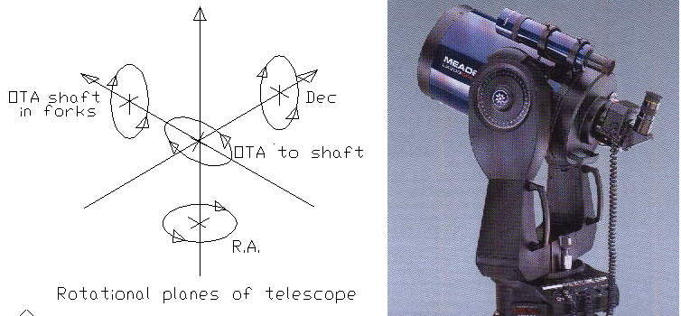

Figure 6 LX200 telescope showing the rotational planes

The optical alignment of the OTA is required in four planes see fig 6. What we will refer to as N/S is the plane the tube revolves around in the declination axis. E/W is the plane of the fork arms rotating about the RA or azimuth bearing which we will use as the datum. The plane of the OTA shaft in the forks reference to the RA or azimuth plane and the optical axis angle of the OTA to the Declination shaft. The RA plane accuracy depends on the OTA shaft-bearing axis being parallel to the RA bearing plane and should be checked first before making any further adjustments. Normally it should not need to be touched unless it has been damaged as it is set to a high precision in the factory not easily duplicated in the field. The N/S is easily compensated for by moving the declination scale to correspond to the object positions as set in the initial startup alignment procedures and is part of that procedure. The angle of the Optical axis to the declination shaft is far more difficult and involves adjustment to the OTA in the retaining brackets on the fork bearings and coupled with the OTA shaft alignment to the forks has the greatest effect on accuracy. This procedure is principally to correct these errors. Another error that can be introduced is in using the star diagonal for primary alignment as the position of the reflecting surface can move the true centre of the telescope off centre. This can be checked by observing a star that is accurately centered in the eyepiece and rotating the star diagonal through 360º and noting that the star does not move off centre. If it moves this error must be corrected or compensated for before doing a precision alignment.

The mass produced Schmidt-Cassegrain Telescopes particularly the Meade LX200GPS telescope which is the subject of this procedure are assembled in general, manually from well designed and precision made components.

Standard assembly line inspections and QA will find obviously faulty components but some parts with obscure faults will inevitably slip through. The components are then assembled manually with jigs on an assembly line where assembly time is an important factor in the overall cost of production.

Because there needs to be some tolerance in the manufacture of components this final assembly does not always produce a consistent result. Some of the tolerance is taken care of by semi automatic grading of components like mirrors and corrector plates that can be matched for optimum performance but the final product can still have variations in overall accuracy particularly in the orthagonality of the rotational axes. Rough handling during transport around the globe can further complicate this.

Luckily there are adjustment facilities for the rotating axes of the telescope but measurement and correction is fairly complicated. The procedures can be time consuming and require some special jigs and tools and if they were carried out on the assembly line they would add 100’s of dollars to the cost with no guarantee that they would survive transport and delivery. In fact they should be carried out at the final destination and periodically checked.

In this procedure I will describe the method I used to align my 12" LX200GPS and 10” LX200 classic and make it secure from accidental movement in the case of vibration during transport. I will also detail some notes on the fitting of "Buck's" steel gears to the GPS model and some of the other adjustments made to reduce backlash and retrograde motion.

The addition of mechanical stops on the rotational axes incorporated on the GPS series makes the procedure more difficult than on the Classic series as these need to be worked around to facilitate measuring and positioning of the OTA while zeroing in on the alignment steps. People with good mechanical knowledge and access to workshop facilities should only take on this procedure as for the sake of brevity some of the specific removal and replacement procedures that are well detailed in the instructions for the fitting of "Buck's" gears are glossed over.

The first error to be corrected before any mechanical movement of the OTA is attempted is to do a precise optical collimation on a bright star to establish the true optical axis of the OTA. In fact this may be all that is necessary to achieve the accuracy that the telescope is capable of.

The next step in this procedure is to setup the LX200GPS or Classic on its tripod on a level area that has optical access to a target on the horizon at least 400 metres away for the classic or at exactly 90 degrees for the GPS. This may be difficult unless you are at the bottom of a steep cliff so I will outline a couple of alternate procedures to get around this.

The covers over the declination bearings are then removed by undoing the knob that holds the declination scales and removing them. Then on the declination drive side remove the main cover that conceals the drive mechanism. If Buck's gears are being fitted follow the procedure that comes with Buck's Gears and remove main gear and declination drive assembly. Put this aside to have the steel gears fitted before later replacement otherwise the drive mechanism and gear can be left in position.

When the knobs and covers are removed from the declination bearings the rotational shaft will be exposed and you will see a hole in the centre tapped 3/16” NC (the classic was 1/4” NC). Using one of the declination scales on the GPS receiver side slide it on to the axis bolt (to be used to gauge 180 degrees in the next step) of the machined extensions, see figure 1. Fit the machined extensions in the holes to give an extension to the shafts to measure against. The bolts need to be fairly tight so that there is no lateral movement but if the drive gear and clutch have not been removed not so tight that the declination clutch won’t slip.

Next make a device to form a datum reference to measure the run out and height of these shaft extensions reference to the azimuth turning plane see fig. 2. I did this by clamping a solid rectangular steel bar to the tripod locking plate then clamping a 4ft long piece of angle iron vertically to this, the top end near the shaft extensions close enough to allow the telescope to rotate in azimuth

Next using a dial gauge on a magnetic mount or similar according to the drawing of figure 2. Follow the procedure of measuring the for height error.

Figure 1 Machined shaft extensions

Figure 2. Arrangement of dial gauge mounting.

Measuring the fork height error

The next job is a little bit more complicated. We need to measure the mean height of the shafts above the rotating plane of the azimuth bearing. This is easy done on the 8” and 10” scopes because they can be rotated at least 180 degrees in the altitude plane, the 12” is more difficult because it can only be rotated about 150 degrees because of the mechanical stops. However the mean can still be found within a couple of thou.

Set the dial gauge to ride on the shaft extension in a position that will allow the telescope to revolve freely in the azimuth plane and adjust it to give a suitable reading on one shaft extension. Rotate the OTA in altitude to the top stop (about 10 degrees past 90) and take a reading on the dial gauge. It will be necessary to swing the forks in azimuth back and forth a little to establish the peak reading. With the 8” and 10” rotate the OTA in altitude exactly 180 degrees (the declination scale will be accurate enough), with the 12” use the bottom stop, and take a second reading on the dial gauge the same way. Repeat this procedure two or three times to ensure that the readings are constant. Calculate the mean height of the shaft from the difference between the two readings and without disturbing the dial gauge mount rotate the fork assembly 180 degrees in azimuth and repeat the measurement on the other declination shaft. If the two mean readings are the same your forks are exactly the same height and no adjustment will be necessary. You can go straight to the method of aligning the OTA in its carriers.

If the mean readings are different as all of the telescopes I have examined were, subtract the lowest reading from the highest to establish the error. The worst case I have seen was on a 12” GPS and the difference was 3.00mm amounting to an error of about 17 arc minutes, another was 1.17mm. This sort of error would take goto slews out of a 26mm eyepiece view after about 30 degrees of slew assuming that you could get some sort of a two star alignment. When the difference in height is established remove the plastic covers from the bottom of the forks. There are four screws in each side. With a torch or other light if necessary look at the fork attachment bolts onto the azimuth housing and note that they are in slotted holes. Closely examine the amount of movement available and in which direction up or down the fork can be moved. On the fork that was the highest check that a portion of the slot is visible above the four attaching bolts. So the fork can be lowered. If there is none check the other side (lowest) and see if there is any portion of the slot visible below the bolts so that the fork can be raised. There should be enough on one side or the other. Unless you strike the trouble I had with the rogue 12” GPS which I will discuss at this point.

On one particular 12” LX200GPS that I eventually set up, the fork that would need to be lifted was at the top of its slots so I looked at the other side. Yes there was plenty of room for adjustment so I proceeded to loosen the screws and lower it a bit. After loosening the screws nothing happen. The fork would not move down. On closer examination I discovered the problem (which was why the scope was so much in error in the first place) a fillet (see fig. 3) on the base assembly that stopped the spacer block from moving down. After much deliberation I decided that I would need to modify the spacer block (see fig. 4). Getting it out was quite a job as all the wiring to the declination drive and battery compartment had to be removed first. The four screws that held the arm were removed while two people supported the tube. The arm was moved sideways enough to remove one of the Allen screws that held the spacer block to the arm, then moved the other way to remove the other screw. This allowed the spacer block to be removed. The undone fork was then moved to a safe position and tied so that the OTA was suitably supported while the block was being milled in the lathe. When the milling operation was complete the fork arm was reassembled and the whole measurement routine repeated. This time there was ample movement on the fork and I was able to reduce the difference in height error quickly to 0.03 mm which calculated out to an error of 18 arc-seconds, a great improvement. As I was now running out of time and did not have a suitable fine adjustment device to reduce this error further we left it at this position till next time. Subsequent testing of this telescope has revealed a "Goto" performance now better than 1.5 arc minutes!

Figure 3 showing the fillet on the LX200 base that causes the problem

Figure 4 Enlarged view of the spacer block and the section that was milled out.

Adjusting the fork height.

The easiest way to adjust the height is to select the fork that needs to be lifted. Then using a supply of steel shims in suitable combination force them between the bottom of the arm or spacer block and the azimuth base assembly (there is a space here that works perfectly for this exercise). These large flat shims will also help to keep the fork vertical with respect to the base. When enough shims are in place tighten the fork bolts to pre-load the bearings and repeat the measurements made previously to establish whether you have moved the right amount. If there is a difference we can now measure it pretty closely and if the fork still needs to be lifted we can insert a shim of this thickness. If the arm needs to be lowered we can remove one of the shims already in place and replace it with on that much thinner.

When the forks are correct and you are happy that they are exactly the same height they can be keyed to this position if you wish (this step can be left out if you do not wish to drill holes in the arms and base). Look at the mating surfaces between the azimuth base and the fork arms or the spacer blocks if fitted. To make the keys we must first locate the center of the joining surfaces of the azimuth base and fork arms or spacer blocks (adjustable faces). There are four such positions two on each fork. At the center of these faces drill a 5/32” hole about 1/2” deep so that half of the hole is in each face. Tap these holes with a 3/16” NC intermediate tap and insert a hex drive 3/8” x 3/16” NC grub screw into each hole and tighten it so that it locks into position. This will ensure that the forks will not move relative to the base.

At this point the declination drive components can be re-assembled and all the covers can be replaced unless Buck’s Steel gears are going to be fitted and you can go to the section on aligning the OTA. Otherwise follow the procedure that comes with the gears kit.

Fitting of Buck’s Gears

When fitting Buck’s steel gears to the declination drive I found the gears fitted the worst case as described in the instructions. See annex at end for removal of pesky gears. My gears were cogging with only about 60% mesh. I read through the solutions in the instructions and saw that I would need at least the 3rd method! After reading the instructions a couple of times I wasn’t too happy with the method because I felt removing the location bush altogether was not a good idea.

However I disassembled the worm gear from the motor bracket and removed the bush and “O” ring by punching it out with a drift while the bracket was clamped in the vice. I examined the bush closely and checked the holes that it fitted in and decided it would be easy enough to make an offset cam to fit into the bracket and worm gear housing. This I hoped would give me a positive adjustment method for the gear meshing.

I found a length of 1/2 diameter bright steel round bar in the scrap box and clamped it in the lathe. I next bored a 17/64” hole up the centre (my nearest clearance drill for the 1/4” step on the worm shaft) for about 1”. I cleaned up the end with a file, see figure 5, and checked that it was a nice fit in the worm gear housing. I next cut a little less than 3/4” off this cleaned up end and clamped it in the three jaw chuck with a piece of a mini hacksaw blade under one of the jaws (the nearest thing to about 20 thou I could find around the work bench). This gave a nice offset to the piece of shaft in the chuck. I next machined the shaft to about .01" less than 3/8” for a distance of 11/32” as shown in the drawing. (Saved me having to change the chuck in the lathe to get the required offset).

Figure 5 Dimensions of locating cam for the motor drive on the LX200

I cleaned up the job with a file and emery paper and removed it from the chuck and tried it in the holes of the motor bracket and worm gear housing. It was a perfect fit and I could turn it with a pair of pliers from the gear side of the motor bracket while in situ. I next opened out the holes in the motor bracket with the 9/64” drill in the kit. The worm gear assembly and motor bracket were then mated together with the “O” ring and cam locator and the four screws started in their holes. I then checked the meshing of the gears, rotating the cam with the pliers a little bit at a time removing and refitting the gear each time till I got 100% mesh. I then tightened up the screws till the new “O” ring was about 50% compressed and rotated the gears to check for stiffness. All being well I completed the re-assembly as per the instructions (I only dropped the spring once and found it within 15 minutes) and tested it out. The Dec. slewed correctly so I did a quick alignment on Sirius (easy to find in the daylight) and checked for retrograde motion. There was no noticeable evidence but I did have a small amount of backlash, which I will try to remove later when I train the drives and do a PEC (after I fit the gears to the RA drive). All in all it was a very satisfying exercise.

Adjusting the OTA

Before any adjustments are made to the OTA in its carriers the optical collimation must be correct as this will establish the true optical tube axis which will be used as the basis to measure the errors against. This test may be carried out in a number of different ways depending on whether the telescope is the GPS series or the classic series and it essentially will measure the E/W offset a star has when the optical tube set at exactly 90 degrees in declination. With the GPS series the test carried out to establish the OTA 90 degree will also show this E/W offset which may be noted when the tube is rotated 180 degrees around the azimuth bearing. This effect will also be noted in the classic series if the same procedure is used to establish 90 degrees of declination.

The Classic series

I will tackle the classic series first, as this is the easiest because there are no stops on the declination axis. Turn the telescope on and select the “Land Mode”. Turn the telescope off. Swivel the telescope around manually and locate an easily identifiable object on the horizon. Centre this object using the cross hairs of a graticle type eyepiece and lock the azimuth bearing. Turn the telescope on and let it settle. Press the mode button on the controller till the RA and Dec scales are on the display. Operate the E/W control till azimuth reads 0:00:00 then look in the eyepiece. Your selected object should be right where you set it. Now using the E or W control move the azimuth exactly 180:00:00. If you have followed the procedure exactly this should be 180:00:00 Tilt the optical tube though the forks till the selected object is in view again. Accurately centre the object with the controller buttons and read the new
Azimuth from the hand control. Subtract the new reading from 180:00:00 to give the error figure. If the adjusted second azimuth reading is higher than 180:00:00 the correction was West. If it is less the correction was east. Repeat

this step 3 or 4 times and ensure that the error is constant.

Inspect the six bolts that hold the optical tube onto the declination bearings brackets. They are in slotted holes. Tilt the optical tube down so that the corrector plate faces the azimuth bearing and check the position of the screws relative to the slots. Work out which way the tube has to move as follows: - If you have dropped the tube from the 180:00:00 position stand behind the telescope and look towards the alignment object. If the new angle was greater than 180:00:00 then the tube was pointing too far to the right. This means that in the tilted position the corrector plate end of the telescope is too close to your right hand fork and will need to be moved away from it. If the error is the other way it will be too close to the left-hand fork.

When you have established which way to move check which side of the telescope has enough movement in the slots to make the necessary correction. Make all the adjustments on this side. To assist with the fine adjustment of these screws there are two holes tapped 4/40 in the end of each bracket opposite the two outer screws. These screws are too fine to apply any pressure so I drilled out the holes and tapped them 6/32. Insert 3/4” by 6/32 screws in these holes before adjustment and use them to make fine adjustments while looking at the target through the eyepiece. A total movement of about 4mm is available at the corrector plate end.

Check the amount of the error and divide it by two. This will give the required correction. Carefully loosen the screws on the side you intend making the adjustments and move the optical tube the required amount. Tighten the screws and go through the entire process again and check the improvement. Do this as many times as is necessary to remove all the error (in practice about 1 arc minutes will be the limit). When this is achieved the OTA should be in near perfect alignment. Tighten all the screws and remove all the test jigs and reset the telescope for normal operation. Set the telescope back on its polar mount and go through the full alignment procedure. If all has been done correctly there should be a marked improvement in the alignment of stars over the whole area of the sky

Alternate method (see also Annex A to Polar~1.DOC for finding 90deg.)

This method described originally in an article published on the "Mapug" site will only work if the axis of rotation of the azimuth bearing and the axis of rotation of the altitude bearings are in the same plane and the OTA is laterally centered in the forks. Proving this parameter met is almost impossible without special measurement aids and is less precise than the previous method but it can give quite acceptable results if this criteria is met and care is taken see Annex A below. Position the telescope under a diffuse light source such as a fluorescent fixture and point the tube straight up. Remove 2 Allen head screws holding the RA bearing cover and remove it. Insert a long focal length eyepiece into the visual back holder. If the you use an eyepiece that comes to within an inch of the bearing an image of the secondary mirror will be sharply focused on the bearing with your normal optical focus as used when viewing the stars. If the optical tube is not aligned to the Dec axis, the spot will be offset to the left or right. Next, LUBRICATE the thread on two 4/40 1" Allen head machine screws and thread into the ends of the optical tube shaft mounting plates. If these screws don't thread in smoothly, chase the threads with a 4/40 tap, otherwise there is a good possibility the screws will seize and break. In any case do not apply any real force to the screws. Rather move the OTA manually and use the screws as a datum only. Next, slightly loosen the 3 optical tube shaft mounting plate bolts on the side where adjustment is needed. For example, if the light spot is offset to the right, you will loosen and adjust the left side. When the light cone is centered, tighten the 3 mounting plate screws. The accuracy depends on how sharply you can observe the position of the light cone. If you can center this light spot within 10 thou (the thickness of a business card) the accuracy with a 12” telescope will be about 2 arc minutes if you can center it to 5 thou the accuracy will be close to 1 arc minute. Quite an acceptable figure

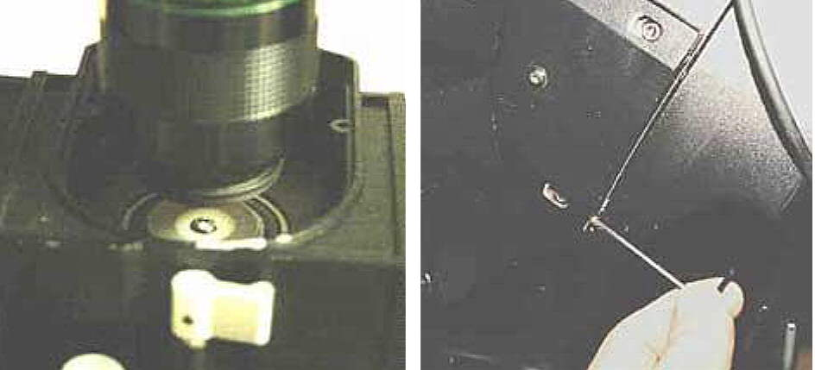
Figure 8 Light cone and adjustment screws

LX200 GPS models

It is not possible to rotate the 12" models through the required amount in the declination plane to use the first of the above methods because of the stops. The alternate method is not really suitable because of the same limitations in the previous paragraph and also because the cables come up through the centre of the bearing so that there is no accurate centre mark. This can be overcome with a jig as described in Annex A to polar~1.doc to fit over the bearing retainer nut. An eyepiece of 40mm F/L is needed to focus the image of the secondary mirror on this jig. I have used this method to get the OTA within about 2 arc-minutes when I marked a cross on the bearing cover where the light beam focused after previously finding 90 degrees by the method used in the manual and the optical tube axis by other means. With the 12" telescope the position of the image of the secondary mirror is about 2 mm in diameter and quite sharp and the lateral displacement approximately 7 arc minutes per mm. However the following methods I will describe will work with either series.

Method 1

With the telescope mounted on the tripod (power can be on or off in the land mode) set the OTA pointing straight up and the forks set north/south so that the OTA declination axis follows the equatorial plane. Move the telescope back and forth in the declination plane till you find a bright star that can be put near to the center of the eyepiece by adjustment of the declination control only. When you have found it note that the star only drifts (due to the earth's rotation) in the declination plane. Note the star's position relative to the fork pointing north. Rotate the telescope in azimuth though 180 degrees and check the star's position relative to the fork now pointing north. Any offset will be due to the error in the OTA mounts. Try to correct half the error by adjusting the screws as explained in alternate method above and repeat the test. . Repeat this procedure as many times as it is necessary to bring the star to a stable position relative to the forks. This adjustment can be quite tedious due to the difficulty in accessing the adjustments due to the telescope position and the star movement due to the earth's rotation. This method will also be good to about 1 arc minute.

Method 2

Figure 8 Arrangement using fabricated wedge. Note the forks are shown in the
vertical position to emphasize the clearance. They need to be swung to the
horizontal position for the measuring.

This method is the most accurate but needs a special wedge to mount the telescope on that will allow the telescope to point to a terrestrial object with the optical tube within 5 degrees of the 90 degrees position see figure 8. Although I have not tried it I believe the super wedge could be reassembled to meet this requirement. For my use I made a suitable wedge from some scrap steel bar stock. The method is basically the same as method 1 but it uses a stable terrestrial object to align on.
Method 3

Fig 9 Arrangement of OTA to set alignment in forks using dial gauge

This method is not quite as accurate as method 2 but doesn't require any extra special tools. It relies on the accuracy of the machining of the corrector plate mount and the optical axis of the OTA being very good and is the method I now use. The OTA is set to the vertical position and the dial gauge is aligned on the corrector-plate retaining ring. The OTA and fork assembly is rotated about the Azimuth bearing and measurements are taken. The special 4-40 screws in the OTA support brackets are adjusted as in the other methods and the declination control is adjusted also till the dial gauge reading stays constant as the assembly is rotated. I can get the dial gauge to read within .02 mm without any problems, about 1.3 arc-minutes on a 12" OTA. This method will also find the 90 degree point for the OTA to the same accuracy and I have pinned my declination scale to the declination shaft so that coupled with the magnifying cursor I can reset the 90 degree position within about 3 arc minutes quite easily at any time.

Annex A

When attempting to use the light pattern on the axis of rotation centre on the azimuth bearing the results will be useless if the condition shown in fig, 2 or fig. 3 is present. This is especially so if you are trying to establish the 90-deg. position of the telescope as required in the LX200GPS procedure. Because the fork arms are only attached to the azimuth body by bolts there is no permanent datum to set to and the OTA may not be laterally centered either. Note the offset shown in the drawings is exaggerated for clarity but could be as much as 4 or 5 millimeters.

Referring to fig 3 it is possible to measure this offset with a large set square by setting the azimuth exactly to zero and aligning the square with the forks at the declination bearing and the telescope base and reading the variation in the distance to the base centre line. I measured one telescope at 5 mm!

Note: See annex A to polar alignment Doc for an alternate method of finding 90deg.

Annex B

Removing the grub screw from the plastic gears

There has been much said about the difficulty of loosening the grub screws in the plastic gears because of poor fitting hex keys. I was able to remove a couple that had beaten the experts by using a small star key in lieu of the hex key. These keys come in the kits of keys that can be purchased from electronic supply houses. The second smallest (SD5.5) is a tight push in fit and will remove even damaged screws.

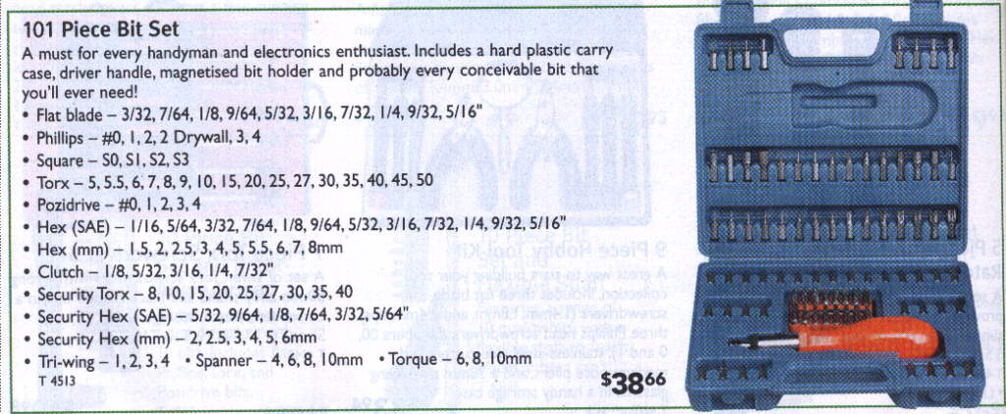
Figure 9 The key set referred to above

Rev 3.1 09/06/05 B.G.

