Símbolos
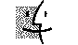Pág 3
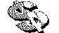
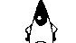
Simb wsbl14 Simb wsbl31 simb wsbl41


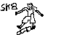

Simb wsbl 45 sk8 u turn

Zorak

