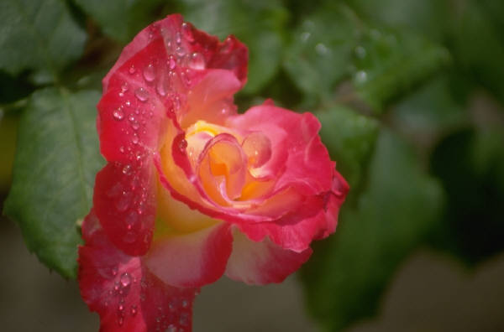

Chapter Two

Attentively, Erik relieved Christine of her basket. Gusty winds whipped the leaves around them in tiny tornados of dust. Erik felt the conditions appropriate as his own insides were swirling as wildly as the wind. He had not been able to turn around and walk in the other direction when he noticed Christine in the market. It was distasteful for him to be in such close company with other people, but he had needed to buy more ink and so he risked it. Moving briskly on the outskirts of the main thoroughfare, he had noticed her small figure and as she pushed her cloak back to smell the roses, he saw her face. His heart had stopped within him when he saw her. Christine was already well past him when he roused himself and impulsively bought a red rose from the vendor. Impatiently, he handed the man far more money than need be but he did not have time to wait for change. Braving the crowd, along with the side glances, he kept his eyes on Christine lest he lose her. His heart compelled him to speak to her; if only to ask after her well-being. The urge was too irresistible.

Now, the two were leisurely walking together attempting distractedly to think of something to say. At precisely the same moment, each spoke out. They looked at each other abashed and laughed simultaneously. “Please.” Erik elegantly gestured for her to speak.

“I was going to say that I am glad that I insisted on going to the market this morning. I can’t tell you how good it is to see you again, Erik.” she said softly. Erik nodded without looking towards her, not trusting his voice. “You should know that I continue to sing.”

That surprised Erik enough to pause and glimpse her way. “Yes?” he cautiously answered.

“Yes, but not in as grand a fashion as I did when I was your pupil.” Christine peeked out of her hood. “I sing at the cathedral on Sunday mornings. It isn’t very impressive, I know, but it is the only singing Raoul permitted me to continue and it keeps my voice limber.” She went on, uncomfortable at the mention of her deceased husband in front of Erik.

Erik, ignoring her reference to Raoul “permitting” her to sing and all it inferred, answered sincerely, “They are lucky to have you to sing for them. Your voice is a beauty, Christine, and I cannot conceive of a more appropriate place for such an angelic instrument.”

Christine blushed under his effusive praise. His voice was so melodious and caressed her hearing. “Well, it would have been nothing had you not instructed me.”

They both remained uneasily lost in thought, remembering. Neither had forgotten the singular pleasure of singing together as their voices reached inside the soul of the other. Presently, the two came to a great iron gate that Christine made to enter. Looking back where Erik had halted, she gazed at him questioningly.

Apologetically, he said hoarsely “This is as far as I should go.”

His posture reminded Christine of a frightened colt and she understood his reluctance. She went back to him and reached for her basket. Gently, she answered “You are more than welcome to come inside, Erik. I live alone now.”

“No.” he stated evenly. He would not endure the stares of her servants. He must get away to calm the storm she had caused when he first saw her.

“Well, perhaps I will meet you again soon, Erik. Thank you for seeing me home.”

Again, they regarded each other. Both were inexcusably reluctant to part company; each feeling the meeting preordained.

Erik bowed toward her murmuring “It was my pleasure, Christine. Perchance I will have the honor of hearing you sing again some time.”

“That would be lovely. I do hope you will come visit.” she offered hopefully.

“Adieu, ma cherie.” His whisper lingered in the air around her as he strode down the path from which they had come. Christine stood and watched him move away from her with mixed emotions. She recognized with a sigh that Erik had always caused mixed emotions within her. His cloak lashed around him violently. She was struck by his imposing, strong gait laced with gracefulness. Before he rounded the turn, he did as she had hoped he would and looked back towards her. His eyes pierced her even from a distance and she lifted her hand in farewell. Erik slowly lifted his fingertips to his lips and was gone.

Christine drew a shaky breath as she began toward her home. She would never have imagined meeting with him when she woke up this morning. It would be an immense lie were she to try to convince herself that she had not thought of him in the past five years. Often, she would sit singing in the garden remembering their lessons and speculating how Erik had fared. When she had left him, she was merely a child. Now, as a woman, she recognized much of her fears unfounded. Without fail, Erik had always treated her with respect and would have died rather than hurt her. She had not known that at the time. They had been so young, Raoul and herself, she thought fondly. Yet, marriage had not been what she expected. There were clear-cut class distinctions and Raoul made those very apparent to her. She was not permitted to raise her voice in song unless it was in worship. There were stigmas attached to women who performed on stage and she knew he desired to leave her singing in Paris.

Erik. My God, was it possible that she had just seen him? So much to think over. As she entered the doorway, a light rain had started to fall softly behind her.

Nighttime rain pelted the roof as he sat brooding before the fireplace. His brandy sat untouched on the side table as he contemplated the flames. For the hundredth time that day, he questioned his decision to speak to her. Christine. How had he lived without looking into her beautiful blue eyes? The years had been kind to her and, if possible, she was even more lovely now. He had shocked her, he knew. Yet, he still reeled from the astounding knowledge of her loss. Christine had not been emotionally strong when he knew her before. Now, he was taken aback and oddly pleased at her unassuming, controlled demeanor. She must have gone through hell, but, as she herself declared - she had survived. Tears stung his eyes as Erik imagined her loneliness. Somehow, his own isolation seemed different since he was so accustomed to it. He realized that, as heart-rending as it was, he had counted on Raoul to protect Christine. However, Erik had not counted on this…….on his death. Curiously, he felt no victory in realizing his rival was dead. Erik had thought of Christine in Raoul’s safekeeping, at least in this life. The realization that Christine was abandoned did not sit well with Erik.

He sighed as he thought of her invitation to come into her home. Not that he ever would, still, it was good to know she didn’t think of him with total revulsion. Hours passed as he pondered late into the night.

