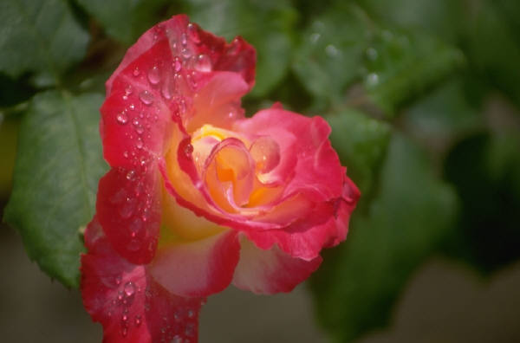
Chapter Four

Growling roguishly, Erik corrected her yet again. “No, now pay attention, Christine.” He leaned over her instructing her fingers on the keys determined to teach her the tune. She was in a decisively playful mood and it was not conducive to learning. She affected a serious expression as he moved to the side of the piano. Deliberately playing the last note incorrectly, she looked up at him in mock horror. Giving up, Erik rested his head in his hand. “You are quite vexing today, Christine. I can see that it will be useless to try to teach you anything.” Christine laughed unselfconsciously and proceeded to play the correct notes in perfect succession. Erik put his hand over his heart and staggered to the nearest chair. “Is it possible?” he asked in awe.

Christine could not remember when she had enjoyed an afternoon more. She and Erik had sang lovely, albeit safe, songs and he had played for her for hours. Their time had been relaxing and with none of the turbulent undercurrent usually felt by both of them. Chuckling, she replayed the incorrect notes once more and Erik resignedly rolled his eyes.

Off her guard, Christine sat back considering him. Her face shone with happiness making it difficult for him to breathe. “Oh, Erik”, she sighed contentedly, “I don’t remember when I’ve had such a good time. Thank you so much.” She knew she had surprised him but couldn’t care. He had long ago divested himself of his hat and cloak and sat enduring her silliness.

“It is I who should be thanking you. I’ve not ever spent so pleasant an afternoon.” He returned while becoming abruptly aware of her beauty once again.

Christine had continued to play nonsense on the keys. She was not looking at him anymore but could literally feel the moment when his mood changed to yearning. Briefly, she wondered how it was possible they could still know each other so well. She’d not experienced such oneness with Raoul, she realized with guilt at comparing them. Once more braving his gaze she asked, “Erik, will you play again or have I completely tired you?”

In answer, he rose and came toward her. He extended his hand to help her up from the bench but she scooted over and patted the space next to her. With every nerve in his body warning him of the danger of such proximity, he stiffly sat beside her. Tightly, he managed, “What would you like to hear?”

“Anything of yours.” Christine said quietly.

Making an authoritative effort to collect himself, Erik launched into one of the first songs he had ever taught Christine. She smiled vaguely in remembrance, looking up at him shyly. He had closed his eyes and she looked up at the unmasked side of his face. He had such strong features and would have been exceedingly good looking if fate had been kind. The memory of his deformity sprang to her mind but she dismissed it. There was nothing to fear.

Acutely aware of Christine’s regard beside him, Erik suddenly stood and went to the window. It was very late afternoon and still overcast threatening possible snow. Christine looked worriedly at him and tentatively asked, “Erik, is something the matter?”

When he whirled to face her, she brought her hand to her throat at the passionate emotion obvious in his expression. “Is something the matter?”, he whispered in a calm that froze her more than an angry outburst would have done. “Christine, tell me. What do you think could be bothering me?” Swallowing, she looked down at the floor unable to meet his eyes. Tension was thick between them as he strode to stand behind her. He brought his hand up to her hair, lightly touching her curls. Brokenly and without warning, he spat, “You left me.” Filled with shame, Christine felt tears threaten her in the truth of his words. She couldn’t move or speak. He had every right to be angry with her. Before she had left with Raoul, she had planned to betray him to the managers. She could have given him excuses, even reasons, but in the face of his pain she decided it was much kinder to be silent.

“I thought I would not survive without you.” he continued. “Unfortunately, my body continued to live on inexorably. I had to leave Paris soon afterward. Too many memories....”

Ashamed at his outburst, he moved to retrieve his cloak and hat. Christine stopped him with her arm but he did not turn towards her. “Erik, please don’t go.”

He chuckled, amused at the irony of Christine saying that to him.

Wearily, he replied “Christine, I must go. Now. Before I do something we will both regret. We’ve shared an enjoyable afternoon and I’d like to keep such a precious memory.”

Christine detained him with her hand, astonished at how badly she did not want him to leave. All throughout their relationship, her wishes had dictated Erik’s will. She decided to give him what he needed for a change and what he needed now was space. She removed her arm. “Very well, Erik. I will see you to the door at least.” After he collected his things, she walked down the hallway before him towards the entrance. Once again, the air was almost electric with the unspoken emotion. She looked resignedly up at him and once again thanked him for the afternoon.

Erik was in awe of the mature bearing of the young woman before him. He was sure she would offer the plausible excuses for her leaving, thus, ending in a deluge of tears. This was most unexpected. For a few moments he stood examining her as though she were a remarkable specimen under glass. She returned his regard with a timid smile and he was irrevocably lost.

Bridging the space between them, he held her tightly to him breathing in the scent of her hair. She clung to him mightily and for many moments, they held each other in absolution. His hands were lightly stroking her hair and she felt his lips gently kiss the curls above her forehead. Knowing she tempted fate, she looked up at him with her heart in her eyes. Restraint broke and he lowered his lips to hers feverishly. Gloriously, she received him with all the desire she felt. He gently parted her lips and she felt a wave of heat pour over her when his tongue lightly caressed hers. Grasping the back of his neck, she pulled him down to her, deepening their kiss. Erik would have reeled had she not had such a strong hold on him and he wrapped his arms around her engulfed in hunger. They kissed with unrestrained emotion releasing years of pent-up longing. Trembling, Erik reluctantly broke their union, turning her head on his shoulder and continued to hold her. Christine’s breathing was heavy and she felt faint. After some moments when he was certain they could both stand alone, he eased away from her.

His hand on the doorknob, he looked back at her. Her eyes were glazed and her parted lips were swollen from his kiss. With a groan, he wretched the door open and his black figure was swallowed into the night.

