Name:_______________________________________________________________________________Date:_________________
Please write and draw about the following:

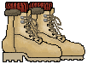
Characters


Problem

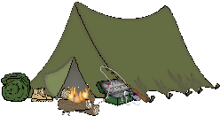
Setting

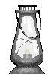
Solution

