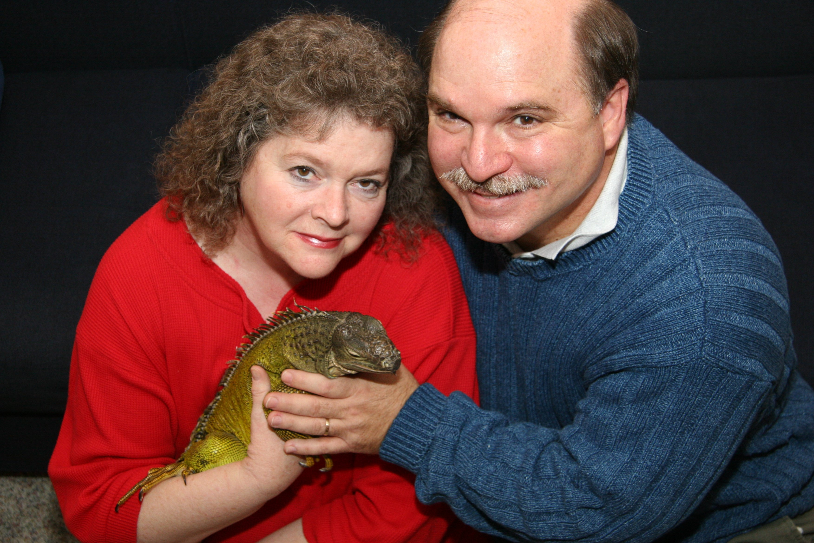
Preston
PrestonSmithPhoto.com
Bubbette’s Words of Comfort to her Loving Parents

When you hold the box of ashes, I really won’t be seen.
It’s just the remnants of my bones and spikes and scales so green.

I’m no longer bound by this earthly shroud,
My spirit now glides and dances on clouds.
There’s no more medicine or needles poking my scales,
I can eat my food now and swing my long tail.

Though you can’t touch me, you can whisper my name.
My spirit’s still with you, it’s just not quite the same.
I’ll bask with you in the rays of sun,
I’ll rest on your pillow when the day is done.
On top of the mountains and under the sea,
Enjoy those gifts, and remember me.

Don’t cry for me and don’t be sad,
I’m riding on God’s shoulder now, rejoice and be glad.

Darry Conner
5-25-06

