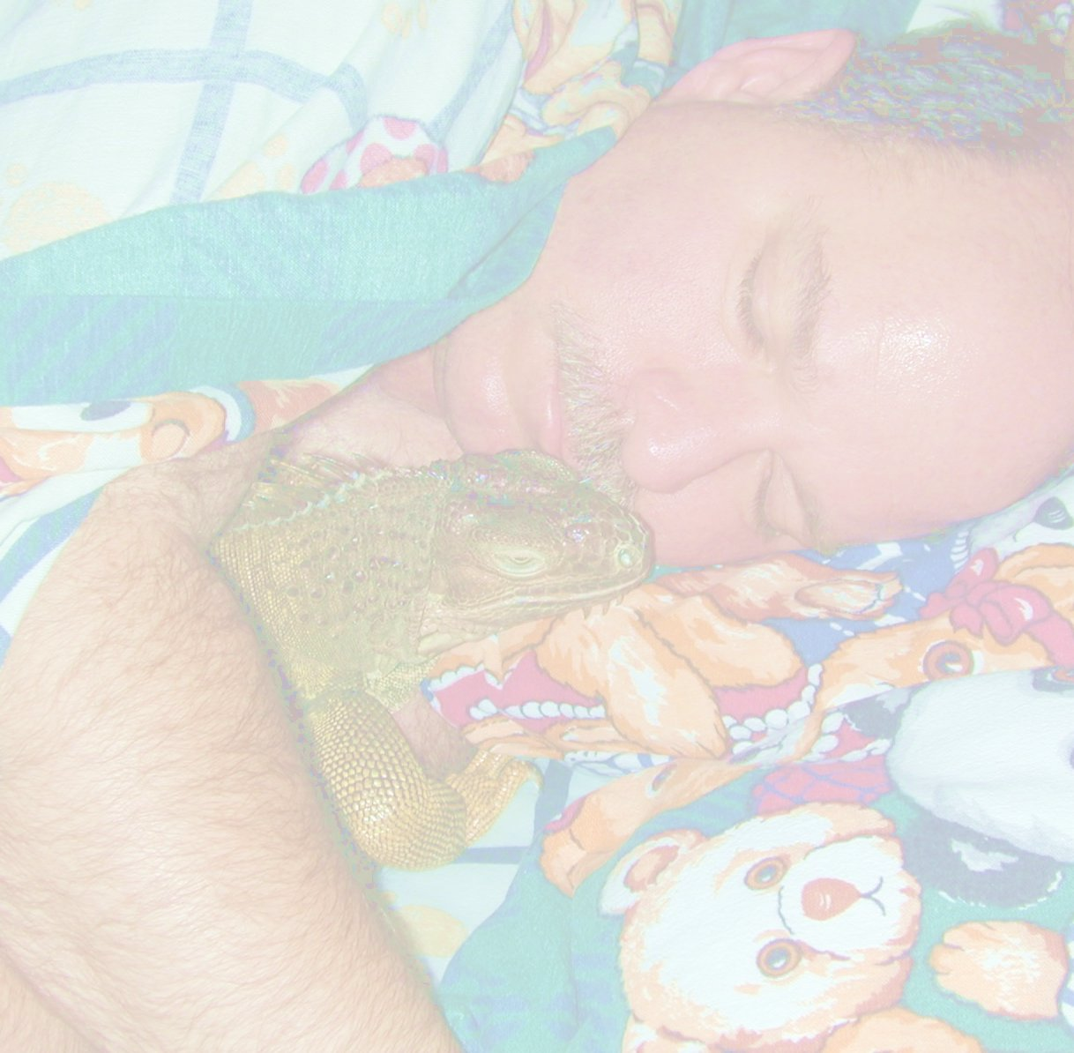

A "GREEN" GOOD-BYE

I sit and try to write the words, I want your heart to hear.
Hoping to find some comfort, in the fact that your not here.
I look out into the open room, that you once occupied,
Knowing now that room is empty, because my love, you've died.
I do believe with all my heart, that your soul has gone to be,
With all the other angel pets, that you were meant to see.
We will have to stay behind, until God calls us too,
So do not be afraid that He's only called for you.

The water is gone from the tub where you played,
And your pillow is so empty, where your pretty head laid.
Our bed is so empty, where you once laid between,
The two people who LOVED you and now only dream,
That one day our eyes will shut one last time,
and you will come greet us, angel of mine.
Until then, I'll keep trying to see through my tears,
with memories you left us, to reflect through the years.
We'll never forget one minute we spent,
of loving and laughing, of places we went.
But one day will come, when we'll start to see through,
the pain of the moment, and remember just "you".
Now you go and play, and look down when you can,
remembering we love you, and this isn't the end.
from “A Golden Goodbye” –adapted by Charlotte Blowe for Ted & Darry

