In memory of my green friend, Mannie…

You came into my life unexpectedly and without warning.

A suffering being, hurting and not trusting.

Previous abuse and neglect had worn you down,

but your beautiful soul refused to frown.

I patched you up and administered care,

with lots of love and many a tear.

I was told that your kidneys had been severely damaged

and that your time here on earth would have to be carefully managed.

That was four years ago, how quickly the time went,

and today I was told that your time here was spent.

I knew this day was going to come,

but not so quickly, we were just starting to have fun.
Our times outdoors basking on the lawn in the sun,
the flowering hibiscus tempting your tum!
How I loved you, Mannie, my green little friend,
you were one in a million and I hope to see you again.
If there is a heaven, I know you are there,
basking and bobbing without any care.
Free of pain and human restraints,
your natural beauty now free to radiate.

I love you Mannie and you will be severely missed.
Take care my handsome boy.
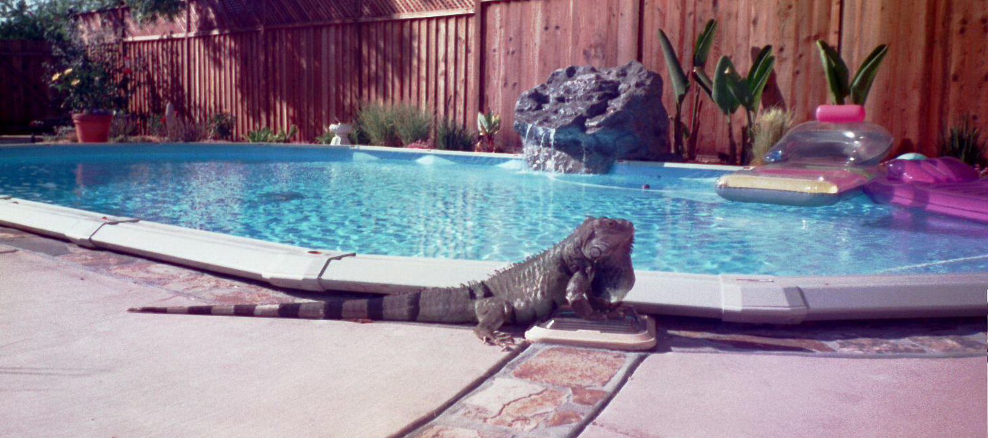
Dana Belstler 7-20-2002

