She Is Gone
You can shed tears that she is gone
or you can smile because she lived.
You can close your eyes and pray that she'll come back
or you can open your eyes and see all she's left.
Your heart can be empty because you can't see her
or you can be full of the love you shared.
You can turn your back on tomorrow and live yesterday
or you can be happy for tomorrow because of yesterday.
You can remember her and only that she's gone
or you can cherish her memory and let it live on.
You can cry and lose your mind,
be empty and turn your back
or you can do what she'd want:
smile, open your eyes, love and go on.
-- Author Unknown
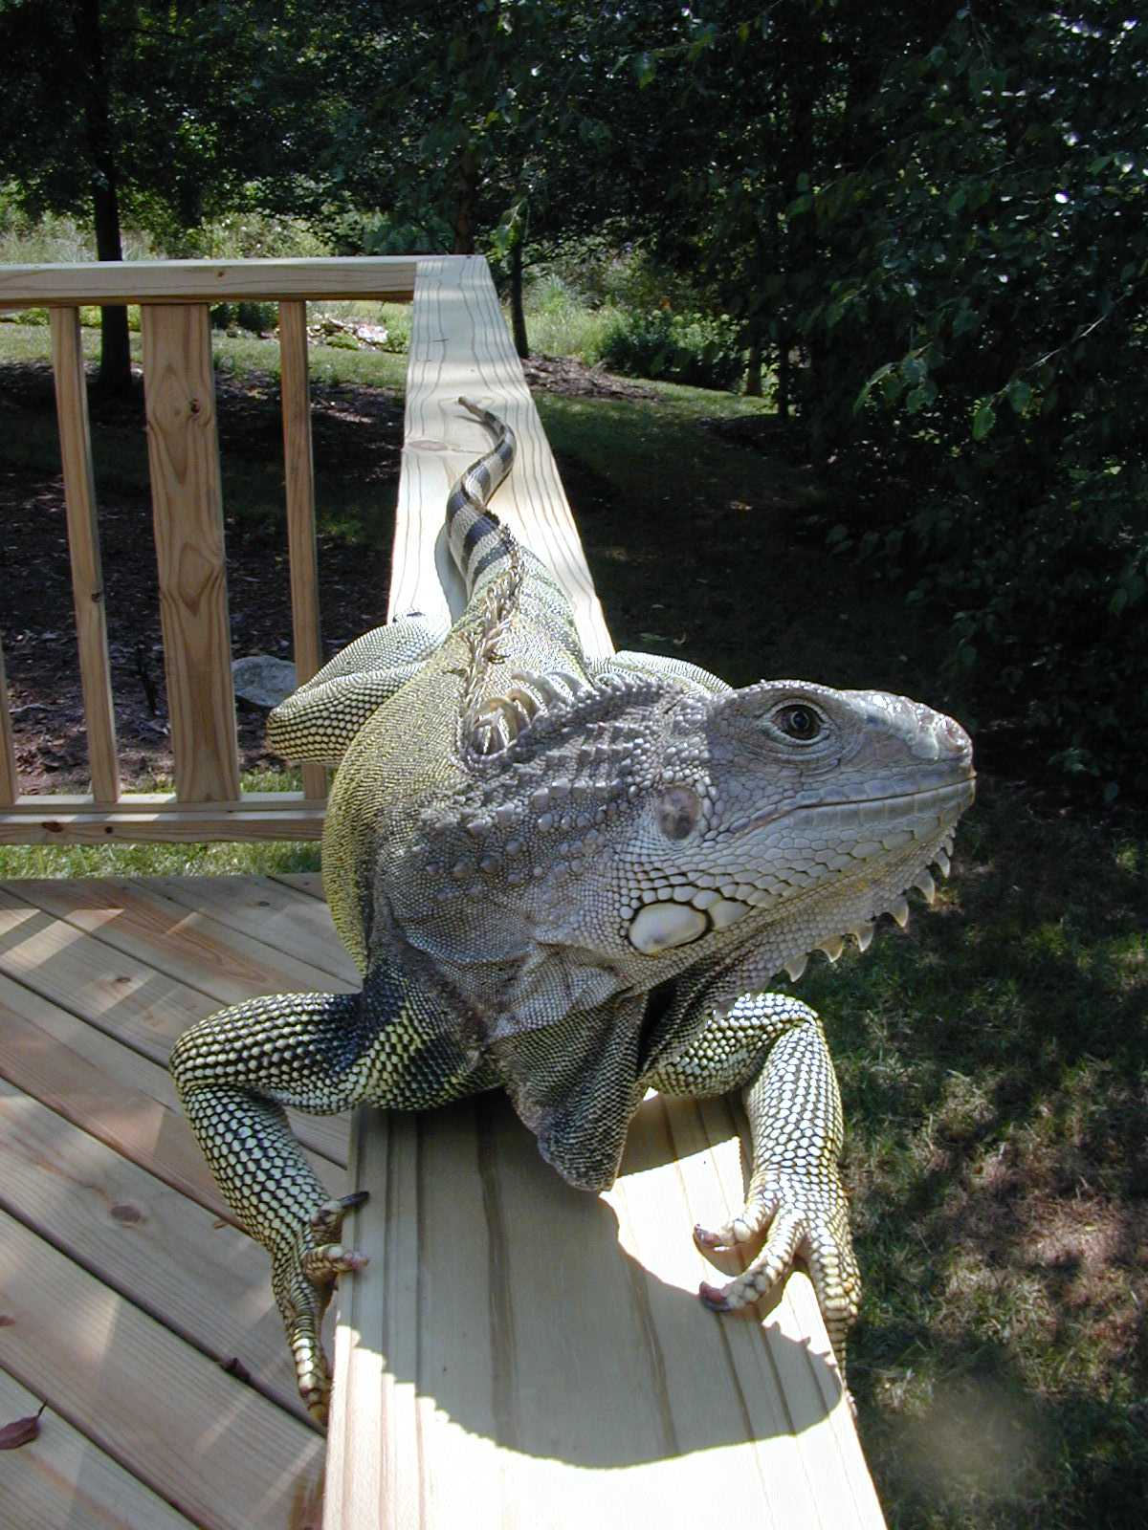
Preston
PrestonSmithPhoto.com

