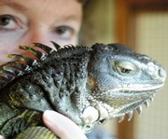

Words of Love

We have found that one, perfect green companion who meshes so closely with us, so completely. We can be surrounded by others, yet they never touch us in that same way. When you find that green soul mate, you are at peace. You have a sense of well being...comfort.... confidence. It’s a surreal feeling knowing that you have connected with a creature in way that most people never will. It's a special gift, a blessing form God...to allow us to experience this wonderful relationship with one of HIS creatures. When I look at Bubbette, I see the miracle God has created...an animal so diverse, so mesmerizing, so truly fascinating. How can we get so intimate with a lizard? I don’t know how, only that a lucky few of us do. And when we lose them, we feel the loss so very deeply...to the bottom of our senses, and the depths of our soul.

Darry Conner 1-04
Written for a friend at the loss of her beloved green buddy.

