To the Luu's Residence
14905 Coles Chance Rd, North Potomac, MD 20878 (301) 217- 9383
From the Capitol Beltway I-495, take I-270 north to I-370 Sam Eig Highway west. Take a right on Great Seneca Highway. Take a left on Muddy Branch Rd. Take a right on Darnestown Rd Rt. 28. Take a left onto Dufief Dr. Take a right onto Silent Valley Drive. Take first left onto Coles Chance Rd. 3rd house on left.

To Washingtonian Woods Recreation Facility
511 Hillside Lake Terr, Gaithersburg, MD 20878.

From the Capitol Beltway I-495, take I-270 north to I-370 Sam Eig Highway west. Take a right on Great Seneca Highway. Take a left on Muddy Branch Rd. Make a right onto the "first" Midsummer Dr. Take the third right to Hillside Terr. In front of the parking lot is the community center with a swimming pool.

To Tibetan Meditation Center
9301 Gambrill Park Road, Frederick, MD 21702 (301) 473-575
The Tibetan Meditation Center is located in northern Maryland approximately 55 miles north of Washington, DC. To reach TMC, take I-270 or I-70 into Frederick, then follow Rt. 15 north to West Patrick Street, Exit 13B. After about 2 miles, turn right on Gambrill Park Road and continue through Gambrill State Park approximately 3.5 miles. The Center is on the right side with a "Dharma" sign at the driveway.

By virtue of this Dharma activities may all sentient beings be free from
suffering and attain enlightenment


14905 Coles Chance Road
North Potomac, MD 20878
www.geocities.com/DrikungMahayana

September, 2001 Registration Form

Names(s)

Address

City State Zip
Phone (day) (evenings)
E-mail address

Schedule of Teachings | Cost/Person | No. of People | Subtotal Cost
Vajrayogini Empowerment & Teachings  (Tue.9/11 & Wed. 9/12, 7 p.m. to 9 p.m.) | Donation  Welcome
Green Tara Empowerment & Teachings  (Thur.9/13 & Fri. 9/14, 7 p.m. to 9 p.m.) | $40  (two nights)
Heart Sutra Teachings  (Wed. 9/12 to Fri. 9/14, 10 a.m. to 12 p.m.) | $45  (three days)
Five Dzambhala Tsok (Sat.9/15, 10 a.m. to 12 p.m.)  Garchen Rinpoche's Teaching "The River That Cannot Be Frozen" (Sat.9/15, 2 p.m. to 5 p.m.)  All day at Tibetan Meditation Center | Donation at TMC
Chod Empowerment & Teachings  (Sun.9/16, 10 a.m. to 4 p.m.) | $35
Phowa Transmission & Teachings  (Mon. 9/17 to Fri. 9/21, 7 p.m. to 9 p.m.) | $100  (five nights)
Bardo I & II Teachings  (Tue.9/18 & Wed. 9/19, 10 a.m. to 12 p.m.) | $30  (two days)
Tonglen Teachings  (Thur.9/20, 10 a.m. to 12 p.m.) | $15  (one day)
Phowa Teachings  (Sat. 9/22 10a.m. to 12 p.m.)  Milarepa Tsok Offering  (Sat.9/22, 2 p.m. to 4 p.m.) | $35  (all day)
Chinese Vegetarian Lunches are provided  (Please indicate the number of your order for 9/16&22) | $5 | 9/16 ___  9/22 ___
Dharma Text with Deity photo (Please indiate the number of your order by 8/31 to guarantee availability)

Vajrayogini ____ Green Tara ______Chod ______ Drikung Phowa ______Heart Sutra _______

TOTAL $______________

You can deduct 10% from the total cost if you sign up for the whole two weeks' teachings. Please send this registration form with your check and make payable to Drikung Mahayana Center. Mail your payment to Drikung Mahayana Center, DMC Event, 315 Argosy Drive, Gaithersburg, MD 20878.

Please bring a cushion for seating.

I need lodging information ___ Y ___ N, if Yes, would like to share room ___ Y ___ N

Pre-registration is requested by 8/31/01. Suggested donations are $15 per weekday, $20 per weeknight and $35 each weekend day; however, no one will be turned away for lack of funds. For more information, you may access our website at www.geocites.com/drikungmahayana, or may contact us by e-mail at drikungmahayanacenter@juno.com. You also may call Maureen at 301-530-2347 (Bethesda, MD), Lee 301-258-0228 & Sue-Sue at (301) 217-9383 (North Potomac, MD),
- Registration Form -

His Eminence Garchen Triptrul Rinpoche
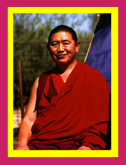
September 11 to September 22, 2001

Garchen Triptrul Rinpoche is a Drikung Kagye lama who was known in the thirteenth century as the Siddha Gar Chodingpa, a heart disciple of Kyobpa Jigten Sumgon, founder of the Drikung Kagyu lineage. In ancient India, he had incarnated as Mahasiddha Aryadeva, the lotus-born disciple of the great Nagarjuna. In the seventh century, he was known as Lonpo Gar, the minister of the Tibetan Dharma King Songtsen Gampo.
His present emanation appeared in 1936 in eastern Tibet and was recognized and enthroned by the former Drigung Kyabgon Zhiwe Lodro.

At the age of seven Rinpoche was brought to Lho Miyal Monastery. There, in a room full of status, he was asked to identify his lama. Pointing to a statue of Kyobpa Jigten Sumgon, he said, "He is my lama." Thus, he was recognized as the true holder of the Garchen throne. From the age of eleven, Garchen Rinpoche lived at and administered this monastery. Studying and practicing under the direction of the Siddha Chime Dorje, he received vast and profound instructions on the preliminary practices (ngondro), the fivehold practice of mahamudra and the six yogas of Naropa. Then, at the age of twenty-two, after completing a two and a half year retreat, he was imprisoned for twenty years during the political turmoil of China’s Cultural Revolution.
While in the labor camp, Rinpoche received all Dzogchen teachings and meditation instruction from his root lama, the Nyingma Khenpo Munsel, Enduring hardship and practicing secretly, Garchen Rinpoche realized the lama’s inconceivable wisdom mind. His accomplishment was greatly impressed by his teacher and praised by this teacher that there is no doubt that Rinpoche is the actual emanation of a great Bodhisattva.

Since his release from prison in 1979, Garchen Rinpoche has made great effort to rebuild the Drikung Kagyu monasteries of eastern Tibet and to reestablish the precious Dharma teachings there. He is presently involved in the establishment of a monastic college at Gar Monastery and two boarding schools for the children of nomadic families. He is also engaged in a variety of projects to restore Gar Monastery to its former glory. In the United States, Rinpoche has recently established Ari Gar Zangchup Choling and Drikung Mahayana Centers for the teaching and practice of the buddhadharma.

His Eminence Garchen Rinpoche, "a great Drikung Kagyu yogi of the present time" praised by His Holiness Chetsang Rinpoche and is respected by many Tibetan lamas as a pure and realized master. An accomplished practitioner of Mahamudra and Dzogchen. Rinpoche’s radiant presence inspires and delights students as the loving mother gathers her children close with sheltering, loving, encouraging, admonishing, laughing, inviting, prodding, teaching, reminding, singing…

Always Rinpoche seemed to teach that specific meaning for which one’s own heart yearned. And always his teachings and his example were both brilliantly inspiring and deeply satisfying – showing us the ideal, giving us skillful means by which to realize it. Through teachings on Nature of Mind and Mahamudra, the Vajra Songs of Milarepa, limitless aspiration prayers offered for all beings, Tummo and Guru Yoga practices, the Refuge and Bodhisattva lay ordinations, and teachings on Bodhisattva activity through cultivating the Four Immeasurables and the Thirty-Seven Bodhisattva Practices, Rinpoche poured out the lineage nectar: devotion, compassion, Muhamudra.

1

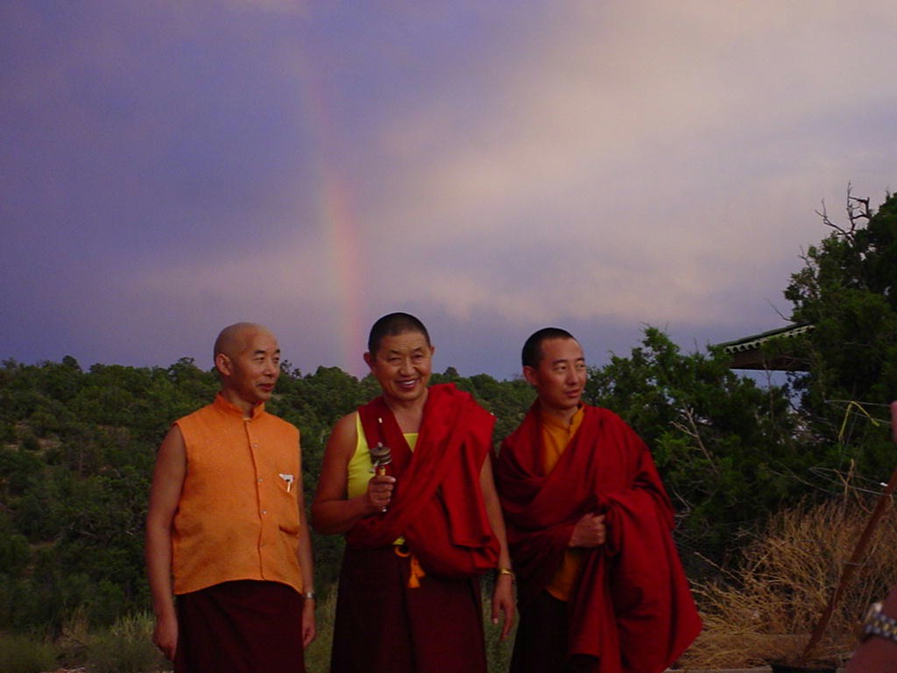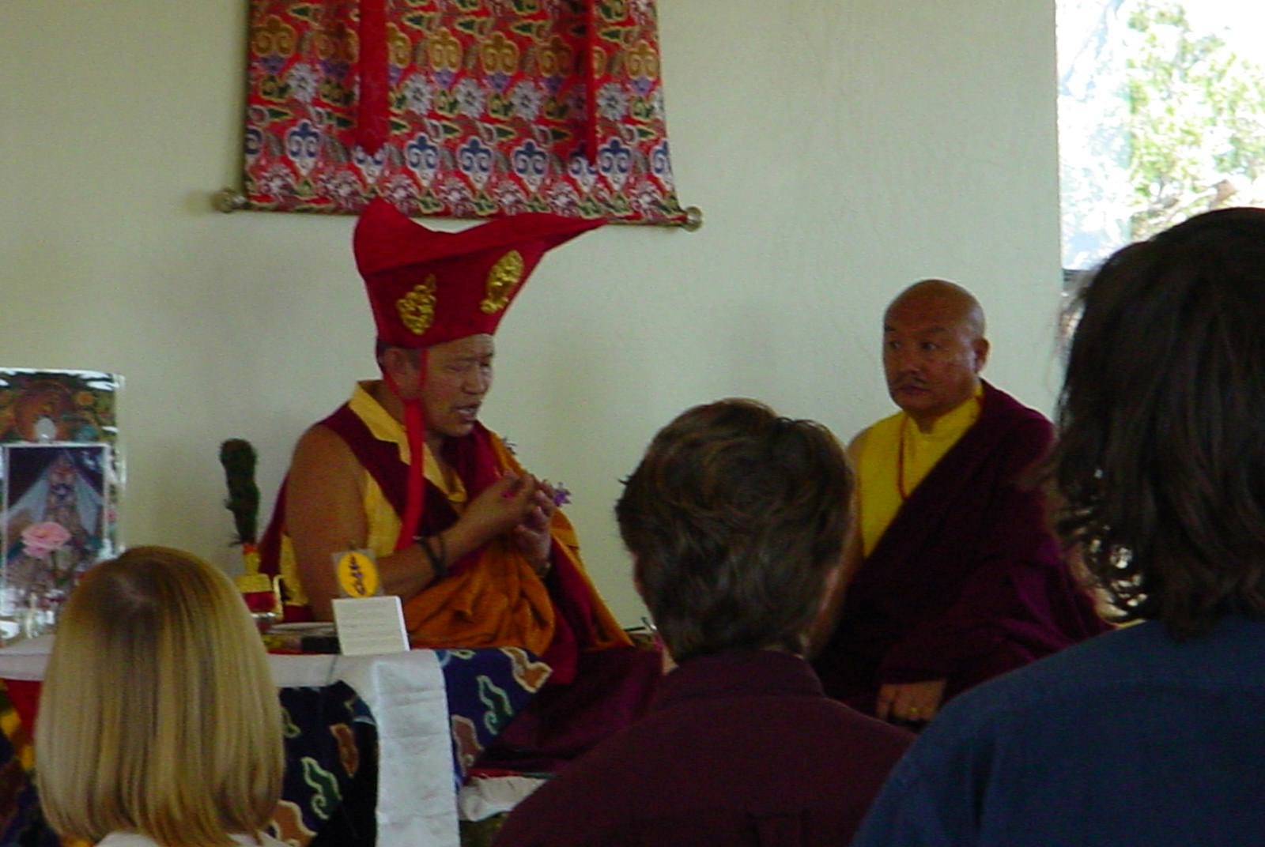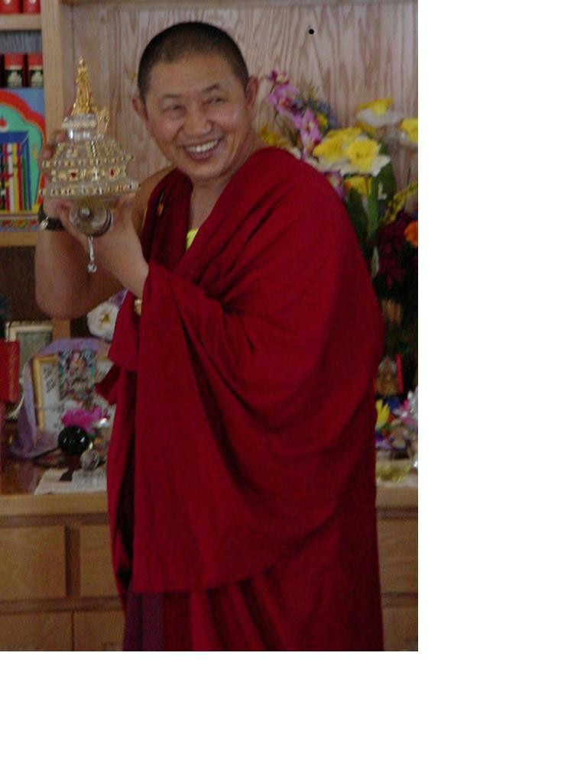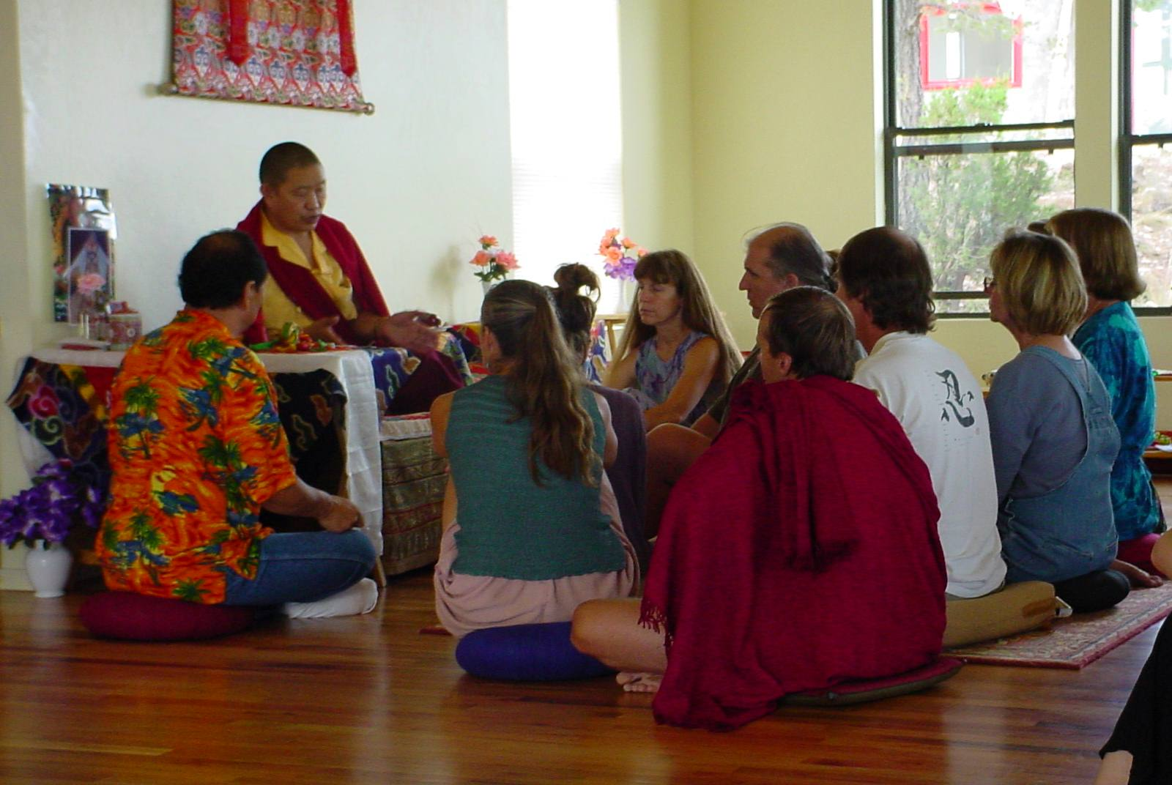
Garchen Rinpoche ,Lamas & Rainbow Teach students Stupa Close Up Taking Refuge

The Washington, D.C. area has a great variety of lodging choices for out-of-town attendees. We list here a few places that are reasonably close to the Gaithersburg's teaching locations. However, we have not stayed at any of these facilities and cannot recommend any one or guarantee availability. The room rates noted by the hotel represent their normal range. You might be able to negotiate a better rate, but room rates tend to be high in our area. We could not identify any camping sites nearby, but you might be able to get more information from Montgomery County (301-495-2503). If you have any suggestions for other attendees, we would be happy to receive the names and addresses of alternative lodging.

Comfort Inn - Gaithersburg , 16216 Frederick Road,  Gaithersburg, MD 20877,  301-330-0023, ww.comfortinn.com/hotel/md413, $79-$129/night | Courtyard-Gaithersburg, 805 Russell Avenue,  Gaithersburg, MD 20879-3500,  301-670-0008, 800-336-6880,Fx#301-948-4538, $84-$129/night
Gaithersburg Marriott Washingtonian Center,  9751 Washingtonian Boulevard, Gaithersburg, MD 20878,  301-590-0044, $89-$219/night | Econo Lodge - Gaithersburg, 18715 N Frederick Avenue,  Gaithersburg, MD 20879-3121,  301-963-3840, Fx#301-948-7443, $68/night
Red Roof Inns, 497 Quince Orchard Road, Gaithersburg, MD 20878,  301-977-3311, $55-$65 | Holiday Inn, 2 Montgomery Village Avenue, Gaithersburg, MD 20879,  301-948-8900, Fx#301-258-1940, $149/night
Sleep Inn Rockville, 2 Research Center, Rockville, MD 20850,
301-948-8000, $79-199

"Also, some housing space will be available in Dharma friends' homes. Please call Sue-Sue for information at 301-217-9383."
6

Bardo I & II Teachings (Tue.9/18 & Wed. 9/19, 10 a.m. to 12 p.m.)

While the term ‘bardo’ can refer to any interim period, in this instance it refers to the state between death and rebirth. When the time of death arrives, the dying person maintains awareness of the signs of the dissolution of five elements. Having knowledge of this process, the dying person observes it closely and with meditative stability. Then, as the moment of death draws near, they engage in samadhi and meditate in accordance with the way they have practiced during their lifetime. The strength of this will then carry over into the bardo and allow them to achieve liberation. These classes will consist teachings
of the different stages of Bardo and guidance on the awareness of the wisdom mind as an antidote toward liberation.

Tonglen Teachings (Thur.9/20, 10 a.m. to 12 p.m.)
Tibetan Buddhism has passed down many practical methods for overcoming negative emotions involving in daily life.
Tonglen is a very profound method to quickly transform one's afflicted emotion by training in the giving and taking.
These teachings will provide advice on how to apply the Buddhist meditation techniques of love and compassion for
all those in suffering, especially when difficult issues arise in daily life.

5

September 2001
Schedule of Teachings and Empowerments by His Eminence Garchen Rinpoche

Sunday | Monday | Tuesday | Wednesday | Thursday | Friday | Saturday
9 | 10  4 pm Rinpoche Arrives | 11  2-4 Audiences  4-7 Dinner Break  7-9 Vajrayogini Empowerment | 12  9-10 Tara Practice and Meditation  10-12 Heart Sutra Teaching  12-2 Lunch  2-4 Audiences  4-7 Dinner break  7-9 Vajrayogini  Teachings | 13  9-10 Tara Practice and Meditation  10-12 Heart Sutra Teaching  12-2 Lunch  2-4 Audiences  4-7 Dinner break  7-9 Green Tara Empowerment | 14  9-10 Tara Practice and Meditation  10-12 Heart Sutra Teaching  12-2 Lunch  2-4 Audiences  4-7 Dinner break  7-9 Green Tara Teachings | 15  Tibetan Meditation Center, Frederick, MD. 10-12 Five Dzambhala Tsok  12-2 Lunch  2-5 Teachings on Garchen Rinpoche's  "The River that cannot be Frozen"
16  9-12 Chod teachings and practice  12-2 Lunch  2-5 Chod teachings and practice | 17  12-2 Lunch  2-4 Audiences  4-7 Dinner break  7-9 Phowa Teachings | 18  9-10 Tara Practice and Meditation  10-12 Bardo Teaching  12-2 Lunch  2-4 Audiences  4-7 Dinner break  7-9 Phowa Teachings | 19  9-10 Tara Practice and Meditation  10-12 Bardo Teaching  12-2 Lunch  2-4 Audiences  4-7 Dinner break  7-9 Phowa Teachings | 20  9-10 Tara Practice and Meditation  10-12 Tong Len Teaching  12-2 Lunch  2-4 Audiences  4-7 Dinner break  7-9 Phowa Teachings | 21  12-2 Lunch  2-4 Audiences  4-7 Dinner break  7-9 Phowa Teachings | 22  9-12 Phowa transmission and practice  12-2 Lunch break  2-5 Milarepa Guru Yoga and Tsok
23
12 (noon)
Rinpoche departs

2

Vajrayogini Empowerment & Teachings (Tue.9/11 to Wed. 9/12, 7 p.m. to 9 p.m.)

Vajrayogini practice is named by the lineage of the great Indian master Mahasiddha Naropa, who received it directly from
Vajrayogini. Vajrayogini is annutara yoga tantric practice, which is the highest of the four classes of tantra. The teachings
consist of detailed explanations of meditation and visualizations methods for this precious practice. [Within the broad family
of Vajrayogini, this specific empowerment is for Vajravarahi (Skt.) or Dorje Phagmo (Tib.)] It is recommended that
practitioners receive the empowerment before receiving the teachings.

Green Tara Empowerment & Teachings (Thur.9/13 to Fri. 9/14, 7 p.m. to 9 p.m.)

Green Tara is in the form of a female Bodhisattva. She is the embodiment of all the Buddha’s compassionate activities. The
practice of Green Tara removes obstacles and gives the practitioner fearlessness for Dharma. This transforms the
practitioner’s Dharma activities into positive causes and results. Tara is one of the most popular tutelary deities of Tibet.

Tara Meditation & Practices (before all morning teachings, 9 a.m. to 10a.m.)

There will be a Tara practice with guidance on meditation offered in the morning sessions before H.E. Garchen Rinpoche’s
teachings. These will be lead by one of the Lamas who are Rinpoche’s attendants and who are highly accomplished practitioners as well as special teachers. This is an excellent way to help your practice improve and grow.

3

Heart Sutra I, II & III Teachings (Wed. 9/12 to Fri. 9/14, 10 a.m. to 12 p.m.)

Prajnaparamita is the wisdom mind. The Sanskrit term Prajnaparamita means wisdom (prajna), especially experientially
realized wisdom, and perfection (paramita). The vast Prajnaparamita Sutras are sometimes described as consisting of 600
scrolls classified into eight groups. The perfection of wisdom Prajnaparamita Heart (or Hrdaya) Sutra combines Dharma, i.e. Prajnaparamita, with the specific example of Heart or Hrdaya. The Heart Sutra is one of the most frequently recited Buddhist
sutras because it is the “Heart” or Essence of all the wisdom texts. A Bodhisattva who understands and cultivates the wisdom
mind achieves liberation and can help end the suffering of all sentient beings. Please come and “experience” the Heart Sutra
through the teachings of a true Bodhisattva, H.E. Garchen Rinpoche.

Chod Empowerment & Teachings (Sun.9/16, 10 a.m. to 4 p.m.)

Chod is an advanced practice. Those who are interested in practicing Chd are encouraged to engage in general study and
meditation practices. In particular, one must engage in the Bodhisattva way of mind training, which is based on great
compassion and wisdom, the perfected altruistic thought In this practice the main focus is cutting attachment and hatred
through uprooting ignorance. The system of this practice was founded by the great enlightened Lady Machig Drolma in Tibet
in the 11th century. She is a manifestation of Prajnaparamita. Out of infinite compassion, she has shown this method of practice to
free all sentient from samsara and attain enlightenment.

Phowa Transmission & Teachings (Mon.9/17 to Fri. 9/21, 7 p.m. to 9 p.m., Sat. 9/22 10a.m. to 12 p.m.)
The Bardo and practice at the time of death (Transference of consciousness).

Phowa is a practice unique to Tibetan Buddhism that, at the time of death, transfers one’s consciousness directly to Buddha
Amitabha’s Pure Land of Bliss (Dewachen). These teachings are suitable for all practitioners. The practitioner must train
thoroughly in advance before performing Phowa at the time of death. Please come and learn how to walk with impermanence
and face death without fear.

4

Music CD

H. E. Garchen Rinpoche's Chants ……………………….. $10 each

(Eight fold Om Mani Padme Hum, Amitabha mantra, Guru Rinpoche, Vajrakilaya, mantra of Enlightenment without meditation, Kagye mantra, Ratnashri mantra, Medicine Buddha, White Tara, Promotion of Buddha's teachings, Heart Sutra)

Traga Rinpoche's chants ………………………………... $ 8 each

(Amitabha, Medicine Buddha, Guru Rinpoche, Green Tara, Mahakaruna, Om Mani Padme Hum)

Traga Rinpoche's 100 Syllable Mantra ………………. $ 8 each

audio and CDs - will be available and posted on our web site after the September's teachings

Bardo

Chod

Green Tara

Heart Sutra

Mahamudra (April, 2001 by H. E. Garchen Triptul Rinpoche)

The Words of My Perfect Teacher (April, 2001 by H. E. Garchen Triptul Rinpoche)

Tonglen

Phowa

Vajrayogini

