Experiment 4

Ground Bounce

March 19, 2004
CMPE 173/L
S.C. Petersen
Winter ‘04

Norman Hsieh
nhsieh@ucsc.edu
570933592

Introduction:

The purpose of this lab was to create an experiment on a 3x3 PCB. There were many ideas to choose from and we were given the freedom to do anything you wanted as long as it was related to digital design. At first I was thinking about metastability, which looked really interesting, however, what bothered me about metastability was that it dealt with insufficient setup and hold times that would lead to the metastable state. Looking at a design sense, that would be something you could control with the right timing diagrams and right devices used. So then I decided to look into something more practical that could more or less happen out of my control. A good experiment that I ended up discovering was ground bounce. Ground bounce described the effects of shifts in the internal ground reference voltage due to output switching. The phenomenon is due to switching in the output current. When a output switch closes or clears, the load capacitance discharges to ground. As the stored charge flows back to ground, changes in current flows across the inductance of the ground pin, inducing a voltage V_{GND} between the system ground plane underneath the device and the internal ground to the package. V_{GND} = L_{GND} (di/dt)
When the chip looks back to differentially compare the input voltage against its local internal ground reference, ground bounce can cause voltage spikes in the ground reference changing the total difference of V_{in} - V_{GND}. If the ground bounce spike is large enough it can sufficiently change the output logic values.

Concept:

The experiment I implemented is straight from the “High Speed Digital Design” book, page 71.

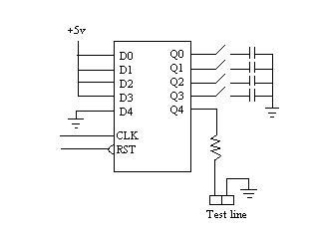

Using a HCT174 chip, +5v is tied to three of the inputs and the last pin is tied to ground. The first three outputs are then loaded with capacitive loads of 33pF each, and the last output is tied to test line and isolated with a 1kΩ resistor. Using an appropriate clock, a delay is implemented using a HCT04 inverter. Passing the clock through multiple inverters, the clock should be delayed for a good 65ns taking the typical propagation delay of the HCT04 inverter as 13ns. While the clock is high, the +5v on the inputs will begin charging the load capacitance on the output side. This is where the delay kicks in, and the delay will trigger a reset on the HCT174 chip itself causing the charged voltage in the capacitors to discharge and sink into the ground. Looking through the test line, you can see the voltage spike that occurs through ground bounce.

Design, Data, and Analysis:
Setting up the circuit board, there were three main flaws that I had. Using the jumpers for the clock inputs and VCC inputs, the pins were so close together that often times the two leads would touch shorting the inputs I was giving my board. I solved this usually by clipping the ground clips to the ground plane on the board. The only problem was that as I tried to increase my clock frequency the signal coming became really noisy and ugly looking so I had to make compromises on what frequency I wanted to use. The next problem was the soldering; many times the pins would look soldered to the chip, but didn’t always seem to be exactly what was going on. I had to spend extra hours figuring out which pins were on correctly. What also ended up happening was that the probing and testing I was doing with the oscope pins would often cause much wear and tear on solder and connections. In the end, I decided just to throw extra solder blobs on any of the connections or chips that were giving me any grief. This seemed to clear up some noise but also make the ground bounce more effective in the end. The last thing I would’ve liked to implement was the use of SMA cables, using the probes on the oscope seemed to cause a lot of shifts in signals and phase changes from the capacitive integrity of the probes.

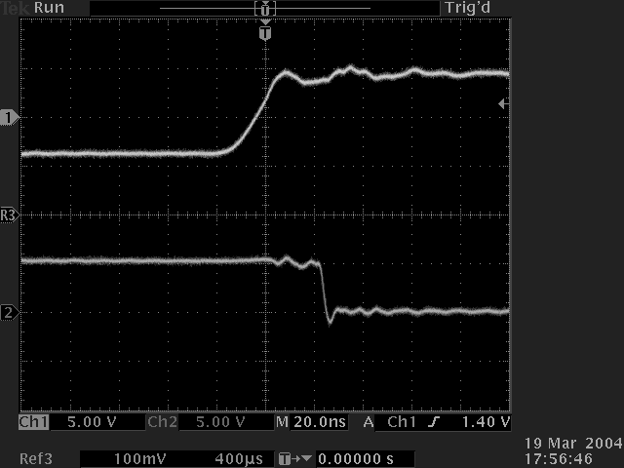
Figure 1. Clock vs Reset Signal
Measuring the delay from the inverter, I was hoping to get a delay of about 65 ns total, but ended up getting a much faster delay of 45ns. Which looked something close to this. (Figure 1). The next thing I did was check the test line for the ground bounce with all the capacitive load loaded onto the output.

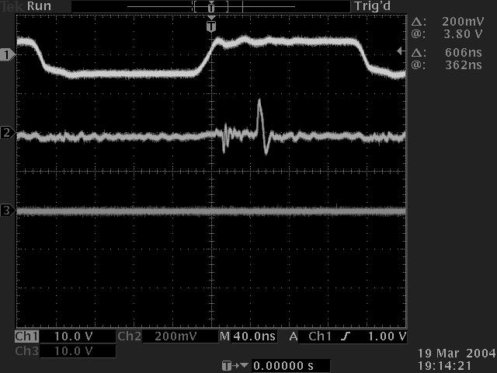
Figure 2 Ground Bounce and Clock signal

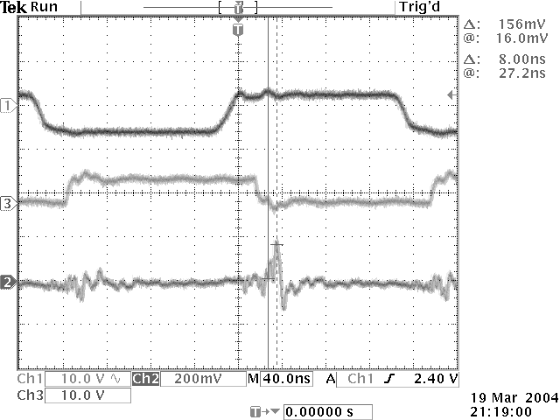
Figure 3 Clock, Reset, and Ground Bounce signals

Looking at both Figure 2 and Figure 3, you can clearly see the ground bounce occurring on the line. The ground bounce seemed to come in clearer when the Reset was not getting probed, but Figure 3 gives you a good sense of when the clock is going high, when the reset is taking effect, and the ground bounce occurring.
To measure the different capacitive loads, I decided just to measure the ground bounce without the clock or reset signals probed to give me the clearest signal possible. Table 1 shows the results of the measurements.

Load Capacity (pF) | V_{GND} ( mV )
0 | Too much noise, not measurable
33 | 28
66 | 40
99 | 70
132 | 115
165 | 170
Table 1

The measurements were very unstable most of the time, so I did the best I could to estimate an average of the measurements. To see all the measurements and the averages please refer to page 1 in the “notes section” for Lab 4, in my engineering notebook. Adjusting the capacitive load will clearly affect how much ground bounce that will occur along your ground reference. Although the voltage seemed to rise in somewhat of a linear fashion, it was not linear enough to produce a significant estimation of further capacitance added. You could essentially figure out the ground inductance in the chip and use that as a gauge of how much ground bounce you receive.
Another factor that would play a huge role in this could be the transition times of the chips. Referring to my schematic pg 1 in the engineering notes, I was planning on testing two separate logic families hoping to see a difference with different transition times on the chip. I was also planning to compare results with Elisa Huang who would also use two different families from mine. Due to time constraints, and mishaps in the ordering I didn’t exactly get what I wanted and ended up with two chips that had similar characteristics. However, there are many new families that have fast transition times that also have current limiting characteristics built into them, and could play a limiting factor of how much ground bounce will occur.
As I was beginning to design this experiment the last factor I wanted to test was the use of bypass capacitors on the chips. The one thing I didn’t realize when I did this was that the ground bounce occurred with the internal inductance and would not change my internal ground bounced measured. This proved to be true when I attached the bypass capacitors onto the chip. At first I was worried that my bypass capacitors weren’t working until a further analysis, which led me to my current conclusion. After talking to Professor Petersen, one thing I realized the caps would do is not limit the ground bounce but limit the amount of VCC bound occurring. Referring back to Figure 3, you can clearly see the small VCC bounce occurring when the clock edge turns on, since there is a bypass capacitor connected on the chips VCC, when the MOS transistors are sourcing from the internal VCC the capacitor prevents the immediate change in voltage produced.

Conclusion:
Ground bounce can seem to cause multiple problems if you don’t pay attention to it. There is no real way to really prevent it from happening, it can happen in all applications and even if you have current limiting chips, you will always have that internal inductance on your chip. Using bypass caps will help limit the VCC bounce, but in most chips, Vcc isn’t the referenced, so it will not be a problem. You can clearly see that if there were several outputs driving high capacitive loads you can have some real problems in logic outputs. Lows would end up being highs, and high values will become low values. This experiment proved to be very practical and was much harder to investigate and understand that I had first thought. However, this project gave me great insight on how ground bounce exactly works and the real physical voltage produced. It also gave me a great experience on PCB design and surface mounting.

