GE Workout
And
Osborn-Parnes

Creative Problem Solving Technique

Colliding Two Terrific Techniques Into One Great Session

Duke Rohe
Performance Improvement Specialist
M.D. Anderson Cancer Center

Estella Woodard, MS,
Clinical Director
Diagnostic Center
M.D. Anderson Cancer Center

An idea is nothing more or less than a new combination of old elements
... Webb Young

Introduction
Here you have it. We have looked outside healthcare to connect two seemingly opposite techniques to derive a hybrid culture-busting, solution-finding methodology ready to be tried out in your organization. “Workout”, used by the data disciples at GE is a technique that forces accelerated change when it’s time for a new paradigm. The Osborn-Parnes Creative Problem Solving Technique, although it has been around for twenty-five years, is not recognized in healthcare yet is common knowledge to those in the creativity world. It’s idea generation is three times conventional means.

Why not take the great elements of structured problem solving and creative problem solving and generate a combo of the best of both. We can no longer work at rates that try to catch up with change. Our change resources are finite and we cannot afford to burnout our best employees moving cultures by conventional means. We must bring in new thinking and new technique that leverage our energies against the status quo.

This proceeding will summarize the magic behind these two great techniques and supply addendums and examples to be used as take-away tools for conducting your own session.

BACKGROUND

My learnings of GE Workout TM Attachment 1
My first impression from training of GE Workout TM was grrr…, because I was expecting the magic formula, tools that make a corporation smile, a silver bullet to put in my holster. What I found was a set of fairly simple tools that were used in a high-commitment environment to get solutions in short manner.

It is giant strategy session orchestrated with as many as 40 plus high-level people with their knowledgeable counterparts working together on a shared need. All with the goal of developing a committable action plan before the session’s end. The “silver bullet” is that a Jack Welch-type leadership comes to the meeting and says, “you are the best in the company, you have all the knowledge needed for success and you don’t leave the session until you have a committable solution.” The session is not over until it is over. It is amazing how quick personal agendas drop when all know they can’t leave the group until they discover a solution best for the group. And they look bad in front of the big boss if they don’t play. The mere inertia of everyone working toward the solution forces consensus and compliance. Workout is the means for bureaucratic culture-busting at GE.

Seriousness is the only refuge of the shallow… Oscar Wilde

Safely Tubing Specimens to the Lab
This shouldn’t be hard. Many hospitals do it. Not at M.D. Anderson Cancer Center. This is the process that sliced through eight disciplines of the hospital and all had their own opinion of what they wanted to be included in the policy. However, none had the ability to come up with a collective solution. After three months of committee gridlock, they called on the Office of Performance Improvement to get objective facilitation support. Having just completed “Workout” training from GE and having creative problem solving experience, both were combined into a high-impact session that resolved in 5 hours what couldn’t be accomplished in 3 months.

The following was the Call For Participation sent to each of the members. Every function that might be impacted by sending specimens and later sending blood products through the tube system were included. The team leader called each of the discipline’s leader for a representative team player to speak for their discipline. She stacked the deck for success where possible. She requested those who had a proven record for dealing with change. The following are attachments sent to the participants.

Everyone is a genius at least once a year; a real genius has his original ideas closer together… G.C. Lichtenberg
Attachment 2
Invitation to a GE type Workout session:
Safely Tubing Specimens to the Lab
You pit a good worker against a bad system, the bad system will wing every time. Rummler Brache

Purpose of the session: Design a committable strategy and process that safely sends lab specimens through the tube system: eliminating unnecessary waste using couriers for specimen transport, accelerating the specimen delivery while keeping safety and infection control standards high.

What is a Workout session: It is a time-compressed strategy session that brings all the parties involved in a problem together to explore, design and craft a solution in one setting. In theory, the doors are locked until a committable solution and plan of implementation are derived. It works off the premise that more time doesn’t make a better decision and a golf game isn’t much better with fifteen clubs than with five. This type thinking was a culture buster for GE. It was top down driven where Jack Welch, Mr. Big, came in and said “You guys all need to workout a common solution and I’LL be monitoring your success”. Imagine a fast-forward decision making process with diverse disciplines all developing a best-fit solution for the good of the system.

Who is invited: Nursing (STAT and routine users), Phlebotomy, Transportation, Facilities (tube system maintenance), Safety, Infection Control, Lab General Services, Nurse Training and Education. In GE, it is the managers of the area who participates, for they are the ones who ultimately required to make the change happen.

Rules of engagement:
- You represent your discipline. That means you come with the authority to decide what will or will not be done by your discipline. Finding the boundaries and non-negotiables beforehand are essential. Remember, that we will be presenting our solution to Mr. Big at the end and he is impatient with unchallenged traditions of the past. There will be a “sensing” session before the workout with each of you to establish what is needed to prepare for the session. To help calibrate the groups solution, we may stage a preliminary presentation to peers to get their feedback on the solution.
- You will do your homework and come equipped. All data gathering, knowledge collection, benchmarking, determination of freedom of authority, rule challenging, pre-thinking are done upfront. Remember that everyone at the session is depending on you to have sufficient knowledge to derive a committable solution in this one setting, so come prepared. A customized set of questions to guide preparation will be provided ahead of time.
- You commit to taking the solution, redesigning your practices and policies for a pilot mode and then aligning your discipline to expand it to a system mode.
- You commit to developing and setting the governance in place to sustain the gain. Remember, you have Mr. Big on your side.
- You will endeavor to have a willingness to come up with a system solution which incorporates the needs of all, is the best fit for the needs of the system.

Nothing is done. Everything in the world remains to be done or done over
… Lincoln Steffens

PREWORK
Attachment 3
PreWork is 80% of a Workout’s Success
Your frame of reference determines what you see

Workout is a way of pooling diverse parties of knowledge to collectively make a more informed decision. Since the trademark of a Workout is to come up with a system solution in a single setting, everyone participating must arrive prepared with the knowledge, pre-thought and system mindedness to make it happen. Mr. Big and the other members of the Workout team are not going to like it if you arrive without the research needed to responsibly answer questions, make decisions and fully participate in the solution-finding. What you prepare for beforehand determines your value to the ultimate solution.

Prepare the way: Think through what might be needed from your discipline’s perspective.

- What is the data that might be needed to make an objective decision? Number of staff involved, cost of negative event, occurrences or volume over time
- What is the leeway you have in making concessions in current policy/practices for the good of the solution? Challenge traditional thinking here. What is the cost of doing it a different way? What about the cost of poor quality? What are the options that can be taken and what are their ramifications? You are preparing for solutions here, not protecting interests.
- What are the resources you might need when you get into the “War Room” of the Workout? A single event solution may require just-in-time answers in the home department. You should have folks back in the home department ready to scramble to bring in what wasn’t planned on.
- Put on your systems hat. It is not you versus another department. It is everyone versus the problem. Come expecting to change how you do things to make it better for the whole. You may have to subordinate your operation to optimize the system output. This kind of thinking will help your research as well.
- Benchmark what other folks are successfully doing on this problem. How did they get there? What is the difference between your way and theirs? What is the scaffolding of their infrastructure or culture and how might we emulate it?
- What can you get rid of? What can others get rid of? Anything in the way of friction free work is in the way.

The pressure is on. All others coming to the table have gone through this preliminary effort to make all critical decisions in this one session.

Come ready to do some horse-trading.
What is not available in objective data and pre-work is done through horse-trading. In the Workout session, you have the best minds working in a collective field, so the corporate gut solution is going to be quite informed. The degree of success is dependent on everyone’s flex.

Always think of what you have to do is easy and it will become so… Emile Coue

Attachment 4
Sensing Session
If you don’t have a shared need, you probably won’t derive a shared solution.

The sensing session is where the facilitator determine the degree of involvement, the level of impact, and the motivation for change each participant has in the system problem. From the facilitator’s perspective, it defines the force fields either for or against deriving an optimum system solution. Formal/informal leaders in each department or discipline will be engaged one-on-one to discover where they are in light of the problem. The sensing session is a two-way preparation. It lets the facilitator know where the department stands, and it reinforces to the department their importance and role is making the Workout come up with a successful outcome. An open-ended conversation could discover the following:

- Can the emotion of the problem be used as leverage?
- What reservations do they have or obstacles to overcome in order to be a full-blooded participant?
- Are there tethers to upstream departments that keep them from acting decisively and do the upstreamers need to be brought into the Workout session?
- What effect does the problem have on their operation in manpower or service?
- Are they improvement-oriented or rule-oriented?
- Do the flex or freeze in the face needed change?
- Do they use data or expert opinion in decisions making?
- Are they influenced by departmental peer opinion?
- Are they influenced by Mr. Big’s opinion?
- How permeable are they to internal and external customer needs?
- Where does fixing the problem fit with respect to their other commitments? Can Mr. Big help here?
- Are they a reluctant or hair-on-fire participant?

The brain is a wonderful organ. It starts working in the morning and does not stop until you get to the office… Robert Frost

Attachment 5

More Probing Questions: Come Equipped to Answer
The right answer begins with the right question.

- What can be sent or not be sent?
- Who is responsible for sending the specimens?
- How can we obtain addition carriers when we need them?
- Who is responsible for tube notification, and what number do you call?
- How do you verify the specimen arrived at its destination?
- Who is responsible for costs? For supplies, for cleanup?
- Will courier be used when the system is down? How are they dispatched?
- What is the contingency for this?
- How to communicate which zone is down? Who does it and how do they notify users?
- How will we effectively communicate the policy?
- Where will additional carriers and liners be stored on the unit?
- Will the same carrier be used for Pharmacy and Lab? What if you don’t have one or the other and you need to send?
- Who will do the pilot study (or do we do all at once.)?
- Will hospital be responsible for all costs (say patient to return for retest, hotel…)?
- Who will handle non-compliance?
- How can we amplify an attitude toward safety?
- What is the role of Patient Advocacy? Risk Management?
- Who receives notification of near misses? What method? Who does Follow-up?
- How do we report back compliance problems?
- How do we educate agency staff?
- How do we get a change in type of specimen container so it can be shipped through the tube system?
- How to Celebrate areas with low spills?
- Will packing supplies be part of PSPD cart?
- How to pack specimens?
- How to have easy visual instructions on each station?
- How do we pass along the correct education? For policy, procedure changes? For initial and ongoing training?
- What are the Do’s and Don’ts of sending?
- Who do you let know when the tube system is down?
- How do we keep awareness high?

Who is Mr. Big
We chose the head of Nursing. He was supportive of the change process. Staff under his authority needed the greatest convincing this could be safely done. And finally, he could convince other leadership over those in the Workout session to follow through on their commitments.

When I go to the beauty parlor, I always use the emergency entrance. Sometimes I go just for an estimate… Phyllis Diller

WORKOUT SESSION

The Osborn-Parnes Creative Problem Solving Technique
This Osborne-Parnes Creative Problem Solving Technique was the tool used inside the Workout session to drive to consensus toward the most effective solutions. It is the most valuable thinking-tool around. Once you get turned onto this technique, it may revolutionize how you conduct meetings. How would you like it if your meetings to be energy-charged? Where all minds are pushing for a collective goal. Where the ideas flow at 3 times their natural rate. Where time is compressed between the problem and the action plan of acceptance. All this and having fun at the same time.

The technique was born from studying how geniuses think. Geniuses have almost a childlike curiosity when solving a problem. In fact, to them it isn’t a problem, it is an exploration to find an answer. They do two types of thinking.
- One is ‘Convergent’ thinking which is fairly easy for us. It is being deliberate, filtering out the unusable, groom/reconnecting those ideas that may be useful, and then, selecting the best idea that fits the objective.
- The other is ‘Divergent’ thinking, which we do not do so readily. This thinking generates lots and lots of ideas. Some great, some not. Divergent thoughts are known by zero judgment, powered by the pressure that quantity yields quality. Set a quota of ideas that is out of reach, seek wild options, combine and build on other ideas. Everything is possible.

Exercising both Divergent and Convergent thinking together is like breathing in and out for the brain. Employing just one, the brain gets exhausted. With both, the brain grows in energy.

So pretend you have six or so employees who want to fix a problem they have knowledge about. Equip them with a pad of sticky notes and center around a flip chart. You are the facilitator and your sole role is to press them through the process. Speed is the secret to push them beyond judgment and the inhibition of participation. Tell them at the beginning of the session, quantity will yield quality. Fun is important; in fact, the zany thoughts spur on breakthrough ideas.

You, the facilitator, will be pushing them through the session at a pace that is faster than they can handle, so challenge them to keep up (people love a challenge). Tell the people when they are in the Divergent, free-thinking mode; as an idea pops-up, write it down on the sticky note (subject and verb form), holler it out for all to hear, then place it on a flip chart. Then they are to rush to write down your next one. The more the better. In this case, quantity is quality because it gives you more to work with. During the session keep the momentum up by barking out new paths for ideas to flow: think crazy, impossible, risk-free, whatever churns their thinking. Lead them through these steps to successful steps.

Finding Sessions

Mess Finding – Divergent: What are the possible challenges opportunities, what keeps us from being successful. What gets us tangled up? Give them a quota. Then, ask them to write down just one more thought. Some of the best ideas happen after you push beyond your last thought. Convergent: After you have an exhaustive list, then ask them to isolate the main ones. They do this walking (important) up to the flipchart and highlighting, grouping, culling, reshaping the mess statement that capsulizes the mess. Force them, as a team, to pick the most critical mess statement. Press them for time and participation now. Repeat this pattern for all the “finding” statements below.

Fact finding – Convergent: What is known, what is not known and what has the greatest impact? This is just a reference for what you know. Again everything is all done via sticky notes.

Problem Finding – Divergent: List all the aspects of the problem related to the mess. This is the most important of the steps. In fact a good portion of the session is spent here. A well-stated and understood problem is half-solved. Organizations biggest wastes are exhausting their best people solving the wrong problems. Convergent: Using the same procedure as in mess finding, identify the best wording of the central problem. A good problem statement can start with “how to”. Ex. How to get people to follow the safe procedure for tubing specimens. Great groups have great enemies. This is about when the team realizes they have a common problem. It is us versus the system and we are going to fix it!

Solution Finding – Divergent: What are the possible solutions? Are there connections between solutions? Convergent: Then, which are the solutions we want to expend our resources on? The ones that will give us the greater gain?

Action/Acceptance Finding – Divergent then Convergent: What are the action steps needed for successful installation? Who is going to commit to take charge of them being fully developed and completed? What are the keys to acceptance by those effected?

That fellow seems to me to possess but one idea, and that a wrong one… Samuel Johnson

Planning, Planning, Planning
The prework for the five hour session actually took about a month of preparation. The biggest effort is making certain everyone coming to the session knows the gravity of not coming prepared. Nothing is left to assumption. We even scripted what we wanted Mr. Big to say. Everything needed to make an informed decision was brought to the session including the authority to speak for your entire discipline.

To follow is a mindmap of the Workout session. This is how a non-structured person (such as myself) can get down a lot of detail. It uses the right side (creative) of the brain to pull out the left brain’s detail.

Next is the agenda that for the session. Remember, this session should include 80% of all the solution-finding, decision-making that needed to be made. The team leader was amazed at the level of decision making. But she could not believe how even the hard-sell members turned 180 degrees during the session.

Shots of the session follows. The Creative Problem Solving requires participation and is high energy. Everyone was looking at the clock, which pressured them to move past their own personal solution to find the best team solution. Twelve members were split in to two parallel teams. One team refused to do the Osborn Parnes process and their contribution was half of the other. This five hour session was so power-packed, it felt like one hour. Mr. Big came in at the beginning of the session and encouraged the team that they were the best, they had his support to make solutions happen and he would be back in four hours to hear what they are.

Finally Overheads used to guide each of the ‘Finding’ sessions. The questions are actually ‘barked’ during the idea-generation to energize thinking, new considerations.

Everyone is a genius at least once a year; a real genius has his original ideas closer together… G.C. Lichtenberg
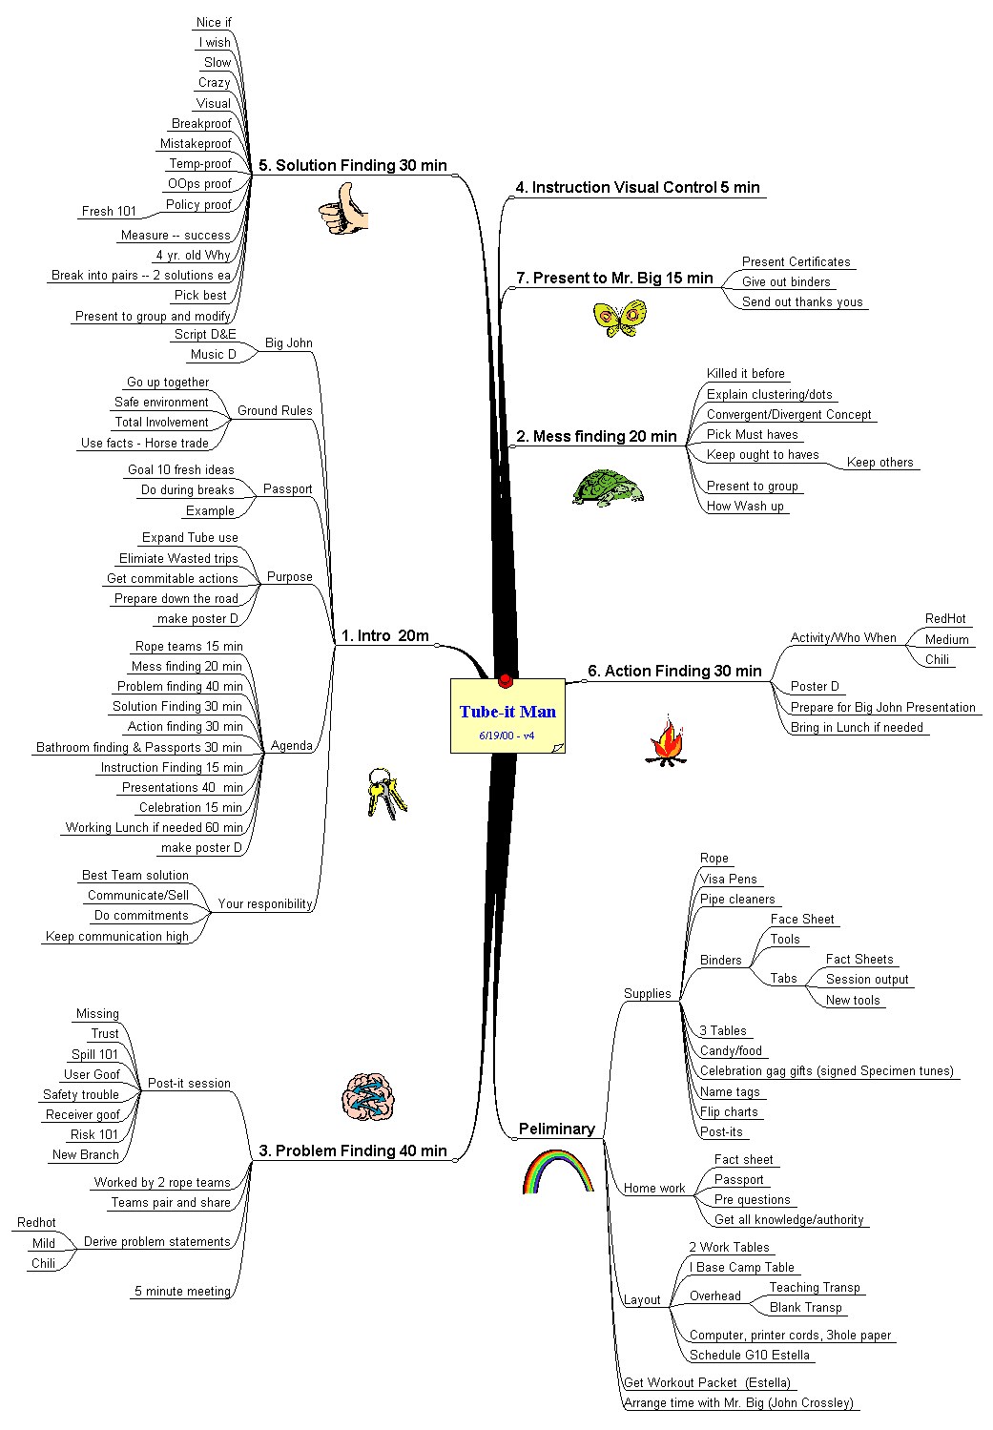

Workout Session Agenda
Sending Specimens Safely Through the Tube System
(Small Print: The faster we come up with an acceptable, committable solution, the sooner we get to leave)

8a You are Here
- Mr. Big stresses a case for action
- Agenda
- Purpose- What are we trying to achieve
- Ground Rules/Responsibilities
- Instruction Finding
- Bathroom Finding
- Passports
8:30 Mess Finding
- Instruction:
- Convergent/Divergent thinking
- Harvesting the best, reshaping
- Session
- Present
- Choose the high peaks we must scale
8:50 Problem Finding
- Possible problems
- Prioritize: Hot, medium, mild
- Teams pair and share
- Regroup and refine problem statement
9:30 OK, take a break, exchange passports
9:40 Solution Finding
- Flurry of ideas that will solve the problems
- Sell and select the best
- Measurement == How do we know we got there
- Present to big group
10:20 Visual
- Instruction
- Generate ‘visual’ ideas
- Present to group
10:35 Break and passport exchange
10:45 Action/Acceptance Finding
- Prioritize: gotta haves, oughta haves, other
- Assign: Activity Commitment, Who and Completion date
11:15 Prep for presentation to Mr. Big
11:35 Mr. Big Delighted With Results
11:45 Celebration
12:00 Lunch will be served. Working Lunch if needed, Fun Lunch if not

Two weeks after this meeting, we will reconvene to show and tell our commitments and finalize implementation pieces.
Two Rope Teams worked through Objective Finding and Problem Finding independently. They worked collectively on Solution Finding and Acceptance Finding together

The right way
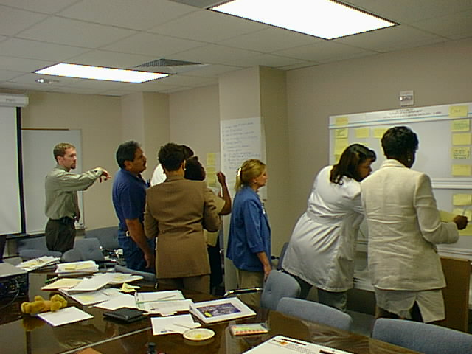

Convergent thinking: All ideas up, all heads in the process, pushing for consensus. Output and speed are (ideas to work with) three times that of conventional brainstorming.
The other way
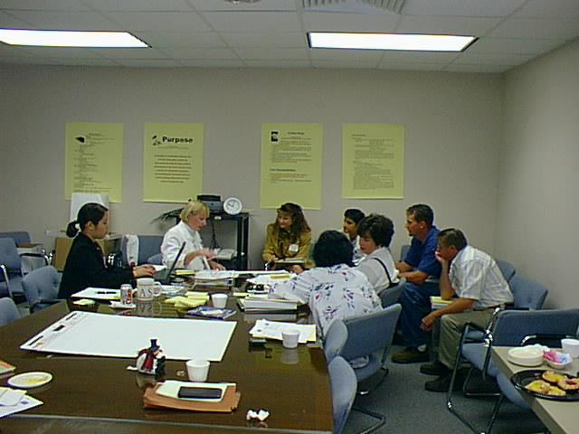

The leader (second from left) was unable to engage the team to follow the process of using post-its, so she collected ideas that others passed on to her. Their output, though good and on target, was not half of the team above. The person on the far left was a real- time scribe taking down everything said.

Workout Slides
Safely Sending Specimens Through the Tube System

Mess Finding

Divergent
- What is keeping is from being successful?
- What is in the way?
- Wouldn’t it be nice if?
- What must change to be successful?

Convergent
- Identify the significant?
- Prioritize?
- Where do we start?
- Where is our showstopper?

Fact Finding

- What is it we know?
- What is it we don’t know?
- What is the cost of doing nothing?
- Where are the relationships?
- What is it we need to know?

Problem Finding (most critical)

Divergent
- What are new ways to view and express challenges?
- Throw all the spaghetti on the plate
- Restate to maximize success

Convergent
- Highlight/dot your favorite
- Combine, choose the more critical
- Hang on to the others

Solution Finding

Divergent
- What are success factors?
- Generate alternatives
- Look from many angles
- Connect what doesn’t seem to connect
- What is an interesting way to fix it?
- How do we measure it?

Convergent
- Choose the most interesting?
- The most exciting, promising?
- What are ways to strengthen their potential?
- What are the best of the lot?

Action/Acceptance Finding

Divergent
What are the assistance/objection/resource needs?
What are creative ways to harness these?
How do we get everyone doing it for the good of the patient?

Convergent
What are the ingredients for action?
What can be agreed on here and finished up in 2 weeks?
Short and intermediate actions?
Who is key that needs to be sold, what is the mode of selling?
Who is doing what when?

The output of the session evolved into action steps needed for success. The list was started by asking the reverse-question: “What will cause our solutions to fail?” Then creating actions items that would counter them. The Workout was July 27th, we were prepared to implement September 18th which was pushed to Oct 2nd due to construction delays. Notice the attention given to communication.

I’m not afraid to die. I just don’t want to be there when it happens… Woody Allen

Outcome:
As of this writing, the team is one week into its implementation. The team was so solid it didn’t just implement sending specimens, but units of blood as well. Did everything go as planned? Not quite, mechanical problems slowed us down. But all obstacles are being addressed, and with everyone working toward success, it is just a matter of time before it happens. As the system gets totally utilized, 6 phlebotomists ($120K) will be diverted to other useful activity in the hospital. An unexpected $250K resulted in the introduction the use of the patient chargeable vaccutainer. Nurses should get their requested blood product consistently in less than 40 minutes (in weekends currently this is around 2 hours).

Above all, the introduction of the hybrid Workout session is available for other applications. At the end of the Workout, we did a Hot Wash-up (Attachment 2) and every single member said they would use this process again in other change sessions. They enjoyed the effective use of their time. They were glad all members were at the table and they all seem to want to come up with a joint solution. There is now a precedent and new methodology for pushing successful change through at M.D. Anderson Cancer Center.

One final note. People will change if they feel they are safe. I did some climbing with a thinking buddy of mine and found some great parallels between moving through what seems impossible in an organization and climbing up the face a shear rock. Attachment 3 describes my learnings.

A conclusion is the place where you get tired of thinking… Martin H. Fischer

P.S. All the quick quotes from a quute book on ideas How To Get Ideas by Jack Foster

Attachment 1
Extracted pieces I liked from GE Workout training:
Workout is a We Fixit mentality instead of a Y’all Fixit mentality.
A Must for Workout: Those that need to make the decisions need to be in the Workout session. The managers are the ones who commit to a unified decision so they must be there along with those who have strategic knowledge. When leadership asks, “Where are you on your commitments?” You better have an answer.
15 Word Objective: Get the team to concisely define what it is trying to accomplish in 15 words or less. This forces everyone on the same page, models the notion that anything more than what is needed is waste, and helps everyone deliver the same elevator speech when they are asked.
Sensing Session is done before hand. Where is everyone on this problem? What will it take to bring them to a new position?
High level leadership kicks off the session. They validate the importance of finding a unified solution.
Purpose of a Workout: Leadership wants you to make an informed decision, make the invisible, visible.
With all the effected parties locked (metaphorically) in a room and not allowed to come out until they have solutions – Two things happen. People get along to get out. It also forces the bulk of the decisions to be made in the room. Everyone is responsible for his or her own output.
Sprinkle learning in the meeting on an as-needed basis. Skill building is not the same as training.
Who what when plan is a common action plan format used.
Where Are We? tool – Where are we in having the knowledge to solve this problem. Everyone has a dot and puts it on the scale. Debriefing can help homogenize the thinking.
No Know Sorta Know Mostly Know Know All

Formula for idea value: Quality x Acceptance = Effectiveness
Retreat from auto-responses: Ever been in a meeting and instead of truthful responses you get auto-bob. To get them involved with the session as “This time will be well spent if…” and get a collection of team behaviors that will make them successful.
It is not uncommon for leadership to ask, “When was you last Workout and what did you eliminate?”
Facilitators should only facilitate. If the facilitator has a solution, it appears they have a hidden agenda. They coach and encourage management to lead the team, follow-up, write minutes….
If key agreed-upon responsibilities are not being kept by the team members – Ask the question, “Has there been a new direction or importance at play here?” Either the answer is Yes, the new hot potato is… or No, I’ll get on it.
The Workout term is reserved for these very intense resolution sessions. You don’t call a meeting a Workout.
Good way to introduce the value of Workout in a slow-go culture. “Do you want quick change?” “Are you willing to make forced decisions to get there?” Create a shared need, a burning platform people are willing to invest in. When you get 40 people in a room with a goal of working on a solution by the end of the session, there is an inertia already moving.

We don’t know a millionth of one percent about anything… Thomas Edison

Attachment 6
The Hot Wash-up

Great new tool to 1) stretch for new learning, 2) set a challenge for action, and 3) improving on what we do. At the end of a team session have the team members write on a stickie note the key word and ask...

Learnings: What were your key learnings from today’s meeting?
or What new insights did you get from our session?

Use: How can we use what we learn today in work, in life?
or What action should we take next?

Best: What did you like best about today’s sessions?
or What was the value of our discussion to you personally?

Improvement: How could have improved today’s meeting?
or What could we have done differently?

My wife has a terrible memory; she never forgets a thing… Eric Morecambe

Attachment 7
Better Safe Than Sorry
Duke Rohe, Performance Improvement

We don’t think much about it, but safety directs so much of what we will and won’t do. Great projects go south, people resist to the death, communication is masked or avoided, actions involuntarily move to protect self-interests, all because people don’t feel safe. It is the unknown that grows into great fear and keeps people from pushing forward. Instead of climbing and experiencing, they dig their heels in and freeze until their internal survival wiring says it is ok to proceed. In mountain climbing, change making, mind growing, whatever… establishing a safe environment is essential if individuals are to freely participate. Remember, there is real danger and perceived danger. To the one climbing through new territory, their perception is their reality. Here are some thoughts that may help secure success.

1. Make it a safe place. Make it ok to say I don’t know, I don’t understand, or I changed my mind.

2. Acclimate where possible. Get them used to the tools, the gear, the lingo. Practice on small stuff before graduating to the more challenging.

3. Show the boundaries. As long as you work within these, you are protected.

4. Be specific on the sender’s end. Gain acknowledgement of clarification on the receiver’s end.

5. Show and explain the safety tools and how they will hold regardless of what it looks or feels like. Show how the individual is tethered in, so even if they fall, it will be negligible.

6. Get them to understand that once they move forward, even into the unfamiliar, there is help and support from their guide and their teammates all along the way.

7. For those actions that require fail-safing, where a fall would be critical, be sure there is an ample back up process in place and that it is strictly followed.

8. Don’t treat change like business as usual. Attention should be higher. Concentration on essential safety elements should never go on autopilot.

9. Focus on the parameter of variables that may impact success. Monitor them and give a heads-up if caution is needed.

10. Clear communication is established up front. All words are codes (ready for misinterpretation), so clarity of what words mean is important. Are we clear on this, are there any questions… Open honesty is important.

11. Frequent feedbacks on progress, encouragement, cautions, will stretch one’s perceived fear zone. People will move farther faster if they know they are on track.

12. Allow folks time to move within their perceived physical and mental capacity. The climb on the inside is greater than the one on the outside. That capacity is challenged under change, but as long as they are allowed to talk or work through their own rough spots, their ascension rate will surprise even themselves.

13. If they feel frozen, see if they can be persuaded to try an incremental step. Little successes help people push beyond the rough spots.

14. Take every opportunity to remove the element of surprise. Think through the possibilities. Never abandon a trust. Safety starts with, ‘Can I trust you’.

Once people know they are safe, they will reach out and do what they thought they could never do. The difference between perceived danger and real danger becomes smaller. They ‘safely’ stretch their fear zone to the next level. The climb up to the unfamiliar goes smoother, faster and freer.

Whether climbing a mountain, establishing a team, pushing through a great project, these safety measures, if ignored, will stifle progress. If built into the change process, they will cause folks to soar beyond what they previously thought was possible.

Even if you are on the right track, you’ll still get run over if you just sit there
… Will Rogers

Just to prove, we do everything big in Texas

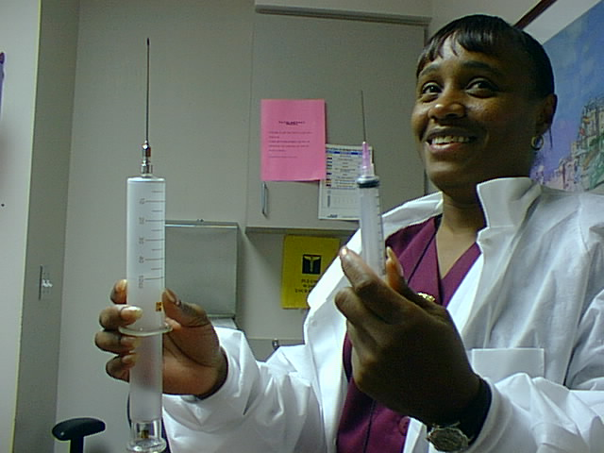

If you want an electronic copy of these tools, email Duke Rohe at drohe@pdq.net

