Practice multiple choice questions.

- Which regulatory system coordinates homeostatic responses in the body?
- Endocrine system
- Nervous system
- Endocrine and immune systems
- Nervous and immune systems
- Endocrine, nervous and immune systems.

2. Which function is under the influence of the endocrine system?
- Regulation of plasma potassium levels
- Regulation of water balance
- Regulation of sexual differentiation
- Regulation of body temperature
- All of the above

- The chemicals that are produced by a secretory cells and secreted into the blood stream are the
- Autocrines
- Classic hormones (endocrines)
- Paracrines
- Pheromones
- Pituitary hormones

4. Find the FALSE statement.
- The heart secretes hormone(s).
- The adipose tissue secretes hormone(s).
- The major function of exocrine glands is to secrete hormone(s).
- Typically, endocrine glands that produce large peptide hormones have fenestrated capillaries.
- Several organs have both endocrine and exocrine functions.

5. Which one of the following hormones is produced by the pituitary?
- Growth hormone
- Gonadotropin-releasing hormone
- Insulin
- Progesterone
- Atrial natriuretic peptide

- What is the major source of thyroxine (T₄)?
- Hypothalamus
- Pituitary
- Thyroid gland
- Pancreas
- Ovary

- Which hormones are lipid soluble?
- Peptide hormones
- Thyroid hormones
- Catecholamines
- Dopamine
- None of the above

- Which hormones act on non-endocrine target tissues?
- Tropic hormones
- Those hypothalamic hormones that regulate the function of the pituitary
- Thyroid-stimulating hormone
- Nontropic hormones
- None of the above

9. What is true for the AP-1 binding site of the gene?
- It is a part of the transcription unit
- It is a part of the exons
- It is a part of the introns
- It binds transcription factors
- It binds the enzyme RNA polymerase

10. “Splicing” is part of
- Transcription
- Posttranscriptional processing
- Translation
- Posttranslational processing
- the activation of prohormone to hormone

- What is true for posttranslational processing?
- It is the step when the information from the DNA is forwarded to mRNA.
- It includes proteolytic cleavages and derivatization of pre-prohormones.
- It includes “alternative splicing”.
- It is the processing of pre-mRNA to mRNA.
- It is done by RNA polymerases.

12. Find the FALSE statement.
- Hormone levels in the systemic circulation are typically in the nanomol-picomol range.
- 1 millimol = 1 mol/1000
- 1 micromol = 1,000,000 picomol
- 1 nanomol < 1 femtomol
- 1 mol = 10⁹ nanomol

13. What is NOT true for RIA?
- It is more specific and reliable than the in vivo bioassays.
- It requires antibodies to the assayed hormone
- It requires a reliable method by which bound and free hormones can be separated from the reaction mixture
- The more “cold” hormone the unknown sample contains the higher the radioactivity of the bound-fraction in the reaction mixture is going to be.
- It can be used for measuring peptide hormones.

14. Which assay is NOT used for measuring mRNA in a tissue sample?
- ELISA
- Northern blotting
- RT-PCR
- In situ hybridization
- All of the above are used for measuring mRNA.

- Which one of the following methods may give an indication about the hormone producing capacity of a single cell?
- RIA
- ELISA
- In situ hybridization
- Northern blotting
- Parabiosis

16. Which description fits the BEST the method called parabiosis?
- It may be used to determine if a certain biological response in an animal is caused by a (“classic”) hormone.
- It can be used to determine which endocrine organ produces a certain hormone.
- It can be used to determine the secretory activity of a single cell in a tissue sample.
- It helps determine which amino acid sequence within a peptide molecule is responsible for receptor binding.
- It is a form of symbiosis between animals and vitamin-producing bacteria.

17. Which hormone(s) bind to intracellular receptors?
- Catecholamines
- Peptide hormones
- Thyroid hormones
- Water soluble hormones
- None of the above

- If a hormone has a relatively high K_{d} value for a receptor, it means that
- the hormone has a relatively high intrinsic activity on the receptor
- the hormone has a relatively low intrinsic activity on the receptor
- the hormone has a relatively high affinity for the receptor
- the hormone has a relatively low affinity for the receptor
- the binding capacity of the receptor is low

- If you were to design a new drug that mimics the effects of human growth hormone, you would try to create a drug which has
- high affinity for and high intrinsic activity on the growth hormone receptors
- low affinity for and high intrinsic activity on the growth hormone receptors
- high affinity for and low intrinsic activity on the growth hormone receptors
- low affinity for and low intrinsic activity on the growth hormone receptors
- growth hormone receptor antagonist activity

20. Find the FALSE statement.
- G proteins are associated with the plasma membrane.
- G proteins play a role in signal transduction.
- Peptide hormones bind directly to G proteins.
- The activation of G proteins may cause the subsequent activation of second messenger system(s) in the cell.
- The function of G proteins requires GTP.

21. Which enzyme breaks down cAMP to AMP?
- Adenylyl cyclase
- Guanylyl cyclase
- Phosphodiesterase
- Phosphoprotein phosphatase
- cAMP-dependent protein kinase

22. What is the function of CREB?
- Binds to the regulatory sequence of a gene and affects DNA transcription
- Catalyses the formation of cAMP
- Hydrolyses cAMP
- Causes the phosphorylation of proteins
- Activates phospholipase C

- Which one of the following molecules is part of the plasma membrane or attached to the plasma membrane?
- Ion channels
- Receptors for peptide hormones
- Phosphatidylinositol biphosphate (PIP2)
- G proteins
- All of the above

- Find the FALSE statement.
- Estrogen-response element is a part of the DNA.
- Steroid hormone-intracellular receptor complex binds to the regulatory sequence of certain genes.
- Intracellular receptors bind to the DNA in the absence of hormone ligands.
- Chaperone proteins bind to the intracellular receptors in the absence of hormone ligands.
- Vitamin D acts on intracellular receptors

25. Which is NOT the function of the hypothalamus?
- Control of biological rhythms
- Control of body temperature
- Control of appetite
- Control of the function of the anterior pituitary.
- All of the above are functions of the hypothalamus.

26. What is true for the anterior pituitary?
- It is also called adenohypophysis
- It develops from the hypothalamus
- It only stores hypothalamic hormones, it does not produce its own hormone(s)
- It secretes oxytocin into the circulation
- None of the above is true.

- Hypophysiotropic hormones are secreted
- by the adenohypophysis
- by the hypothalamus into the first capillary bed of the hypophyseal portal circulation
- by the hypothalamus into the second capillary bed of the hypophyseal portal circulation
- by the neurohypophysis
- by the cerebral cortex

28. The tuberoinfundibular tract provides connection between
- the hypothalamus and posterior pituitary
- the hypothalamus and anterior pituitary
- the two lobes of pituitary gland
- the cerebral cortex and the hypothalamus
- the pituitary and the thyroid gland

29. Which hypophysiotropic hormone is NOT a peptide hormone?
- CRH
- TRH
- GHRH
- Somatostatin
- PIH

- Which hormone suppresses growth hormone secretion?
- CRH
- TRH
- GHRH
- Somatostatin
- PIH

1. Which hormone is produced by the acidophilic cells of the pituitary?
- GH
- FSH
- ACTH
- TSH
- None of the above

2. Growth hormone is structurally related to which other hormones?
- PRL and chorionic somatomammotropin
- TSH and ACTH
- LH and FSH
- Somatostatin and GHRH
- Aldosterone and angiotensin

- Which is NOT an effect of GH?
- Mobilizes fat stores
- Increases plasma glucose levels
- Suppresses protein synthesis
- Conserves glucose for the brain
- Suppresses sodium and potassium excretion

4. Which one of the following factors DOES NOT stimulate GH secretion?
- Hypoglycemia
- Fasting
- Insulin-like growth factor 1
- Fever
- Increase in plasma amino acid levels

5. What does “iatrogenic damage” mean?
- Damage caused by a tumor
- Damage caused by a doctor or medical treatment
- Damage caused by the inappropriate function of the immune system
- Damage caused by heat
- None of the above

6. Who has the highest prolactin plasma level?
- A two year old girl
- An adult non-pregnant female
- An adult male
- A pregnant female
- A person, who secretes too much dopamine into the hypophyseal portal circulation

7. What is NOT an effect of prolactin?
- Increase in the number of LH receptors in the gonads
- Stimulation of mammary growth
- Stimulation of milk ejection by acting on myoepithelial cells in the mammary glands
- Suppression of ovulation
- Stimulation of the proliferation of certain white blood cells

8. Find the FALSE statement.
- Sleep stimulates PRL secretion.
- Increased PRL secretion suppresses reproductive functions in men.
- Increased PRL secretion is the most common endocrine cause of infertility in women.
- VIP stimulates PRL secretion.
- PRL suppresses hypothalamic dopamine secretion.

9. Proopiomelanocortin (POMC) is the precursor for all these hormones, EXCEPT
- ACTH
- αMSH
- βendorphin
- Cortisol
POMC is not the precursor of any of these hormones.

1. What is NOT a typical characteristic of the endocrine glands?
- They receive a relatively rich blood supply
- They are supplied by fenestrated capillaries
- The secreted hormones are channeled through complex duct systems in the gland
- They receive some degree of innervation from the nervous system
- They contain connective tissue as well as secretory cells

2. Which organ has both endocrine and exocrine function?
- Pituitary
- Hypothalamus
- Heart
- Pancreas
- Thyroid gland

3. How are steroid hormones stored in the endocrine glands?
- They are stored in the smooth endoplasmic reticulum
- They are stored in the secretory granules
- They are stored in the Golgi complex
- They are stored in the Herring bodies
- They are not stored

4. Growth hormone gene (DNA) is present in the cells of the
- Hypothalamus
- Acidophilic cells of the anterior pituitary
- Basophilic cells of the anterior pituitary
- Posterior pituitary
- All of the above

5. Growth hormone gene is expressed (growth hormone mRNA is present) in the cells of the
- Hypothalamus
- Acidophilic cells of the anterior pituitary
- Basophilic cells of the anterior pituitary
- Posterior pituitary
- All of the above

6. What is the function of adapter proteins?
- They bind to the enhancer sites of the gene and facilitate transcription
- They bind to the silencer sites of the genes and inhibit transcription
- They bind to the exons of the genes and facilitate transcription
- They integrate and forward the signals from activator and repressor proteins to the core transcription factors
- They slice out introns from the pre-mRNA

7. Find the false statement
- Hormone carrier proteins are produced by the liver
- Only lipid soluble hormones bind to transport proteins in the circulation
- Carrier proteins protect hormones from enzymatic break down in the circulation
- The characteristics of the local circulation in the pancreas allow relatively high concentrations of insulin to be delivered to the glucagon-secreting cells of the pancreatic islets
- The blood-testis barrier provides a relative protection to the developing sperm from the influence of large, water soluble molecules in the circulation.

8. If you were to treat an acromegalic patient, you would choose a drug that has
- low affinity for GH receptors and high intrinsic activity on the receptor
- low affinity for GH receptors and low intrinsic activity on the receptor
- high affinity for GH receptors and high intrinsic activity on the receptor
- high affinity for GH receptors and low intrinsic activity on the receptor
- a drug that has a high Kd value for GH receptors

9. Find the correct statement.
- Receptors show specificity for ligands
- The activation of a relatively low percentage of receptors (10%) by a hormone in a target tissue may be enough to elicit a maximal biologic response
- Hormones bind to receptors as well as to other, non-specific targets
- Only cells with specific receptors respond to a specific hormone
- All of the above is correct

10. Which one of the following receptors is associated with an ion channel?
- Certain acetylcholine receptors
- Nitric oxide receptor
- Testosterone receptor
- Growth hormone receptor
- Thyroid hormone receptors

11. Which enzyme phosphorylates intracellular proteins?
- CREB
- Guanylyl cyclase
- cAMP-dependent protein kinase
- Phosphodiesterase
- DAG

12. Which is an inhibitory neurotransmitter?
- Acetylcholine
- Gamma-aminobutyric acid
- Glutamate
- Norepinephrine
- Serotonin

13. What is NOT true for nitric oxide?
- It causes vasodilation
- It is produced by macrophages
- Its receptor is linked to G proteins
- It is highly diffusible
e. It is synthesized from arginine

14. Which hormone is produced by the pancreas?
- Prolactin
- Oxytocin
- Cholecystokinin
- Somatostatin
- Atrial natriuretic peptide

15. Which hormone is NOT a peptide?
- Growth hormone
- Vasopressin
- Epinephrine
- Atrial natriuretic peptide
e. Somatostatin

16. Which hormone is synthesized by the magnocellular neurons of the hypothalamus?
- CRH
- ACTH
- GHRH
- Dopamine
- Oxytocin

17. When does receptor dimerization happen?
- When one receptor binds to two hormone molecules simultaneously
- When one hormone molecule binds to two receptors simultaneously
- When two hormone molecules bind to two receptors simultaneously
- When two receptors bind to two hormone molecules simultaneously
- When steroid hormones bind to intracellular receptors

18. What is true for growth hormone?
- It binds to receptors that belong to the cytokine receptor superfamily
- It reduces body fat
- It suppresses glucose utilization by the skeletal muscle
- It causes positive nitrogen balance
- All of the above

19. What is an important target for prolactin?
- The myoepithelial cells in the breast
- Certain neurons in the hypothalamus
- The smooth muscle cells in the uterus
- Epiphyseal plate
- Thyroid gland

20. What stimulates CRH secretion?
- Hypoglycemia
- Anxiety
- Stress
- Pain
- All of the above
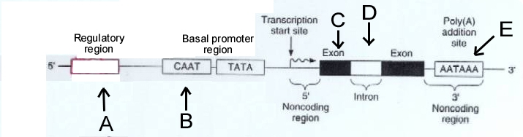
21. Which region on the gene do c-fos and c-jun bind to?
- A
- B
- C
- D
- E

22. Which regions will be transcribed to pre-mRNA?
- only A
- A and B
- only C
- C and D
- only E

23. The coding information from which region will be expressed in the mature, biologically active peptide hormone?
- A
- B
- C
- D
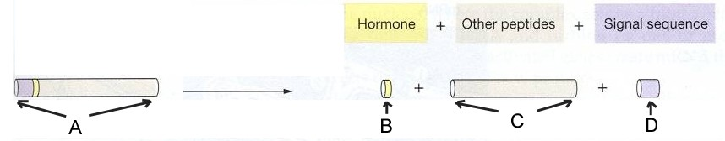
- E

24. Which letter indicates a preprohormone?
- A
- B
- C
- D
- None of the above

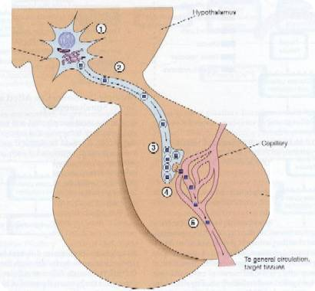

25. Which one of the following hormones is possibly a product of the neuron on the figure?

- Growth hormone
- Dopamine
- Vasopressin
- GHRH
- FSH

26. Which one of the following hormones is possibly “hormone 1” on the figure?

- Prolactin
- Growth hormone
- GHRH
- Oxytocin
- Vasopressin

27. Which one of the following hormones is possibly “hormone 2” on the figure?

- Growth hormone
- Vasopressin
- Dopamine
- Somatostatin
- Cortisol

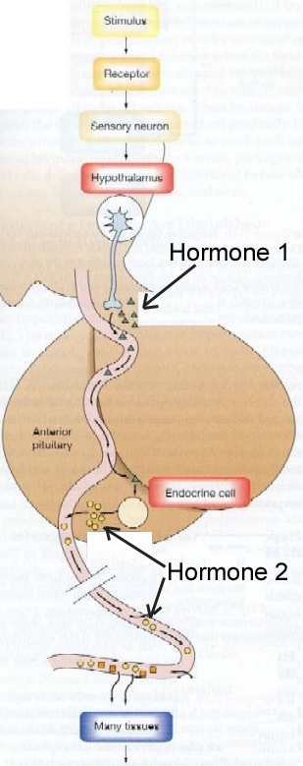

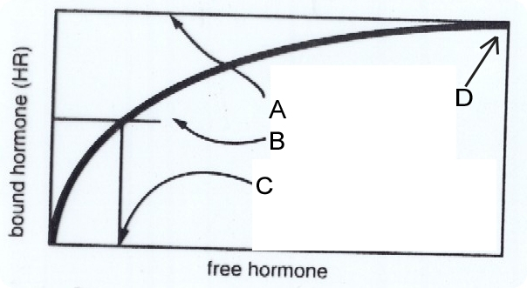
28. Which letter indicates the value of the affinity constant?
- A
- B
- C
- D
- E

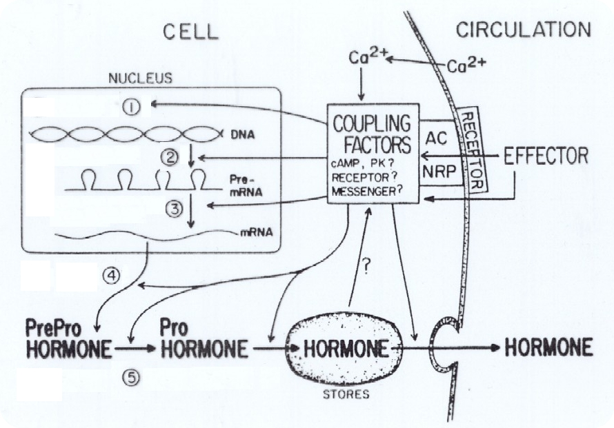

29. Which step is posttranslational processing?
- Step 1
- Step 2
- Step 3
- Step 4
- Step 5

30. At which step is hormone formation regulated?
- Step 2
- Step 3
- Step 4
- Step 5
- All of the above

