A tribute to my father
Archie E. Faulkner Sr.

My dad was born Feb 21, 1925 in a house along the banks of the Little Timber Creek in Brooklawn, NJ. Born the only surviving twin at 1 pound 8 ounces, the doctors did not give him much of a chance back then. But they were wrong. His parents Archie, and Sigrid, and older brother Stanley, had a boat in the backyard in the creek. A wooden motor-sailboat with no mast, it only had a hand started gasoline engine. They would take trips down the Delaware River to places like Cape May, Pennsville, and Betterton, MD at about 4 or 5 knots. Tidal current planning was a must. When the tide changed against you, you tossed out the anchor for the night. One year at Betterton, they entered in the 1st Annual Betterton Yacht Race. They took 3rd place. Of course, there were only 3 boats in the race! He went the Gloucester High School and graduated in May of 1943 to go to war.
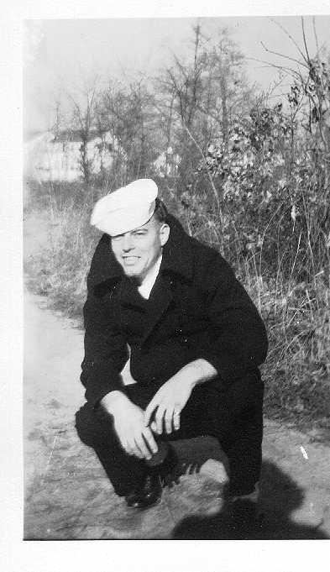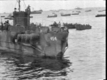

As Navy Motor Mechanic on board a Landing Ship Infantry - Guns (LSI-454(G)) that had been converted to carry extra guns and rockets, he saw action in the South Pacific in the battles for Saipan, Tinian, Palau, Angaur, Kerama Retto Islands, Okinawa and Ie Sima.

After the war, he married my mom, Pauline, and built a new house in Brooklawn, NJ. During the mid 50’s, he bought a skiff, earned his captains license, and began a charter boat business in Waretown, NJ fishing mainly Barnegat Light area out to the Ridge. Unfortunately, chartering did not pay the bills. With 2 daughters to now worry about, the boat had to be sold.
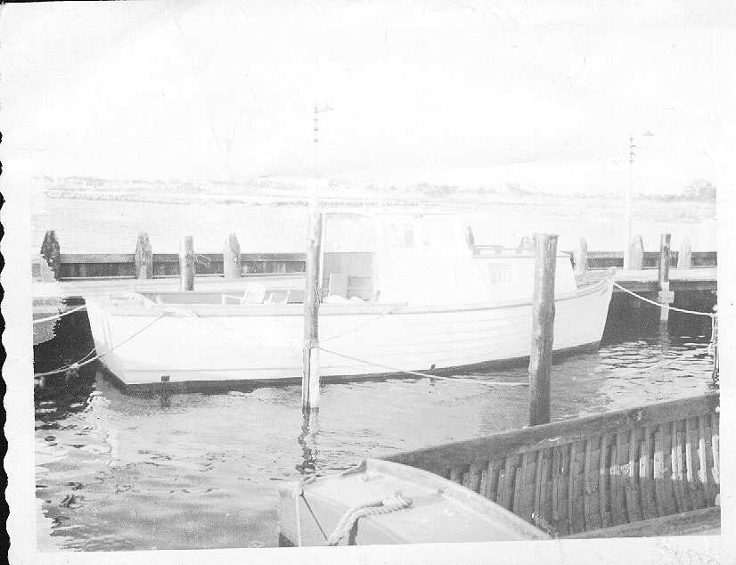
Although the boat was gone, the need to fish remained. Surf fishing took over as the recreation of choice. In 1958, I was born. My earliest memories were of surf fishing with dad on the 18th Street beach of Barnegat Light where we would rent a house for 2-week vacation. I grew up playing in the Little Timber Creek too. I would come home from school and go straight to the creek. My mom would scream at me for the mud caked on my school shoes. My dad never had a harsh word to say. I didn’t know that back when he was a kid, he would do the same. We went on head boats and party boats often. Winning “the pool” on a couple charter trips for the American Legion Post 72 was a special event. I even won the pool once on the Miss Barnegat Light once with a small bluefin tuna. I remember dragging it back to our spot after the mate gaffed it. “Hey Dad! Look what I caught!” After years of playing in derelict boats in the creek, dad took me to buy my first boat with money earned from cutting grass when I was 13. It was only a 10 foot aluminum Jon Boat with oars. He taught me to row first. We went to different places like Newtons Creek, Cooper River, Woodbury Creek, and Lake Absegami. That winter he bought me a Chapmans Piloting, Seamanship and Small Boat Handling book, which I read over and over. In 1973 we took $216 of grass money to Big D Valley Marina and bought a new 4 hp Evinrude outboard. I’ll never forget the first trip with an outboard. We launched the jon boat and put the motor on. I rowed over to a nearby dock. With Owners manual in hand, my dad let me do everything. I started up the engine on the 2nd pull. My dad said “see you back here in 3 hours”.
We took that little boat fishing in the back bays of Ship Bottom, Surf City, and to Mystic Island. Over the next couple years we bought a 16’7 Boston Whaler and docked it in Tuckerton, NJ and then moved up to a 19 ft Mako. We kept the Mako in the Maurice River and fished Delaware Bay whenever possible. Dad liked Delaware Bay, but I liked the ocean. So in 1981, I bought an 18 ft Hydra-Sports center console. Dad kept the Mako. 3 of my friends and I went partners on a house for the summer in Avalon. It had a dock with 2 slips in the backyard. It was the beginning of the best summer of my life, until on June 21, I got the worst phone call of my life. My dad and mom left the marina on the Maurice River that morning. It was a “great day to be out” my dad said to my mom. A few minutes later, he collapsed from a massive heart attack at the wheel. My mom took the helm and drove the boat over to another boat to get help, then fainted. These Good Samaritans drove the boat to the Marine Police dock in Bivalve. There was nothing anyone could do. One month later, we took the Mako for the last trip to ‘19’ buoy, one of my dads favorite fishing spots, and spread his ashes on the water. Since we did not have a grave to visit, this year we sponsored a 10 Reef Ball Habitat patch reef in his memory on the Cape May Reef through the NJ Artificial Reef Association. Thank you Dad for the memories of fishing and boating.
Archie Jr.

