Heidi Before the Osprey Project



Heidi During the Osprey Project

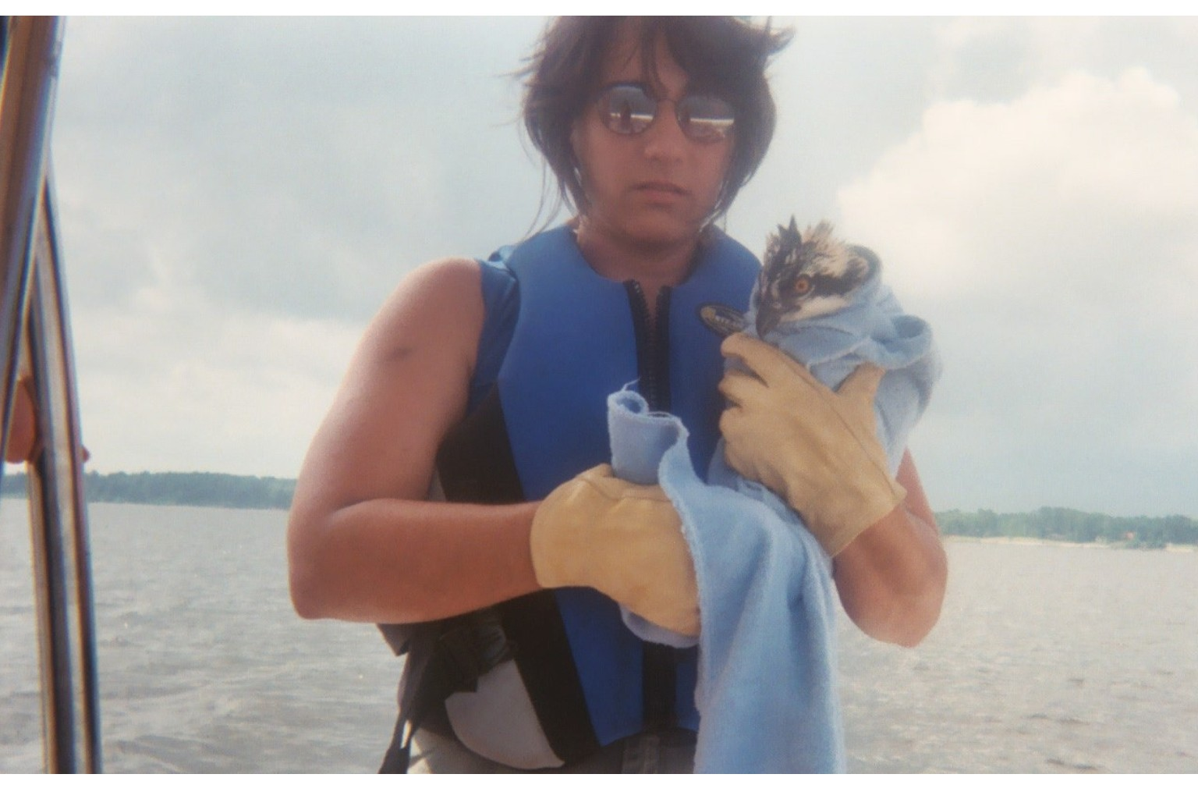

Heidi After the Osprey Project



Heidi still has hope because:

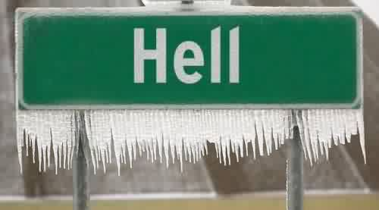

Anything can happen!!!

