Fig. 14.07-08additional SliderDemo2.java Explanation
(0) Desired Outcome

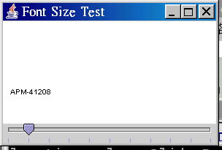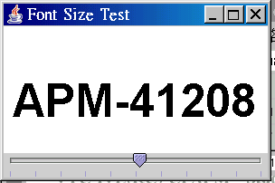

/*-----------------------------------------------------
Programe Name : StringPanel.java
Purpose : This program creates a subclass of JPanel to be called by the program SliderDemo2.
It simulates the class OvalPanel to be called by the program SliderDemo.
Source : Fig. 14. 7 & 8 (pp. 691-5) of Deitel & Dietel: JAVA - Prentice Hall
Tester : Dr. Charles Tang peacemaker@charlestang.org charlestang.org
Test Date : 2003.9.15
Version : 1.0
Organization : VTC-IVE(KC)CP
----------------------------------------------------*/
// Import declaration
import java.awt.*;
import javax.swing.*;

// Begin class StringPanel which inherits
// existing members of the superclass
// JPanel
public class StringPanel extends JPanel
{
private int fontSize = 10;

public void paint( Graphics g )
{
super.paint( g );
g.setFont( new Font
("SansSerif", Font.BOLD, fontSize) );

// Draw a String at x-coordinate 10
// & y-coordinate 100
g.drawString( "APM-41208", 10, 100 );
}

public void setFontSize( int newFontSize )
{
// If font size invalid, default to 10
fontSize =
( newFontSize >= 0 ? newFontSize : 10 );
repaint();
}

// Used by layout manager to determine
// preferred size
public Dimension getPreferredSize()
{
return new Dimension( 200, 200 );
}

// Used by layout manager to determine
// minimum size
public Dimension getMinimumSize()
{
return getPreferredSize();
}
} //End-Class StringPanel
/*-------------------------------------------------
Programe Name : SliderDemo2.java
Purpose : This program creates the JSlider hat controls the font size of the string
drawn on a subclass of JPanel called StringPanel.
The user specifies the size of the string with a horizontal JSlider.
Source : Fig. 14.8 (pp. 691-5) of Deitel & Dietel: JAVA - Prentice Hall
Tester : Dr. Charles Tang peacemaker@charlestang.org charlestang.org
Test Date : 2003.9.15 Version : 1.0
Organization : VTC-IVE(KC)CP
--------------------------------------------------*/
// Import declaration
import java.awt.*;
import java.awt.event.*;
import javax.swing.*;
import javax.swing.event.*;

// Begin class SliderDemo2 which inherits
// existing members of the superclass
// JFrame that provides a window
public class SliderDemo2 extends JFrame {
private StringPanel stringPanel;

// Declare a slider named fontSlider
private JSlider fontSlider;

// (A) Set GUI constructor SliderDemo2
public SliderDemo2()
{ // super to call superclass JFrame's
// constructor SliderDemo2
// i.e. (1) Set title bar string
super( "Font Size Test" );
stringPanel = new StringPanel();
stringPanel.setBackground( Color.CYAN );

// (2) Instantiate a horizontal JSlider
// object fontSlider from 0 to 100.
// The initial value of the slider is 10.
fontSlider = new JSlider
( SwingConstants.HORIZONTAL, 0, 100, 10 );

// (3) Set major tick mark spacing to 10
fontSlider.setMajorTickSpacing( 10 );

// (4) Call appropriate method to display
// the tick marks
fontSlider.setPaintTicks( true );

// (5) Register slider event listener
fontSlider.addChangeListener
(
new ChangeListener()
{
public void stateChanged
( ChangeEvent e )
{
// The stringPanel sets the font size
// to the value obtained by the slider
stringPanel.setFontSize
( fontSlider.getValue() );
}
} // End-Register slider event listener
); // End-Set GUI constructor

Container container = getContentPane();
container.add( fontSlider, BorderLayout.SOUTH );
container.add( stringPanel, BorderLayout.CENTER );
setSize( 300, 200 );
setVisible( true );
}

public static void main( String[] args )
{
SliderDemo2 application = new SliderDemo2();
application.setDefaultCloseOperation
( JFrame.EXIT_ON_CLOSE );
}
} // End-class SliderDemo2

