HONG KONG EXAMINATIONS AUTHIRITY
HONG KONG CERTIFICATE OF EDUCATION EXAMINATION 1995
AJJITIONAL MATHEMATICS PAPER 1
803.am-10.30am(2 hours)
This paper must be answered in English

Answer ALL questions in Section A and any THREE questions in Section B.
ALL working must be clearly shown

Section A (42 marks )
Answer ALL questions in this section.

1.Let f(x)=x²+(1-m)x+2m-5, where m is a constant. Find the discriminant of the equation f(x)=0.
Hence find the range of values of m so that f(x)>0 for all real values of x. (5marks)

2.Let z =-1+√3i. Express z in polar form.
Hence find z⁵+ z⁻⁵ (5marks)

3.Using the information in the following table, sketch the graph of y=f(x), where f(x)is a polynomial.
 | X < 0 | X = 0 | 0<x<1 | X=1 | 1<x<2 | X=2 | x>2
F(x) |  | 1 |  | 2 |  | 1
F’(x) | < 0 | 0 | > 0 | 0 | < 0 | 0 | > 0
(5marks)

4.By considering the two cases x>0 and x<0, or otherwise, solve the inequality
x-5/x>4(6marks)

5.In the same Argand diagram, sketch the locus of the point representing the complex number z in each of the following cases :
(a)∣z-(3+i)∣= 3,
(b)∣z∣=∣z-8i∣
Hence, or otherwise, find the complex number(s) represented by the point(s) of intersection of the two loci.(6 marks)

6.P(4,1)is a point on the curve y² + y√x=3, where x>0.
(a)Find the value of d y / d x at P.
(b)Find the equation of the normal to the curve at P. (7 marks)

7.Let OP =2i+’3j and OQ =-6i+4j . Let R be a point on PQ such that PR:RQ =k:1, where k>0.
(a)Express OR in terms of k, I and j.
(b)Express OP．OR and OQ．OR in terms of k.
(c)Find the value of k such that OR bisects ∠POQ. (8 marks)

Section B (48 marks )
Answer any THREE questions in this section
Each question carries 16 marks
8.
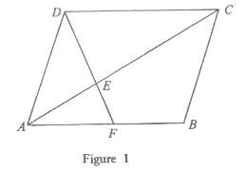
In figure 1, ABCD is a parallelogram and F is a point on AB.DF meets AC at a point E such that DE:EF=λ:1, whereλ is a positive number. Let AB = p, AD= q and
AE = h A C , AF =k A B , where h, k are positive numbers.
(a)(i)Express AE in terms of h , p and q .

(ii)Express AE in terms of λ ,k, p and q.

Hence show thatλ=1/k(5 marks)

(b)It is given that ︳p︳= 3,︳q︳=2, ∠DAB=π/3.

(i)Find P. q

(ii)Suppose DF is perpendicular to AC.

(1)By expressing DF in terms of k, p and q, find the value of k.
(2)Using(a), or otherwise, find the length of AE.(11 marks)
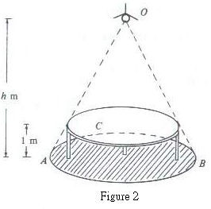
9.

A small lamp O is placed h m above the ground, where 1>h<5. Vertically below the lamp is the center of a round table of radius 2 m and height 1 m. The lamp casts a shadow ABC of the table on the ground (see Figure 20). Let s m² be the area of the shadow.
4πh²
(a)Show that s= ——— (3 marks)
(h-1)²
(b)If the lamp is lowered vertically at a constant rate of 1/8 m s⁻¹,
Find the rate of change of s with respect to time when h=2.(5 marks)
(c)Let νm³ be the volume of the come OABC.
4πh³
(i)Show that ν———
3(h-1)²
(ii)Find the minimum value ofνvaries.
Does s attain a minimum whenνattains its minimum? Explain your answer. (8 marks)

10. Let f(x)=12x²+2px-q
and g(x)=12x²+2qx-p,

where P, q are distinct real numbers, α，βare the roots of the equation f(x)=0 andα,γare the roots of the equation g(x)=0.

(a)Using the fact that f (α)=g(α), find the value ofα.
Hence show that P+q=3(3 marks)
(b)Express β and γ in terms of P.(4 marks)
(c)Suppose ｜β³+γ³｜<7/24
(i)Find the range of possible values of P.
(ii)Furthermore, if p>q, write down the possible integral values of p and q.
11.(a)Let α,β be the roots of the equation
x²-x+1=0……(*),
where –π<arg β in polar form. (3 marks)

(b)
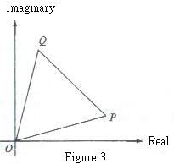

Figure 3 shows an Argand diagram in which OPQ is an equilateral triangle. The complex numbers represented by O, P and Q are 0, Z₁and Z₂ respectively.

(i)Find the values of ｜Z₂/ Z₁｜and arg (Z₂/ Z₁).
Hence show that Z₂/ Z₁ is a root of the equation(*)in (a).

(ii)Using (i), or otherwise, show that
Z₁²+ Z₂²= Z₁ Z₂

(iii)It is given that ｜Z₁｜=Z. Find
(1)｜Z₂ /Z₁｜,
(2)｜Z₁²+ Z₂²｜ (13 marks)

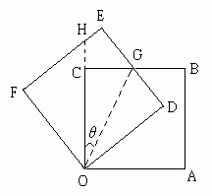
12.

l

In Figure 4, OABC is the position of a square of side l. The square is rotated anticlockwise about O to a new position ODEF.BC cuts DE at G and OC produced cuts EF at H. Let ∠COG = θ , where π/8 <θ<π/4

(a)Name a triangle which is congruent to △OCG.
Hence show that the area of △OFH is l ²/(2tanθ).(3 marks)

(b)Let S be the sum of the areas of △OFH and the quadrilateral ODGC.
(i)Show that S= l ²/2[(2-cos2θ)/(sin2θ)].
(ii)Find the range of values of θ for which s is
(1)increasing,
(2)decreasing.
Hence find the minimum value of S. (11 marks)

(c)Find the maximum value of the area of the quadrilateral CGEH. (2 marks)

END OF PAPER

