C.C.C. Kwei Wah Shan College

Name: ___________________________ Class: _____________________( )

Date: ____________________________ Marks / Grade: ____________________

Form Three English: Comprehension Unit 5: Teens talk about food

A. Last year, Hong Kong International School held a writing competition. Teenagers had to write
about their favourite eating place and about some food from their country. Read the entry from a
Korean boy.
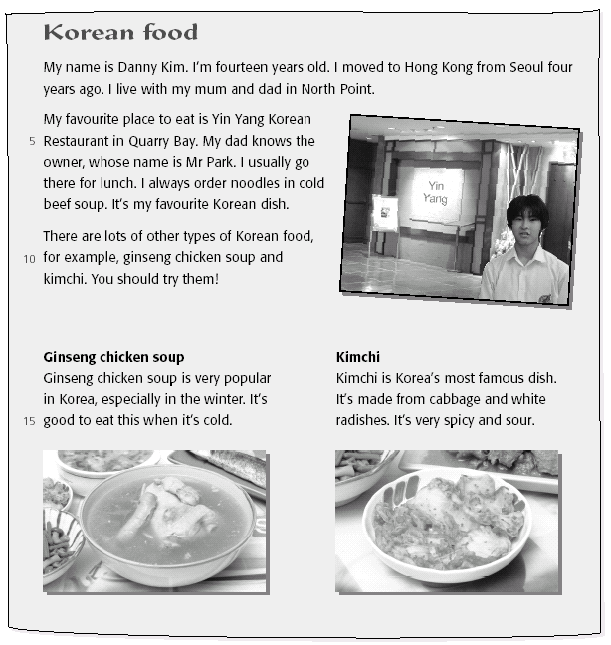
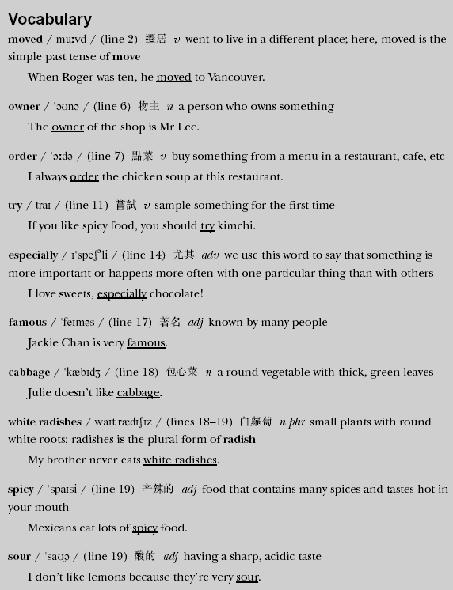

B. Choose the best answer for each question below. Circle the letter.
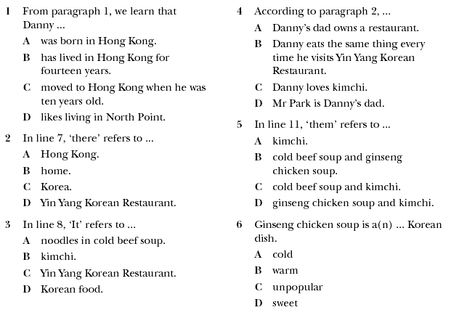

C. Answer the following questions.

- How old was Danny when he first moved to Hong Kong?

____________________________________________________________________

- What does Danny usually have for lunch?

____________________________________________________________________

- What ingredients are found in Kimchi?

____________________________________________________________________

- Which Korean food do you prefer ⎯ Ginseng Chicken soup or Kimchi? Why?

____________________________________________________________________

____________________________________________________________________

