C.C.C. Kwei Wah Shan College

Name: ___________________________ Class: _____________________( )

Date: ____________________________ Marks / Grade: ____________________

Form Two English: Reading and Writing
Read the article. Then do the exercises on the following pages.
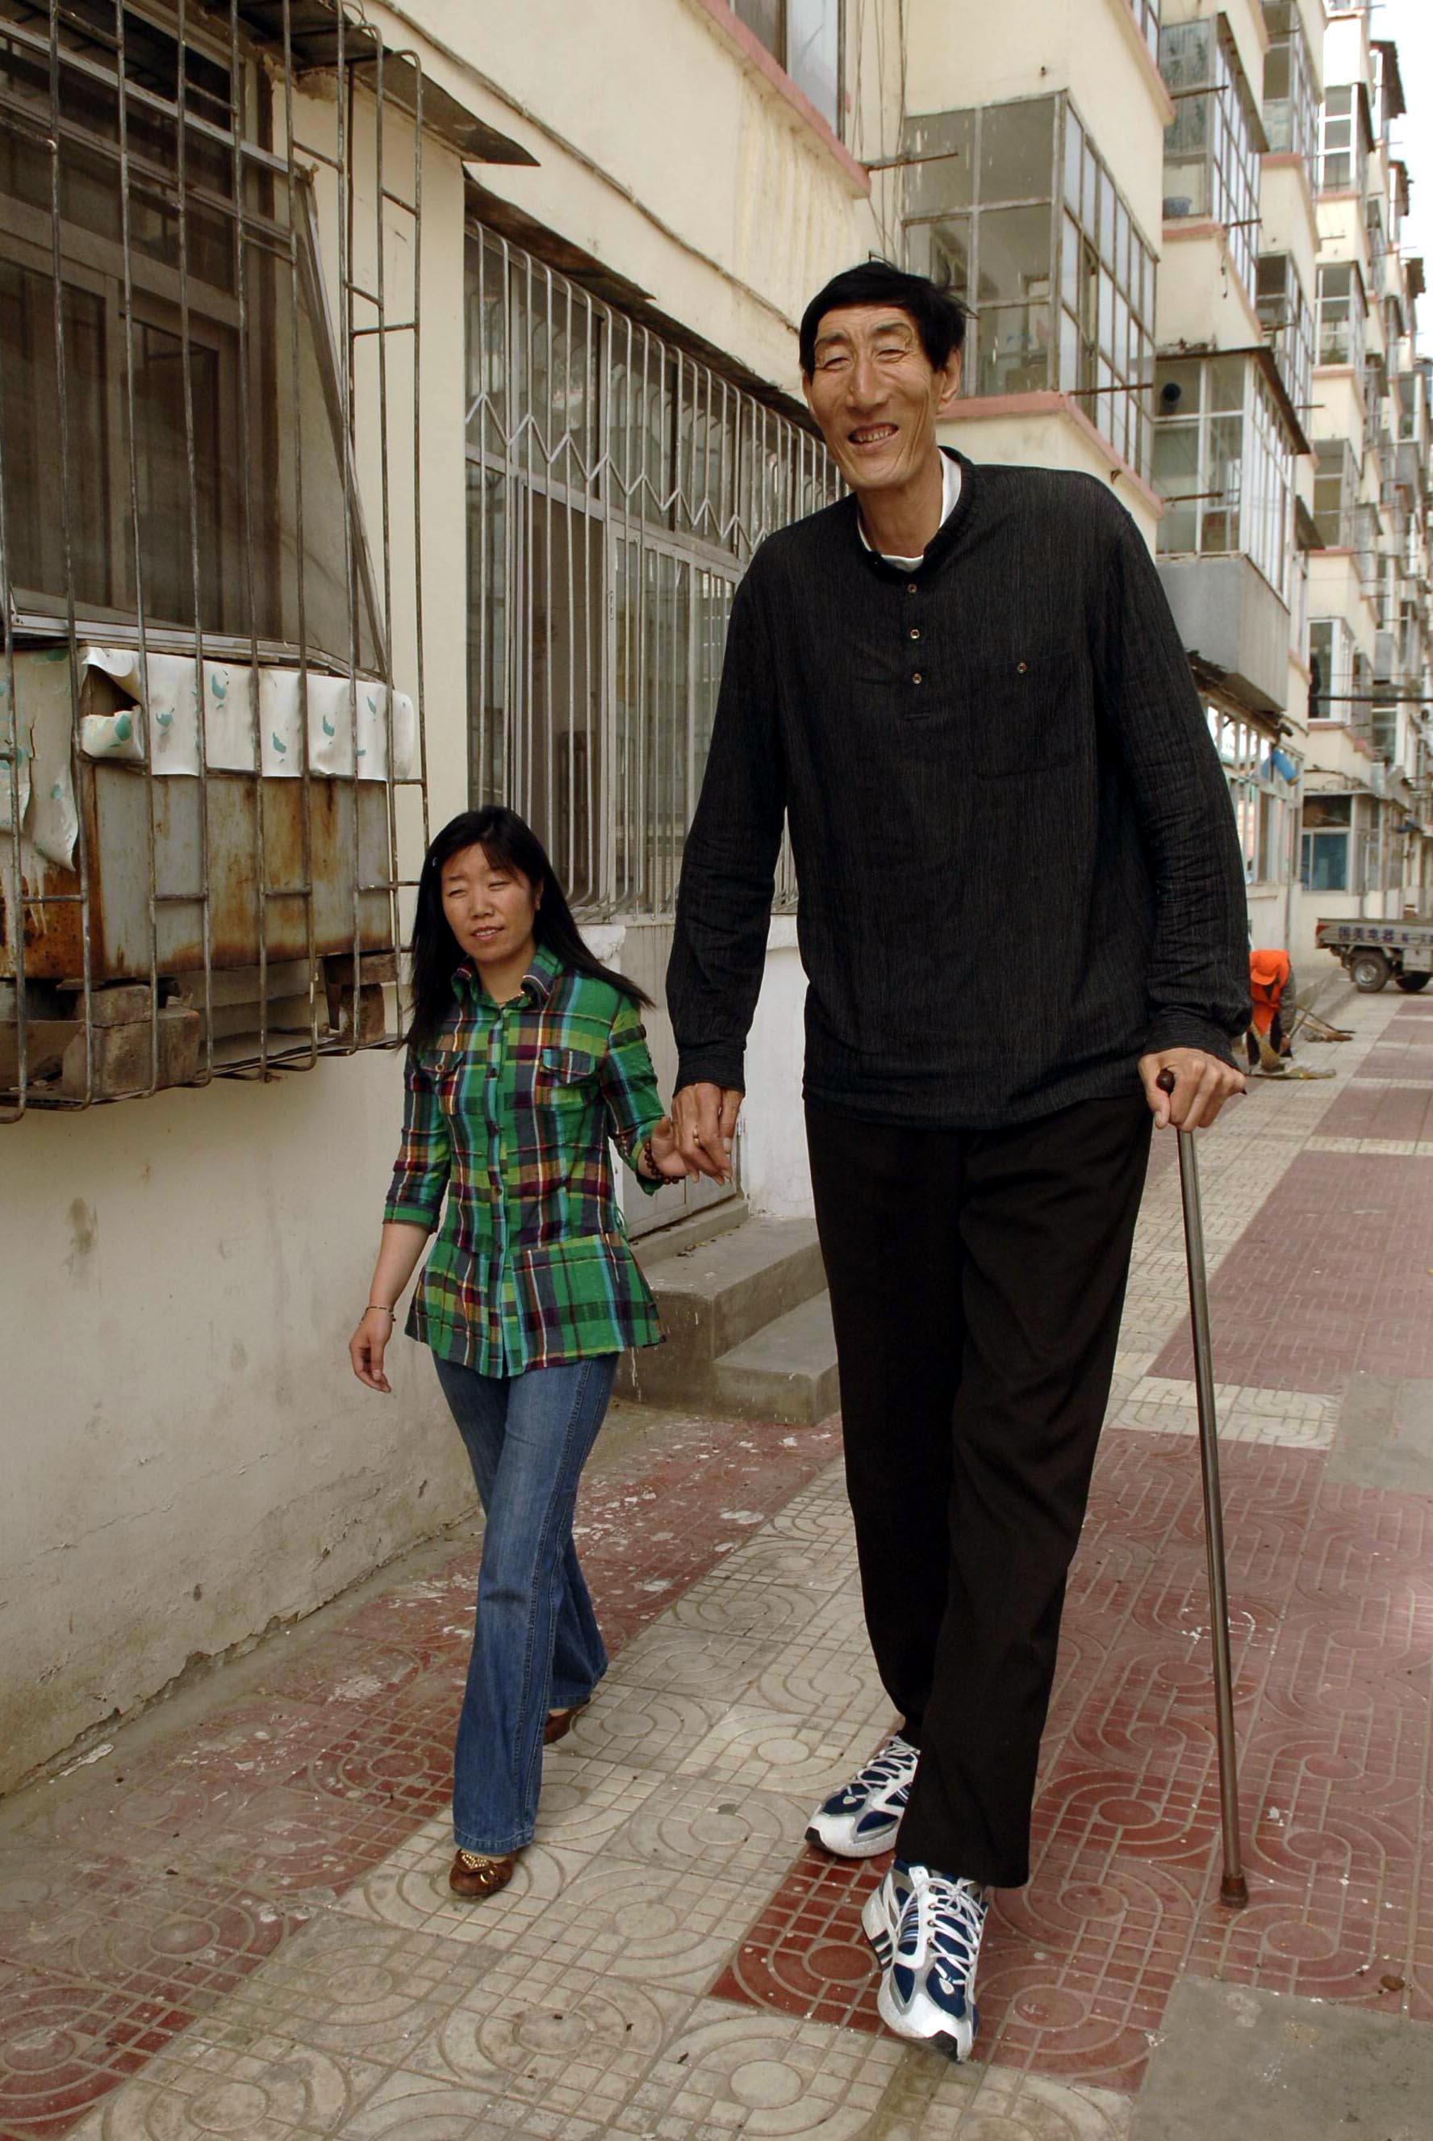
Height of happiness
On 24th March 2007, the tallest man in the world made headlines around the world with news of his marriage. After a widely-publicised search for a bride, Bao Xishun, a shy, gentle herdsman from Chifeng in Inner Mongolia, married Xia Shujian, a saleswoman from his hometown. Standing at 236.1 centimetres, Bao towers over his new wife who is just 168 centimetres tall.
Bao has five brothers and sisters, all of whom are of average height. As a child, Bao’s height was normal, too. Then, at the age of 16, he experienced a massive growth spurt. Within a year he had skyrocketed to a height of 189 centimetres. He did not reach his current height until the age of 23.
When Bao left school, he joined the People’s Liberation Army. He was discharged after three years due to rheumatism, a disease that makes the joints and muscles stiff and painful. Doctors believe he developed rheumatism because when he was young he liked to sleep outside, unprotected from the elements. After he was discharged from the army, he returned to Chifeng to live with his parents and look after the family’s herds of sheep and goats.
Bao first came to the world’s attention when he was confirmed as the world’s tallest living man by the Guinness Book of Records on 15th January 2005. The next year, he made the news again when he saved the lives of two dolphins in a Beijing aquarium. The dolphins had eaten some sharp pieces of plastic and the veterinarians at the aquarium had not been able to remove them. They called Bao, who used his 106-centimetre-long arms to reach down each dolphin’s throat and remove the plastic from its stomach.
Bao was a hero, but he was a lonely hero. Because of his extreme height, he had never even dated. He decided to take out a newspaper advertisement, stating that he needed love and wanted to find a wife. The marriage advertisement was sent around the world but, in the end, it was a woman from his hometown who captured the heart of Bao Xishun, the gentle giant.
To read more about Bao Xishun, follow this link: http://en.wikipedia.org/wiki/Bao_Xishun
A Answer the following questions.

1 | Which town is Xia Shujian from?
2 | How many children did Bao Xishun’s parents have?
3 | What caused Bao to develop rheumatism?
4 | When did Bao save the dolphins’ lives?
5 | Why was Bao lonely?

B Choose the best answer for each question. Circle the correct letter.

1 Bao was discharged from the army because he ...  - suffered from a painful disease.  - was not strong enough.  - was too tall. | 2 In paragraph 3, ‘elements’ means ...  - bandits.  - weather.  - wild animals.
3 The aquarium veterinarians asked Bao for help because ...  - he is a dolphin expert.  - nobody else was brave enough.  - their own arms weren’t long enough. | 4 The writer of the article implies that Bao is ...  - a brave man.  - a nice man.  - an unhappy man.

FREE WRITING
C Answer and discuss the questions below.

1 What are the advantages of being as tall as Bao Xishun?

___________________________________________________________________

___________________________________________________________________

___________________________________________________________________

2 Would you like to be as tall as Bao Xishun? Why or why not?

___________________________________________________________________

___________________________________________________________________

___________________________________________________________________

3 What caused Bao to grow so tall?

___________________________________________________________________

___________________________________________________________________

___________________________________________________________________

4 What kinds of challenges do you think Bao faces in his daily life?

___________________________________________________________________

___________________________________________________________________

___________________________________________________________________

___________________________________________________________________

5 Do you think advertising in a newspaper is a good way to find a wife or husband? Why do you think this?

___________________________________________________________________

___________________________________________________________________

___________________________________________________________________

___________________________________________________________________

