C.C.C. Kwei Wah Shan College

Name: ___________________________ Class: _________________( )

Date: ____________________________ Marks: ______________________

Form Two English: Dialogue Writing: (Activate 2A, Unit 1, P.3)

Title: Going Shopping
Tell each other how often you go shopping at each of the shopping centres and what you buy there. You can begin like this.

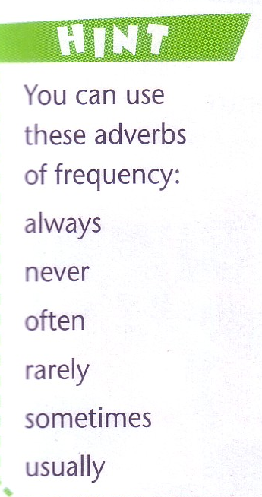
Complete the conversation below.
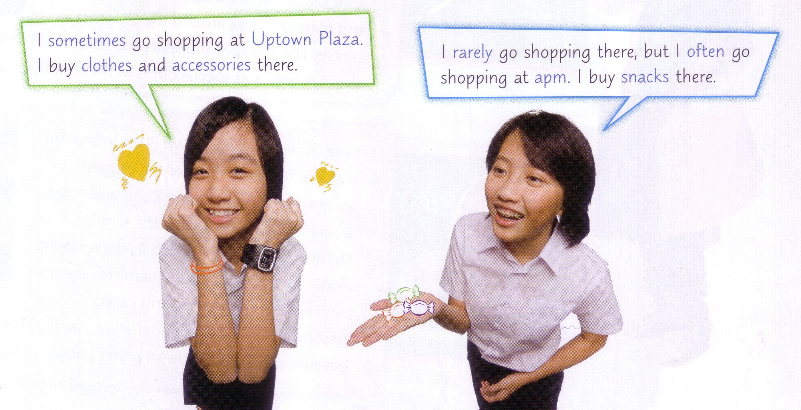

I ____________________ go shopping at ________________________________.

I buy ________________ and ________________ there.

I ____________________ go shopping there, but I ____________________ go

shopping at _______________________. I buy _______________________ there.

___________________________________________________________________

__________________________________________________________________.

