C.C.C. Kwei Wah Shan College

Name: ___________________________ Class: _____________________( )

Date: ____________________________ Marks/Grade: ____________________
Form Two English: Dialogue Writing: (Activate 2A, Unit 2, P.23)
Title: My Favourite Films

Task 1: What type of film are they?
( action film 動作片／ cartoon 卡通片／comedy喜劇／horror film恐怖片／ romance愛情片／science fiction film科幻片 )



1. Moving Dog (超能特工狗)

Type of film: ____________________________________

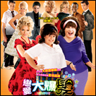

2. Hairspray (戀愛大爆髮)

Type of film: ____________________________________

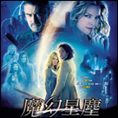
3. Stardust (魔幻星塵)

Type of film: ____________________________________

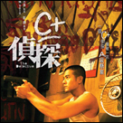
4. The Detective (C+偵探)

Type of film: ____________________________________

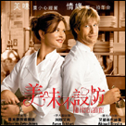
5. No Reservations (美味不設防)

Type of film: ____________________________________


6. House of Wax (恐怖蠟像館)

Type of film: ____________________________________

Task 2: My Favourite Films

Work in pairs. Talk about which films you have seen. Say if you liked or did not like the films and why. You can begin like this, or you can use these adjectives to describe films: boring, exciting, funny, interesting, scary, silly.
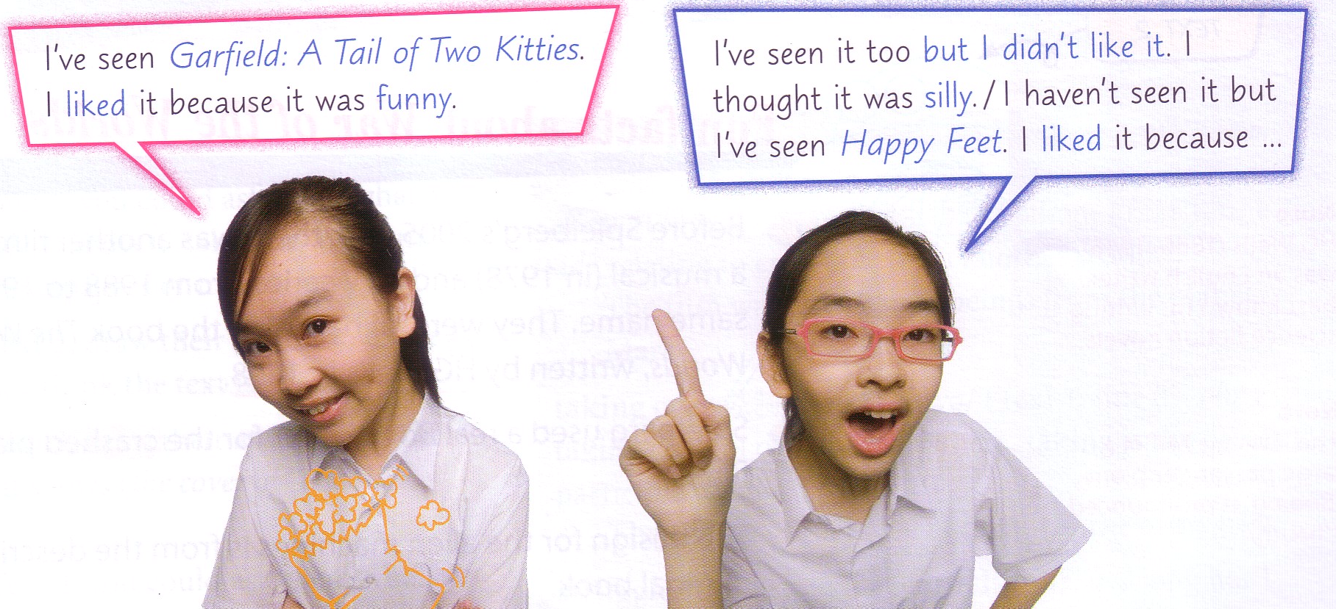

I’ve seen _________________________________________(Name of the film). I

liked it because it was ____________________.

I’ve seen it too but I didn’t like it. I thought it was__________________________.

I haven’t seen it but I’ve seen ___________________________(Name of the film).

I liked it because it was ________________.

___________________________________________________________________

______________________________________________________________________________

______________________________________________________________________________

