C.C.C. Kwei Wah Shan College

Name: ___________________________________ Class: ______________________( )

Date: ____________________________________ Marks: ____________________________

Form Two English: Dictation:
Names of Animals and Body Parts ( Activate 2A, Unit 3, P.48 )
Robbie and Clare are making data cards about some animals for a wall display. Help them to complete the data cards with the names of animals and their body parts.
Name: (1)_______________________________

Location: Africa and Asia

Special features: has a (2)___________, big (3)__________, and white (4)_________.

Diet: grass, leaves, fruit

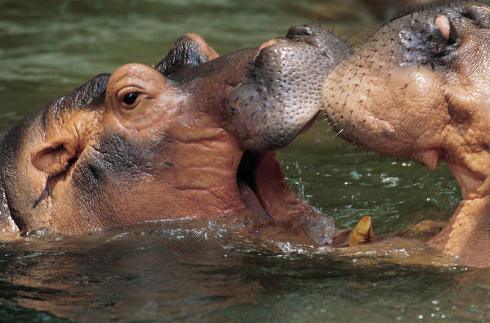
Name: (5)_______________________________

Location: Africa

Special features: has a long (6)_____________, runs very fast, but cannot fly

Diet: seeds and insects
Name: (9)_______________________________

Location: Australia

Special features: has a strong tail, babies live in mother’s pouch

Diet: grass and roots
Name: (7)_______________________________

Location: Africa

Special features: has a big mouth but very small (8)___________

Diet: grass
Name: (10)_______________________________

Location: Asia

Special features: has long (11)__________________, black and orange

(12)_____________ and very sharp (13)_____________, runs very fast.

Diet: other animals
Name: (14)_______________________________

Location: Worldwide

Special features: has two pairs of long (15)________________, active at night.

Diet: almost anything, including rubbish and soap!

