CCC KWEI WAH SHAN COLLEGE
2007/2008 Third Uniform Test
S.2 General English

Date : 27th November, 2007 Class : S.2 ______________
Time Allowed : 40 minutes Name : _________________ ( )
Question Paper : 7 pages Total Marks : 100

Put all the answers on the answer sheet provided.

Part One Listening 15 marks @ 3

You are going to hear a question followed by a conversation. For each question, look at the information provided and the three possible answers. Choose the best answer and write the appropriate letter — A, B or C — in the box provided. You will have 30 seconds to study the questions.

1 Which type of rubbish will Maggie pick up?

 | A |  | B |  | C | 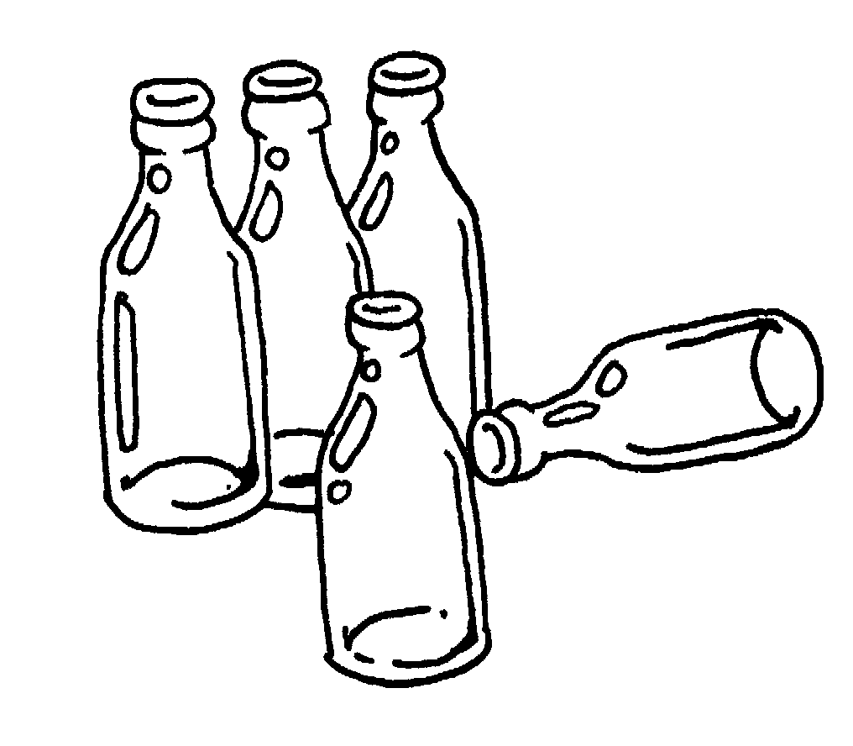

2 Why was Philip late?

A Because of the rain
B Because of the traffic
C Because of his cousin

3 Which poster are the students looking at?

A | Beach Clean-up  at  Yung Shue Wan,  Lamma Island   Wear a hat and  strong shoes   Gloves provided  10 a.m.  Saturday 14th August | B | Beach Clean-up  at  Yung Shue Wan,  Lamma Island   Wear a hat and  strong shoes   Don’t forget to  bring gloves  10 a.m.  Saturday 14th August | C | Beach Clean-up  at  Sok Kwu Wan,  Lamma Island   Wear a hat and  strong shoes   Gloves provided  10 a.m.  Saturday 14th August

4 How long was the environmental awareness course?

A Six days
B One week
C Two weeks

5 Which recycling bins will San Mo Secondary School get?

A | 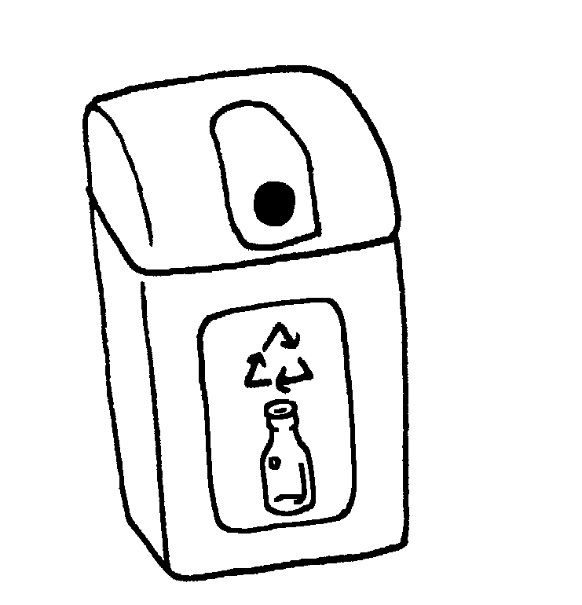 | B | 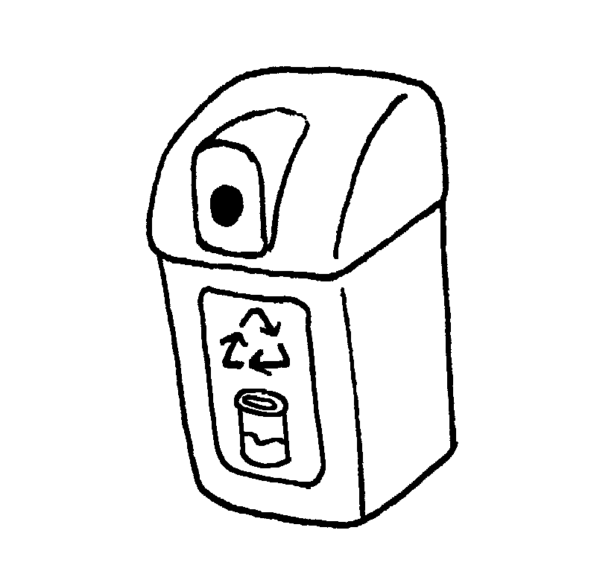 | C | 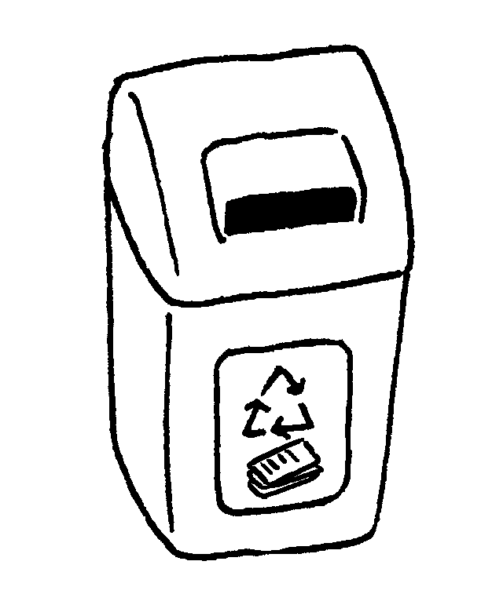

A Bins A and B
B Bins A and C
C Bins B and C

Part Two Reading Comprehension 20 marks

Read this profile about a young actress, and answer the questions.

Katie Leung
Katie Leung is a pretty, intelligent sixteen year-old Chinese teenager. Her family home is a £400,000 ($5,200,000) house in Motherwell, which is a town near Glasgow, Scotland. She lives with her father Peter, two brothers and a younger sister.

Her lucky chance came when she was chosen to play the part of Cho Chang, who is Harry’s first girlfriend, in the latest Harry Potter film. The film is called Harry Potter and the Goblet of Fire. Katie Leung, who bear more than 4,000 hopeful girls, queued for hours for her acting test in February 2004.

“The film company and the author J K Rowling were keen to find a completely unknown actress for the part of Cho Chang. Katie’s absolutely perfect. She’s pretty and smart. You can see why Harry would want her to be his girlfriend. Katie has a wonderful career ahead of her,” said a spokesperson for the film company.

A. Write the correct letter (A, B, C or D). 20 marks @ 2

1 How old is Katie Leung?
A) 14.
B) 15.
C) 16.
D) 17.

2 Where does she live?
A) England.
B) Ireland.
C) Scotland.
D) New Zealand.

- How many brothers and sisters does she have?
A) 2.
B) 3.
C) 4.
D) 5.
- Paragraph 2 is mainly about:
A) why Katie liked to act in Harry Potter film.
B) the story of the new Harry Potter film.
C) the life of Cho Chang.
D) how Katie got a part in a film.

- Cho Chang is Harry Potter’s:
A) teacher.
B) girlfriend.
C) sister.
D) friend.

- According to paragraph 2, Katie Leung:
A) didn’t want the part of Cho Chang.
B) didn’t act well in her acting test in February 2004.
C) was the only actress who wanted the part of Cho Chang.
D) was one of many people who wanted the part of Cho Chang.

- In line 7, ‘queued’ means:
A) waited in line.
B) acted.
C) practised.
D) studied.

8 According to paragraph 3, J K Rowling is
A) a writer.
B) an actor.
C) an actress.
- a film company.

9 In line 9, ‘unknown’ means:
A) stupid.
B) unimportant.
C) forgotten.
D) not famous.

- The spokesperson in paragraph 3 thinks Katie will:
A) not act the part very well.
B) act the part quite well.
C) act the part very well.
D) act the other part quite well
Part Two Usage 65 marks

A. Fill in the blanks with the name of the animal and the names of the body parts.
10 marks @ 2

What animal is it? It’s an 1. ________________.


2 ___________
4 ___________
3 ___________
5 ___________

B. Complete the sentences below with the words in the box. 10marks @2

Tina and her friends are trying to agree on the type of film to watch.
Complete their conversation below using the words and phrases from the box. Remember to use capital letters at the beginning of sentences. Use each word or phrase once only.

action films | cartoons | comedies | horror films
drama | musicals | romances | science fiction films

Tina: I love (6) _____________. Let’s watch a love story. They always make me happy.
Tom: Yuck! I hate those kinds of films.
Tina: How about (7) _____________. Shrek is my favourite one. The animation is wonderful.
Tom: No, thanks. Those types of films are too childish for me. (8) _____________ are interesting. Shall we watch one of them?
Mary: I’m sorry, but I find aliens and spaceships too frightening for me.
Lisa: I guess you don’t want to watch any (9) _____________ either then.
Mary: You’re right. I’m afraid of ghosts in them. They’re really scary! I prefer
(10) _____________, especially the actor is Jacky Chan.
John: Me, too.
Tina: Then let’s watch Rush Hour 3.
Lisa: Great idea, Tina.
Tom: Oh, all right then.

- You saw two film stars, Orlando Bloom and Maggie Q, shopping in a boutique and overheard them talking to each other. This is the conversation that they had.
(Questions 1-4 -- 16 marks @ 4; question 5 – 5 marks)

Orlando: So, how’s your film going?
Maggie: It’s going very well. (1) It’s an action film. (2) I play a woman with excellent kung fu skills. What kind of film are you working on here in Hong Kong?
Orlando: (3) It’s a science fiction film about a policeman how to solve crimes by using a time machine.
Maggie: Wow. It sounds really interesting.
Orlando: It is. (4) The costumes and special effects are really cool. In fact (5) I have to meet the costume designer and try on a new costume now. Let’s have dinner together tonight, shall we?
Maggie: Sure! I’ll call you later then. Bye!

**Example: Maggie: He is a good actor.
Maggie said that he was a good actor.

Here to report what they said.

1. Maggie said that _____________________________________________________________
- Maggie said that _____________________________________________________________
___________________________________________________________________________
- Orlando said that _____________________________________________________________
___________________________________________________________________________
- Orlando said that _____________________________________________________________
____________________________________________________________________________
- Orlando said that ______________________________________________________________
____________________________________________________________________________

- Tanya is writing a letter to her brother.

She wants you to help her to proofread the letter. Write the correct words above the underlined words and also choose the right words by crossing out the wrong words.
24 marks @ 2

Dear Sheldon

How are you? I’m doing very well. Have you seen the movie Last Flight yet? How (1) far was it? I really want to see it. My friend Karen said that she (1) see it yesterday with her brother. She (3) tells me that she really liked Last Flight and that it was (4) my brother’s favourite movie.

The movie is about a young boy who flew a tiny plane (5) through / around / over the world all by himself. Karen said that his plane crashed (6) along / into / onto a mountain as he was flying (7) under / behind / across North America. I told her I thought it (8) sounds very (9) excited. Would you like to see it? Maybe we can go together when you visit next weekend.

Karen also said that they had a problem at the cinema – Karen’s brother thought that she (10) have his ticket, but she didn’t! She told him that he had both of (11) our tickets. He looked and he finally found the tickets in his wallet. They really were lucky (12) tonight!

Anyway, I can’t wait to see you next weekend. Take care.

Tanya

End of Paper

