C.C.C. KWEI WAH SHAN COLLEGE

Answers

2007/2008 First Term Examination
S.2 General English

Date : 7th December, 2007 Class : S.2 ______________
Time Allowed : 1 hour Name : _________________ ( )
Question Paper : 10 pages Total Marks : 100
(20% of the subject mark)

Instructions :

- Write all the answers on the Answer Sheet.
2. Attempt all sections.

Part One Reading Comprehension 30 marks
Passage One

Read the article.

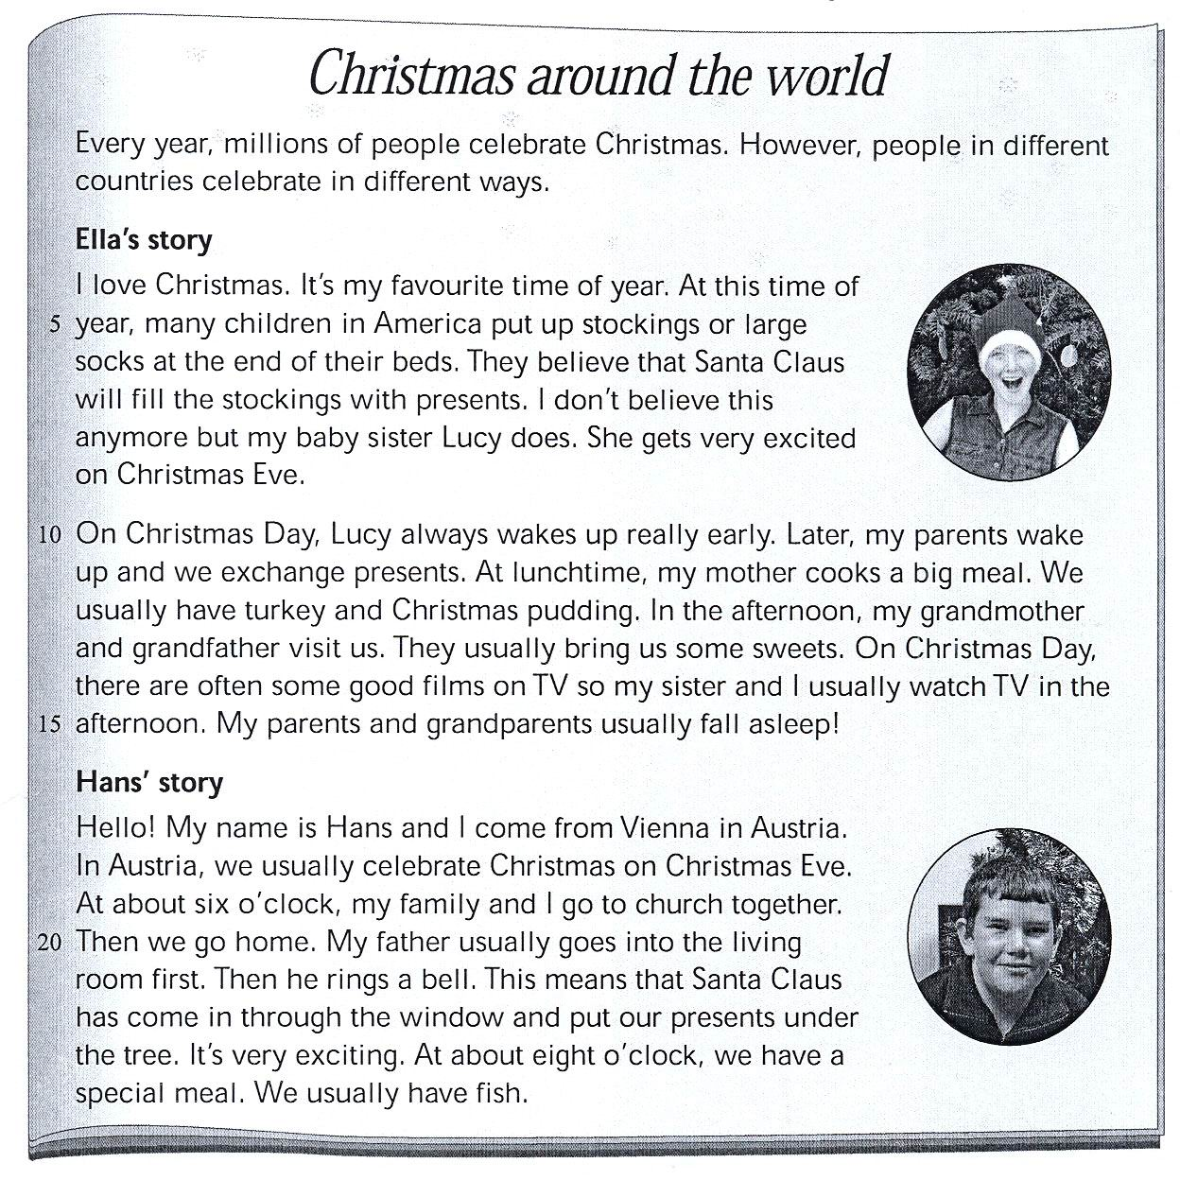

A. Complete the following sentences using the words below. Write the correct letter.
6 marks @ 1

1. Ella’s sister believes that Santa Claus D.
A) likes large socks

B) likes buying presents
C) visits children
D) gives children presents

2. On Christmas Day, Lucy wakes up A her parents.
- before
- at the same time
- after
- later

3. At lunchtime on Christmas Day, Ella’s C cooks a turkey.
- baby sister
- father
- mother
- brother

- Ella and Lucy D while their parents sleep.

A) go to bed
- eat sweets
- talk to their grandparents
- watch TV

5. Hans and his family usually go to church B/C.

in the morning

B) in the evening

C) on Christmas Eve

D) on Christmas Day

6. Santa Claus usually visits Hans’ family C.
- before 6 p.m.
- at 6 p.m.
- between 6 p.m. and 8 p.m.
- after 8 p.m.

B. Who or what do the following words refer to? Write the correct letter. 6 marks @ 1
7. In line 6, ‘They’ refer to C.
- Santa Claus
- stockings
- Children in America
- Ella and Lucy
8. In line 8, ‘She’ refers to B.
- Ella
- Lucy
- Hans
- Santa Claus
9. In line 11, ‘we’ refers to D.
- Ella’s sisters
- Ella ‘s parents
- Ella and Lucy
- Ella’s family

10. In line 13, ‘They’ refers to C.
- Ella’s sisters
- Ella’s parents
- Ella’s grandparents
- Ella and Lucy

11. In line 18, ‘we’ refers to A.
A) the people in Austria
B) the people in Vienna
C) Ella’s family
D) Han’s family

12. In line 21, ‘he’ refers to B.
A) Hans
B) Han’s father
C) Han’s grandfather
D) Santa Claus

Passage Two

Read the letter.

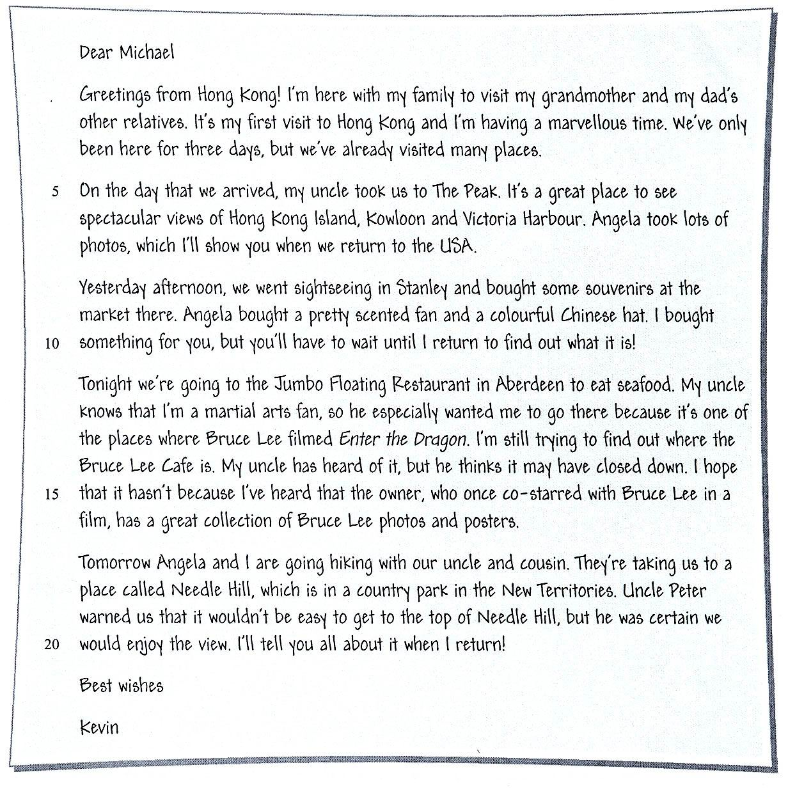

A. Complete Kevin’s diary entry below using words and phrases from his letter to Michael.
The first one is done as the example.
20 marks @ 2

Thursday | We arrived in Hong Kong in the morning. In the afternoon, we visited the Peak. Angela took (13) lots of photos.
Friday | Our uncle took us to (14) Stanley to do some  (15) sightseeing and shopping. Angela and I bought  (16) some souvenirs / a pretty scented fan and a colourful Chinese hat for our friends.
Saturday | We went to (17) the Jumbo Floating Restaurant in Aberdeen. Bruce Lee filmed parts of (18) Enter the Dragon in this restaurant. The (19) seafood dinner we had there was delicious!
Sunday | We went hiking with (20) Uncle Peter and cousin / our uncle and cousin . The view from the top of (21) Needle Hill was spectacular.
Monday | Uncle Peter took us shopping in Central. Later, we tried to look for  (22) the Bruce Lee Café . It was opened in Mid-Levels in 1998 by a former actor who co-starred with Bruce Lee in Way of the Dragon.

Part Two Usage 68 marks

A. Fill in the blanks with names of animals and body parts. 11 marks @ 1

23. What animal is it? It’s an elephant.

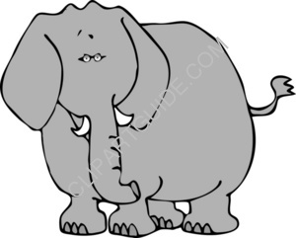
24 trunk

25 tusks

26. What animal is it? It’s a giraffe.

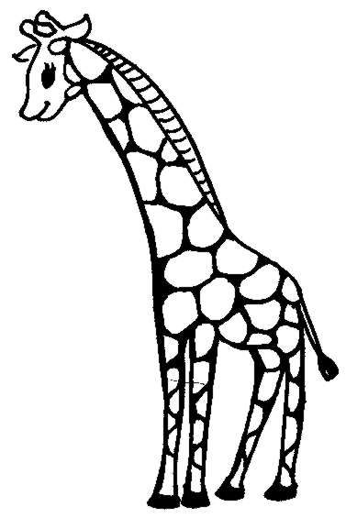
27 neck

28. What animal is it? It’s a tiger.


29 fur
30 whiskers

31 claws

32. What animal is it? It’s a cockroach.


33 feelers

B. Complete the sentences below with the words in the box. 8 marks @1

award | romance | terrified | brilliant | taking over
interesting | desperate | aliens | starred | survive
34. Jenny was a brilliant actress.
35. Dakota Fanning starred in the film War of the Worlds.
36. Aaron Kwok has won the Best Actor award twice.
- I was desperate because I had no food and no money.
- I think Garfield is interesting because everyone was laughing really loudly when Garfield appeared on screen.
- I don’t understand why you always choose scary films. I prefer romance. I was in tears when the main actor went back to his home village and found his girlfriend waiting for him. It was very romantic.
- John was bitten by a dog when he was a child, so he was terrified of dogs.
41. The enemy soldiers are taking over the army base.

C. Complete the following passage using the correct prepositions of movement from the word box. Some prepositions can be used more than once. 8 marks @ 1
across under through onto out of towards along

The bank robber thought he was unlucky. He was just coming (42)out of the bank with a bag full of money when he heard the policemen racing (43)towards him. He ran (44)across the road to the side and jumped (45)onto a bus. The surprised driver didn’t say anything because the bank robber was pointing his gun at him. A child on the bus was so scared that he hid himself (46)under his seat. The police cars were right behind the bus. The robber knew he had to get (47)out of the bus so he jumped (48)through the window and ran down an alley. He continued down a small hill with the policemen running behind him. He came to a river and was just thinking about swimming (49)across to safety when the police caught up with him and arrested him.
D. Match the first half with the second half of the sentences below. 10 marks @ 2
- If you heat water, E A) my parents get angry.
- If you heat ice, D B) you get wet.
- If I come home late, A C) my boss gets angry.
- If I’m late for work, C D) it melts.
- If it rains, B E) it boils.

E. Derek and his classmates were talking about their holiday. Help to report what they said. 12 marks @ 3

Example: Derek said, “I like to go to Japan.”
Derek said that he liked to go to Japan.

- Elaine said, “I do not think it is a good time to go.”
Elaine said that she did not think it was a good time to go.
- Joe said, “When I go on trips, I enjoy tasting the local food.”
Joe said that when he went on trips, he enjoyed tasting the local food.
- Sue and Ellen said, “We prefer to stay in Hong Kong during the holidays.”
Sue and Ellen said that they preferred to stay in Hong Kong during the holidays.
- Rob said, “My siser wants to go to Vietnam with me.”
Rob said that his sister wanted to go to Vietnam with him.

F. Complete the passage below with question phrases. Use the words from the word box.
8 marks @ 2

How far | How often | How many | How much | How fast | How well

Some people love talking and asking questions, for example, ‘What kind of car have you got?’,
‘(59) How fast does it go’, ‘(60) How much did it cost?’ I’m sure these people are very nice, but sometimes they don’t even wait for you to answer because they are busy asking their next question.
Yesterday an elderly couple asked me for directions to a local restaurant.
‘(61) How far is the Traveller’s Tavern?’ asked the old lady. ‘What sort of food does it serve? What time does it open?’
‘If we can’t find it,’ asked the old man immediately, ‘Where else can we go to eat?’
‘Oh no,’ said the lady, ‘We really must find it. Have you ever been there?’ she asked turning to me.
‘Yes, I …,’ I answered but she interrupted me. ‘(62) How often have you been there?’ she said.
‘Many times,’ I said, ‘You’ll love it. It’s just over there.’

G. Here is a brochure about a shopping mall in Canada. There are ten mistakes in this brochure. Correct the wrong words which are underlined and write the missing words in the places marked with a ‘^’. 11 marks @ 1

The world’s biggest mall

West Edmonton Mall in Alberta, Canada, is the (63) big biggest shopping centre in the world. It’s also Alberta’s (64) ^ most popular tourist attraction – hundreds of thousands of tourists visit the mall every year. If you like shopping, then this is the (65) good best place for you.

Even if you don’t like shopping, you’ll still never be bored at West Edmonton Mall. With an aquarium, roller coaster, mini golf and even bungee jumping, it’s the (66) ^ most interesting mall ever! The mall even has two great hotels inside it, and they’re (67) nice nicer than any other hotels in the city of Edmonton. So why don’t you visit it today? West Edmonton Mall is (68) ^ more exciting than any other mall you’ve been to – that’s guaranteed!

Next Wednesday, the mall’s amusement park, Galaxyland, is (69) have having a special ‘Wacky Wednesday’ party. All the rides in the park (including the roller coaster and gokarts) will be (70) cheap cheaper than ususal. On that day, Galaxy is (71) gives giving away special prizes too, like coupons for the food court and cinemas. It’ll be a lot of fun, so why don’t you come along? The park (72) open opens at ten in the morning and (73) close closes at nine at night. See you there!

End of Paper

