C.C.C. Kwei Wah Shan College

Name: _______________________________ Class: _________________( )

Date: ________________________________ Marks: ______________________

Form Two English: Oral Presentation

My Favourite Shopping Centre

Task 1: Mind Map

- You are going to talk about your favourite shopping centre.
- Write your ideas on the mind map below.

Location
Shops

Name of the Shopping Centre

Events

Basic information
Special features

Task 2: Presentation Plan

- Use the ideas above and the following data files to write a presentation below.
- You can use these words and phrases to help you.

- You may start your presentation like this:
  - Today I’m going to talk about…..
  - Say I want to talk about…..
  - I’m going to tell you something about…

- What is the name of the shopping centre?
- Where is the shopping centre? How do you go there?
- What kinds of shops are there?
- Are there any other special features or events?
- What do you usually do there?
- Why do you like to go to this shopping centre?

- You may end your presentation like this:
  - I hope my presentation was interesting. Thank you.
  - That’s all I want to say. Thank you.
  - That’s the end of my presentation. Thank you.


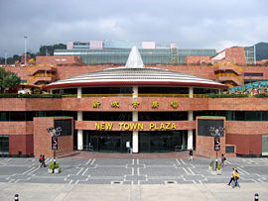
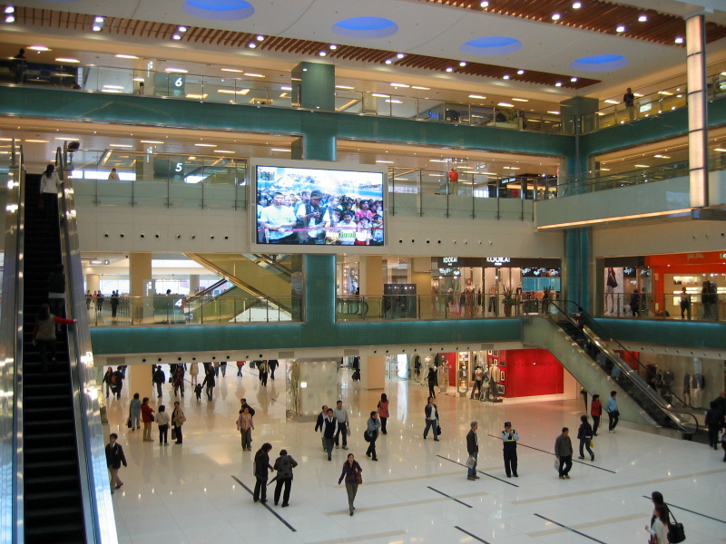

Facts and statistics
Location |  |  | Sha Tin District, Hong Kong, China
Opening date |  |  | 30 January 1985
No. of floors |  |  | 9
No. of shops |  |  | More than 400
Total retail floor area |  |  | 1,300,000 m² (321.2 acres)

Floor plan (Phase 1)
Level 1 |   UA cinemas, restaurants
Level 2 | 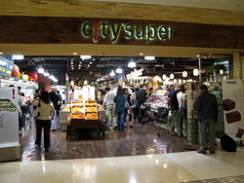  c!ty'super, Cosmetics, Books & Gifts, Banks
Level 3 | 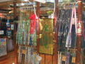  Luxury & Beauty, Fashion,  ZARA,  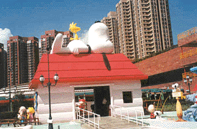  Snoopy’s World
Level 4 |   Fashion & Accessories,  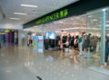  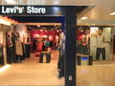  Marks & Spencer, ESPRIT
Level 5 |   Trendy, Casual & Sports Wear, McDonald's
Level 6 | Electric World
Level 7 | 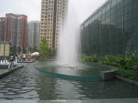  a CD shop and a roof garden in which a music fountain  is included
Floor plan (Phase 2)
Level 1 |   Toys "R" Us, Children's wear and various stores
Level 2 | 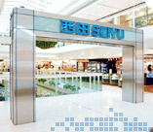  Seiyu Department Store
Level 3 |   Seiyu supermarket & food court, MUJI and various stores

Grand Central Plaza
Levels 1 & 2 |  | Furniture
Level 3 |  |   IKEA flagship store

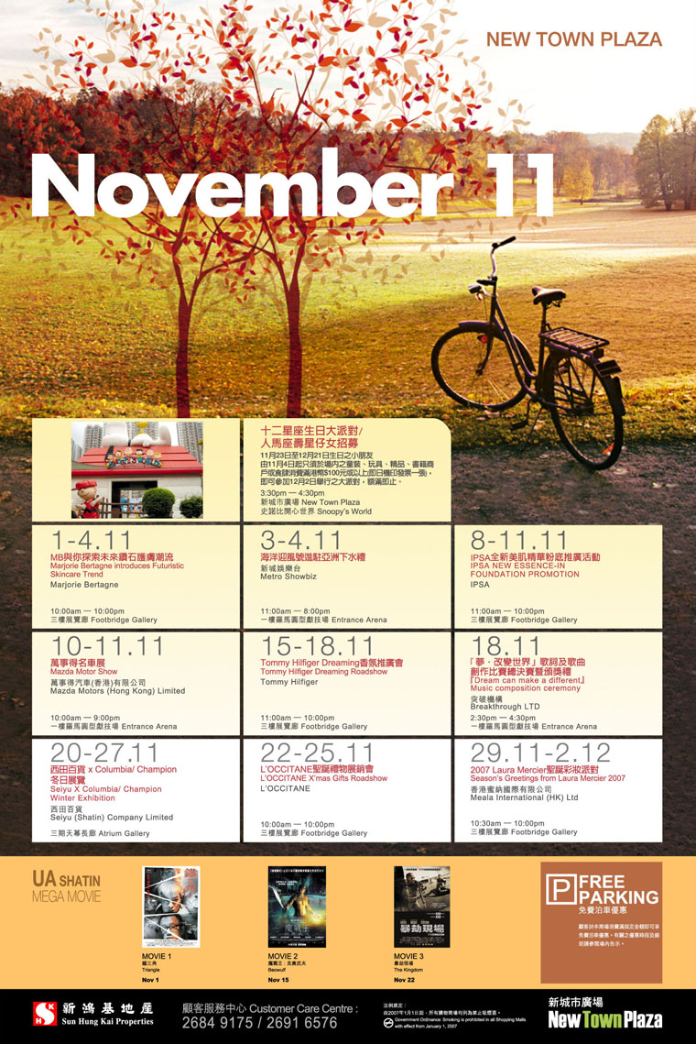
Oral Presentation:
My Favourite Shopping Centre

_______________________________________________________________________________

_______________________________________________________________________________

_______________________________________________________________________________

_______________________________________________________________________________

_______________________________________________________________________________

_______________________________________________________________________________

_______________________________________________________________________________

_______________________________________________________________________________

_______________________________________________________________________________

_______________________________________________________________________________

_______________________________________________________________________________

_______________________________________________________________________________

_______________________________________________________________________________

_______________________________________________________________________________

_______________________________________________________________________________

_______________________________________________________________________________

