C.C.C. Kwei Wah Shan College

Name: _________________________ Class: ______________________( )

Date: __________________________ Marks: ____________________________

Form Two English: Dictation:
Hi-tech Gadgets and Devices ( Activate 2B, Unit 5, P.2,3,8 )
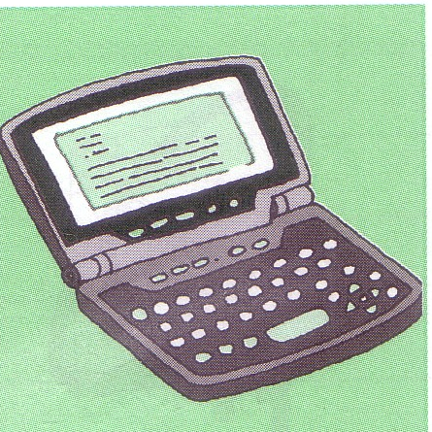
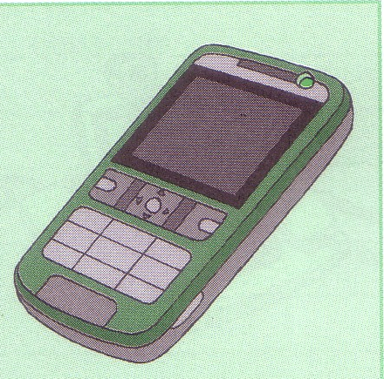
Part A: Write the names of the following hi-tech gadgets and devices.

1. electronic ____________________ 2. ______________________ phone
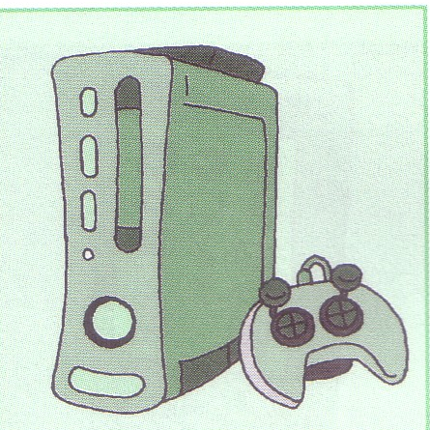
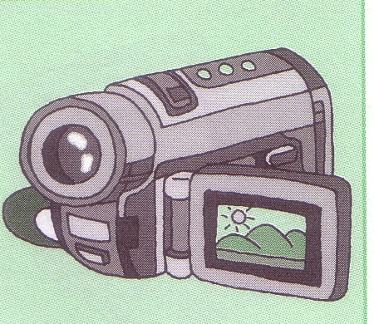

3. gaming ______________________ 4. digital ______________________
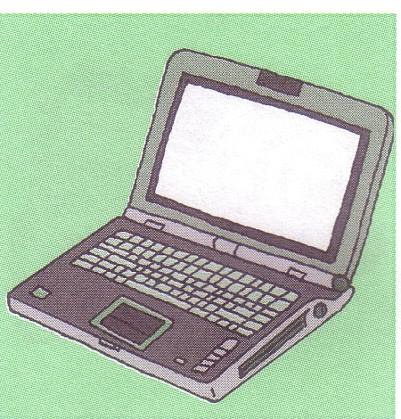
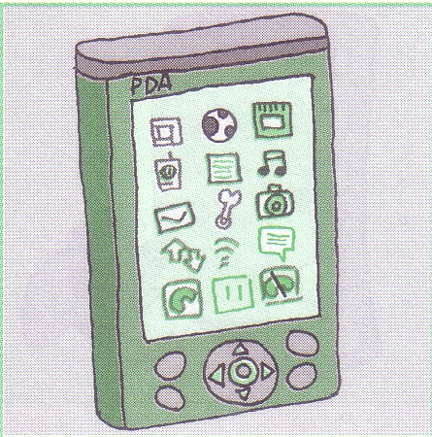

5. _____________________computer 6. personal digital ______________
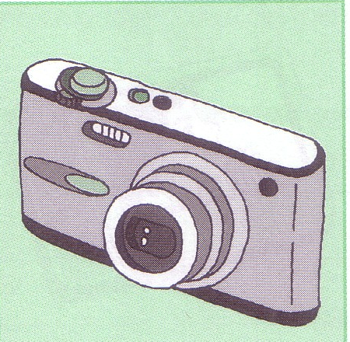
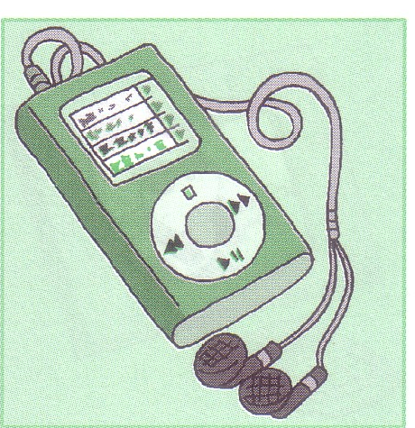

7. ______________ ______________ 8. ____________ _____________

