C.C.C.KWEI WAH SHAN COLLEGE
2007/2008 Second Term Second Uniform Test
S.2 General English

Date : 13th March, 2008 Class : S.2 ________ ( )
Time Allowed : 30 minutes Name : __________________
Question Paper : 3 pages Total Marks : 100

Instructions :
- Write all the answers on the Answer Sheet.
- Attempt all sections.

Part One Reading Comprehension
Read the following passage carefully.
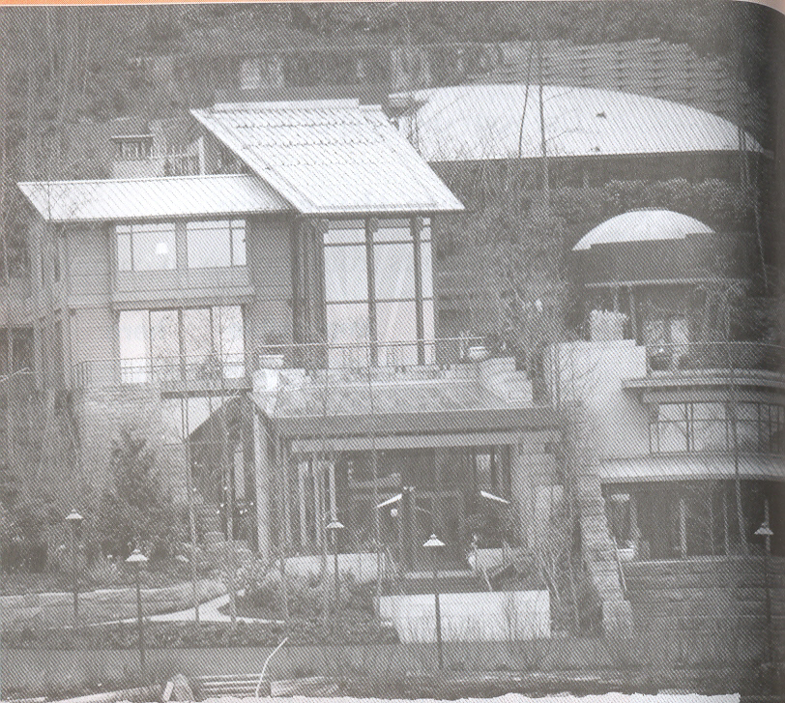
MEDINA, WASH., USA Bill Gates, one of the World’s richest people, lives near Seattle in the world’s “smartest” home. More than 100 computers control everything in this fantastic mansion*.

As Gates is driving home, he can fill his bath with water at the perfect temperature. When he gets near the entrance, the big gate opens just before his arrival. Sensors** under the floor follow his steps inside the house. When Gates enters a room, the lights turn on by themselves. He doesn’t need to turn them off because they darken automatically as he leaves. His favorite music plays in each room as he walks through the house, and it can even follow him outside. When he jumps into the pool for a swim, the same music plays underwater. Gates has a lot of art on his walls, but he never gets tired of it. The pictures change automatically because they are digital***.

A “smart home” is expensive now, but we can all look forward to living in one in the future. “It’s going to happen very quickly,” promises Cave Farber of the University of Pennsylvania.

*mansion: a very large house
**sensors: small machines that can find movement
** digital: stored as electronic signals

A Comprehension
Check(√ )the endings that are true. 16 marks @ 2
1 Bill Gates 2 His house has
________ lives in New York. ________ a large gate.
________ is very rich. ________ sensors under the floors.
________ has many computers in his home. ________ automatic doors.
________ can fill his bath while in the car. ________ digital art on the floors.
________ lives in a mansion. ________ a pool.

B Vocabulary

Complete the sentences with the words from the passage. 14 marks @ 2
- When Bill Gates is in his car, he can f_ _ _ his bath with water and con_ _ _ _ the
temperature.
- When he gets near the entrance to his house, the g _ _ _ opens just before his arr _ _ _ _.
- When Gates en _ _ _s his swimming p _ _ _, music plays underwater.
- Dave Farber pr_ _ _ _ _s that we will all live in a smart house soon.

C Answer the questions in complete sentences. 6 marks @ 3
- What controls Gates’ smart house?
- What happens as Gates walks around his house?

Part Two Usage
A Leo is a volunteer at a youth centre. The centre has asked its members to tell each
other about their role models. Leo is organizing the information for a wall
display. Help him to complete the descriptions using the following adjectives
describing feelings. 12 marks @ 2

embarrassed | excited | proud
Relieved | scared | upset

Ellie and Lisa Ng, 13 and 15
Our mum works as a nurse at Tuen Mun Hospital. She works long hours to take care of
sick people, but she always finds time to spend with us. She’s a wonderful mum. We are
very __(1) of her.

Michael Lam, 13
My brother Terry is my role model. We go rock climbing at weekends. Terry used to be
__(2) of heights, but he worked hard to overcome his fear. He’s very confident now and
is never __(3) when people laugh about his old fear.

Any Woo, 14
My dad is very helpful and clever. He was once a Boy Scout leader. Every weekend, we
go out and have fun together. This weekend, we’re going camping in Sai Kung Country
Park. I’m very __(4)__ about the trip!

Sarah Tang, 12
Aunt Peggy is my role model. She is very kind and enjoys helping people. She always
listens to my problems and comforts me when l’m (5) like the time when my pet
rabbit died.

Peter Tong, 14
My hero is Uncle Tim. Although he’s in a wheelchair, he always helps other disabled
people who can’t see. Last year, he was very ill. We’re all __(6) that he’s much better
now.

B Read the sentences and uses the following words to complete the sentences.
18 marks @2

creepy chores raise gives up admire politician broke into
professions achievement

Mary is a member of the legal and medical _(7) . She receives an award for
her outstanding (8) . She never __(9) her dream to become a (10)
working as an elected member of the government. Recently Mary is going to
__(11) money for the Community Chest. We (12) her devotion to
charity work.
Last month, some burglars __(13) her house. They killed the maid while she
was doing her household __(14) . The police caught them in an old, (15)
house in the countryside.
C Read the sentences and answer the question. 2 marks @ 1
Splodge helped Ruff yesterday. At three o’clock they were building
machine.
(16) Which verb is in the past continuous?
________________________________________________________

(17) Splodge was having a bath when Sticky jumped on his head.
What happened first?
a) Sticky jumped. b) Splodge got into the bath.

D Complete the dialogue below with the simple past tense or the past continuous
tense of the verbs in brackets. (16 marks @2)

Inspector: (18) you __(18) (work) in the garden when you (19)
(hear) the noises in the house?
Witness: Yes, I (20) (be). My wife __(21) (work) in the garden too.
We (22) (plant) flowers.
Inspector: When you (23) (see) the men in the house, (24) they
__(24) (steal) anything?
Witness: Yes, they were. They __(25) (carry) our television out of a window.

E Diane is proofreading Simon’s essay about role models. There is one mistake in each line. Read the article and correct the mistakes. Write the correct words above the underlined words. Mark the position of a missing word with ‘ ^ ’ and write the missing word above it. Cross out any extra words with a ‘ x ’. The first one has been done for you.

16 marks @ 2

China’s Positive Role Models
itself
China should be proud of himself. In a short time, it has produced many
X positive role models that give the encouragement to people worldwide. In the
X world of the sports in particular, there are now many famous Chinese stars.

One example is Yao Ming. He turned herself into an excellent basketball
X player through a lot of hard training. He is also a star on the television. That
X is because many people in China and around the world now watch the
television just to see him play for Houston Rockets basketball team.
^

^ These athletes encourage us to take better care of myself. They also
X encourage us to learn to speak and write the English. That is because they
ourselves are proof of what you can achieve by doing these things.

End of Paper

