C.C.C. Kwei Wah Shan College

Name: ___________________________ Class: _____________________( )

Date: ____________________________ Marks/Grade: ____________________

Form Two English: English Worksheet (1)

Tour in Beijing
What are they going to do? Finish the dialogues.
- A: Shall we go to ?  B: Sure. The weather is good for hiking. | 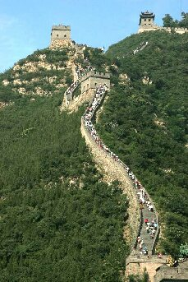

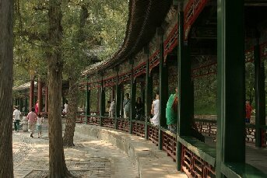
2. A: Shall we ?

B: Great idea! I want to see the longest painted
corridor in the world.

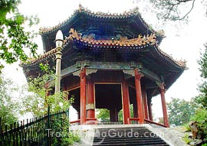
- A: I want to see the entire city of Beijing.
Shall ?
B: Certainly. Let’s go.

- A: ?  B: Good idea. I love shopping. | 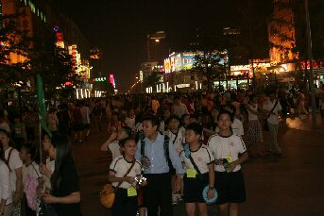

- A: Are you interested in history?  B: Oh, I have a great curiosity of Chinese art.  ____________________________________  _________________________________ | 