C.C.C. Kwei Wah Shan College

Name: _________________________ Class: ______________________( )

Date: __________________________ Marks: ____________________________

Form Two English: Dictation
Patterns, Styles and Opinions of Outfits ( Activate 2B, Unit 6, P.23,29 )
Complete the following dialogues.
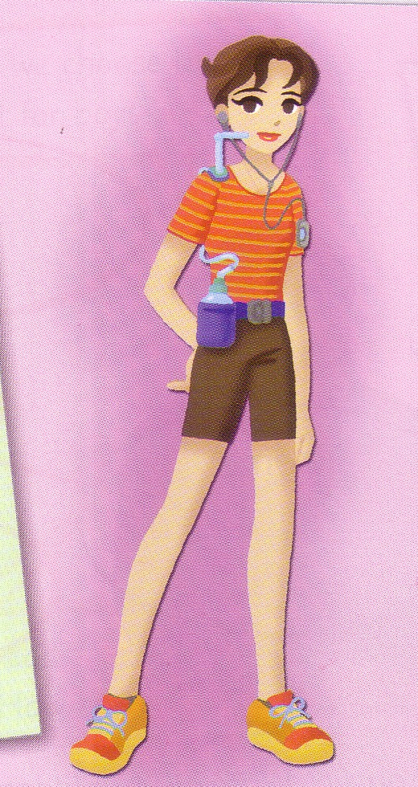
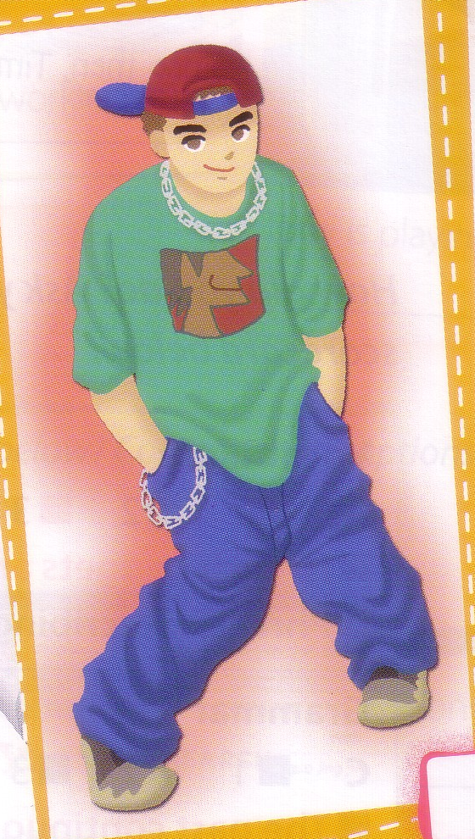
I like this outfit. He is wearing a green, short- (1) ___________________ T-shirt and blue, (2) ___________________ jeans. I think it looks very (3) ___________________.
I like this outfit. She is wearing an orange, (4) ____________________ T-shirt and brown shorts. I think it looks very (5) ________________________.

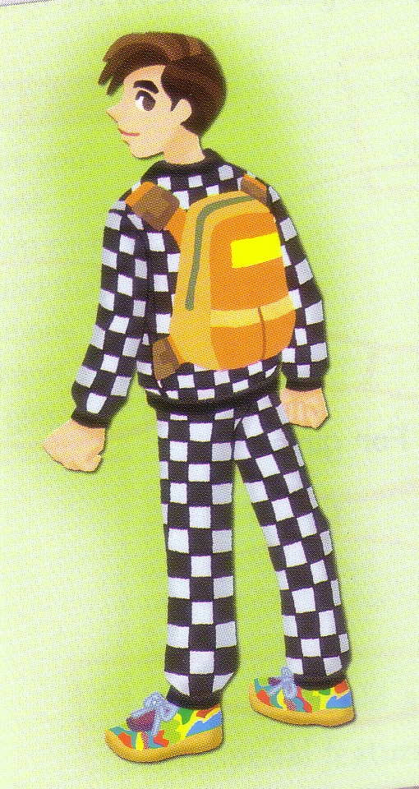
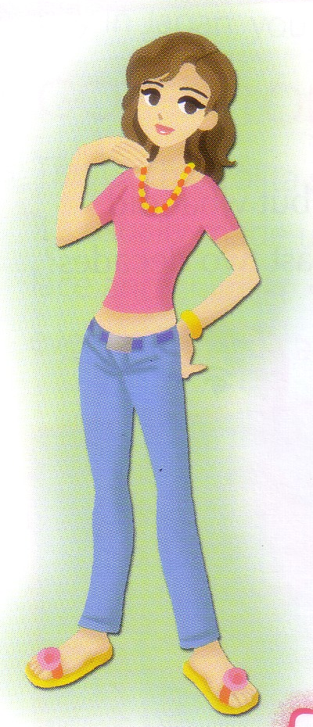
I don’t like this outfit. He is wearing a black and white(6) ___________________ tracksuit and a pair of (7) ___________________ trainers. I think it looks very (8) _____________________.
I like this outfit. She is wearing a (9) ____________________ T-shirt and jeans. I think it looks very (10) ________________________.

