C.C.C. Kwei Wah Shan College

Name: _________________________ Class: ______________________( )

Date: __________________________ Marks: ____________________________

Form Two English: Dictation:
Fashion Favourites ( Activate 2B, Unit 6, P.28 )

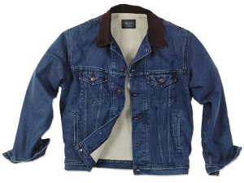
Write the names of the following fashion items.

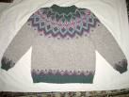
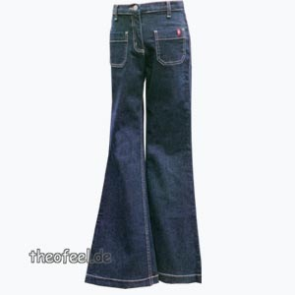
1. T- ____________________ 2. ______________________

3. ______________________ 4. ______________________
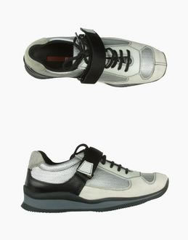
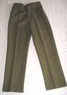
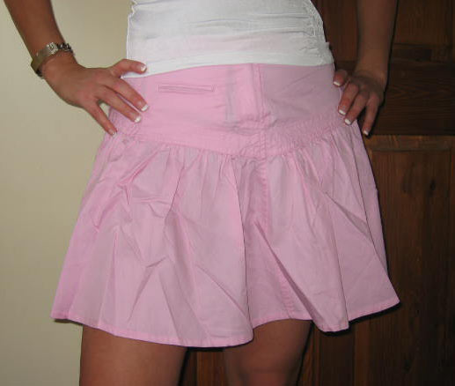

5. ___________________ 6. __________________ 7. __________________
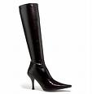
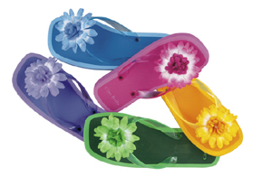

8. ______________ ______________ 10. ________________________

