C.C.C. Kwei Wah Shan College

Name: ___________________________ Class: _____________________( )

Date: ____________________________ Marks: __________________________

Form Two English: Composition_Unit 5 ( Write in 110-130 words )

Title : A Holiday Dream
You had a strange dream about your holiday. Write your story in about 110 words. You may use the following pictures and clues to help you.
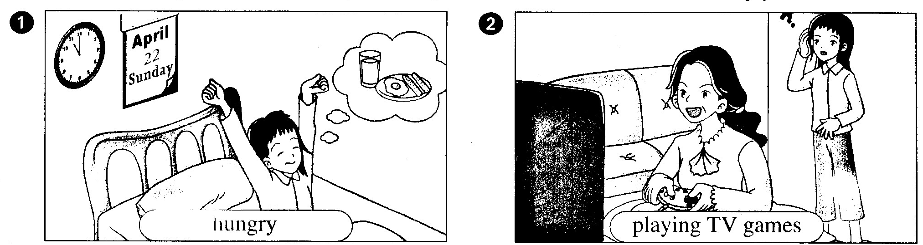
got up/ hungry/ breakfast/ milk/ eggs/ sausages
playing TV games/ excited/ did not look at me

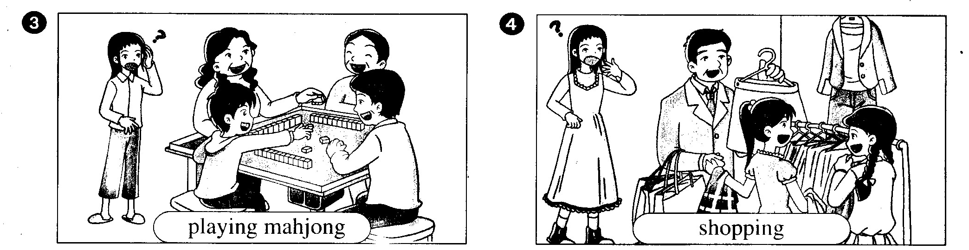
My brother, Jonathan/ playing mahjong/ Mum’s friends/ seven years old/ how could he …….? Strange!
went out/ Dad/ shopping/ my classmates/ clothes/ boutique

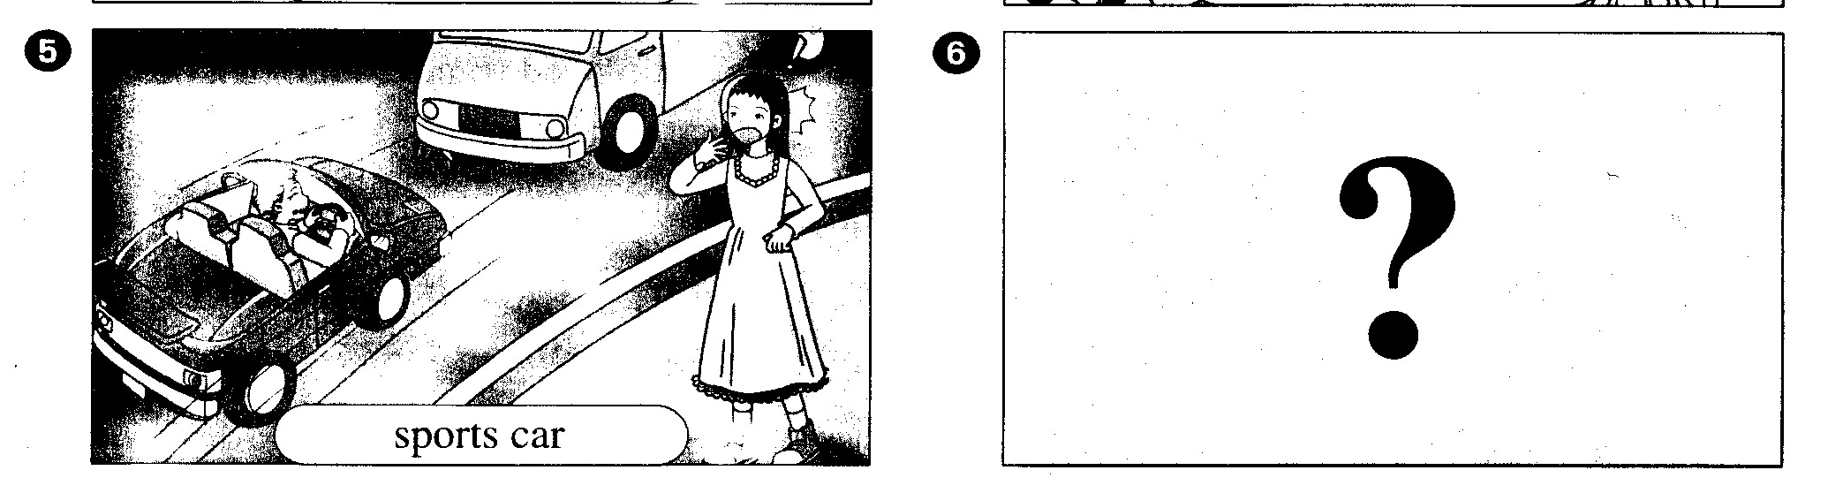
in the road/ Grandma/ driving a sports car/ doesn’t know how to drive?/ surprised/ “What happens to my family?”/ lorry/ going to crash into it
woke up/ dream/ happy/ did not really happen

Beginning | - It was ______________________.  - I got up at _____________________________________________.  - I felt very _________________________, so I wanted to ask Mum to ___________________________________________________.
Development | - When I went out of my bedroom, I saw Mum _________________  _____________________________________________________.  - She was very ____________________ and ___________________  ______________________________________________________.  - My brother, Jonathan, was __________________________________  _______________________________________________________.  - Jonathan was only _______________________________________,  ________________________________________________________.  - How could he ____________________________________________?  - It was so ___________________________!
Climax | - When I went out to buy food, I saw Dad in a ____________________.  - “Why is Dad ____________________________________________?”  I thought.  - Then, I saw Grandma ______________________________________  _______________________________________________________.  - “Oh, no, what ____________________________________________?  - Soon I saw a _____________________. Grandma’s car was going to ________________________________________________________.
Ending | - Suddenly, I _______________________________________________  ________________________________________________________.  - I was happy that __________________________________________.

