C.C.C. Kwei Wah Shan College

Name: ___________________________ Class: _____________________( )

Date: ____________________________ Marks/Grade: _____________________

Form Two English: Oral Presentation

Activate 2B, Unit 6 – Fashion
What are they wearing?

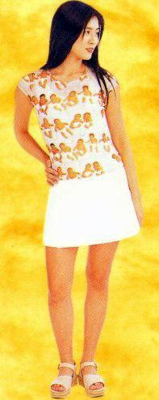

Charlie is wearing ____________________________________

___________________________________________________

___________________________________________________

___________________________________________________

___________________________________________________
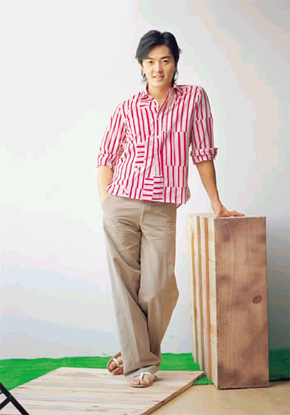

Ekin is wearing ______________________________________

___________________________________________________

___________________________________________________

___________________________________________________

___________________________________________________

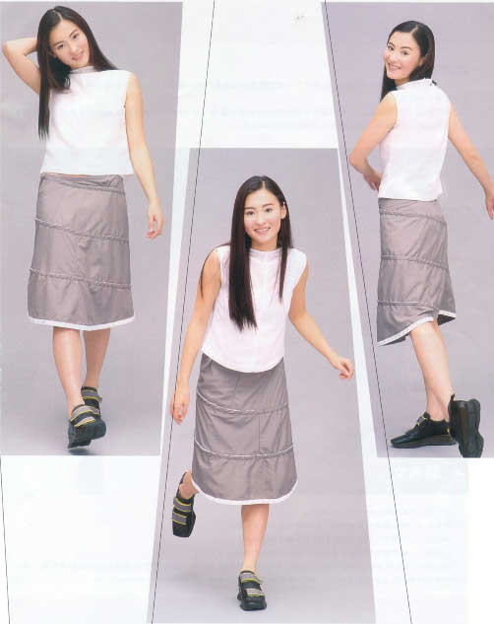

Cecilia is wearing ___________________________

__________________________________________

__________________________________________

__________________________________________

__________________________________________

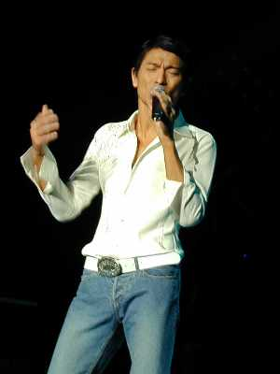

Andy is wearing _____________________________

__________________________________________

__________________________________________

__________________________________________

__________________________________________

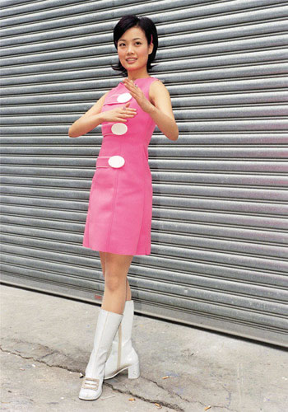

Joey is wearing _____________________________

__________________________________________

__________________________________________

__________________________________________

__________________________________________



Stephy is wearing ____________________________

__________________________________________

__________________________________________

__________________________________________

__________________________________________

