C.C.C. Kwei Wah Shan College

Name: _________________ Class: ________( ) Date: ____________________

Form Two English: Composition 4 ( Write in 100-120 words )

Title: Email Replies

Write replies to Helen King and Dan Hill.

( Please refer to the e-mail messages on Target 2A P.78)

E-mail 1: Reply to Helen King

Model Plan

Greeting

Paragraph 1: Greeting, reason for writing

Paragraph 2: Information about Ocean Park ----- What can you do there?

Paragraph 3: Directions to Ocean Park

Closing

E-mail 2: Reply to Dan Hill

Model Plan

Greeting

Paragraph 1: Greeting, reason for writing

Paragraph 2: Weather ----- clothing needed

Paragraph 3: Information about Hong Kong Space Museum ----- What can you do / see there?

Paragraph 4: Directions to Hong Kong Space Museum

Closing

C.C.C. Kwei Wah Shan College

Name: ________________Class: ______( )Date: _____________Marks: _________

E-mail 1: Reply to Helen King

From: Hong Kong Tourism Board
Sent: Tuesday, 19th June
To: Helen King
Subject: Re: My Hong Kong Visit

Dear Ms King

Thank you for your e-mail message. Below is the information you asked for.

Ocean Park is ___________________________________________________________

______________________________________________________________________.

If you go to Ocean Park, you will ___________________________________________

______________________________________________________________________.

You will also ___________________________________________________________

______________________________________________________________________

______________________________________________________________________

______________________________________________________________________.

Ocean Park is on ________________________________________________________.

The best way to get there is to ______________________________________________

______________________________________________________________________.

Then take the _______________________________________________________ exit.

Take the No.29 Citybus and get off at the _____________________________________

______________________________________________________________________.

I hope you enjoy your stay in Hong Kong.

Chris Wong

E-mail 1: Reply to Helen King

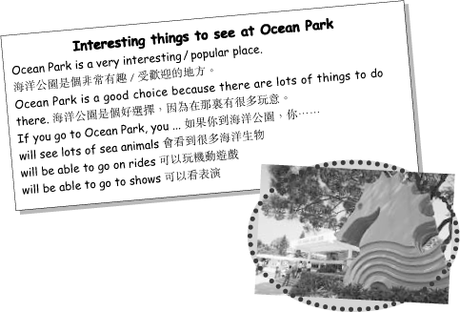

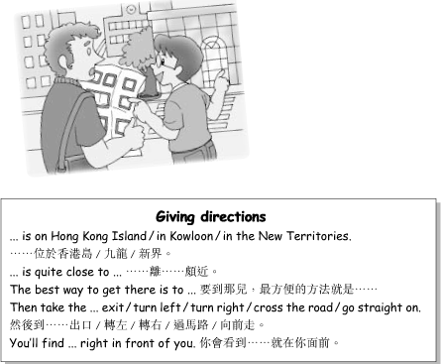

C.C.C. Kwei Wah Shan College

Name: ________________Class: ______( )Date: _____________Marks: _________

E-mail 2: Reply to Dan Hill

From: Hong Kong Tourism Board
Sent: Tuesday, 19th June
To: Dan Hill
Subject: Re: Coming to Hong Kong

Dear Mr Hill

Thank you for your e-mail message. Below is the information you asked for.

The weather in Hong Kong in February is ____________________________________

so you will need to bring _________________________________________________.

However it is very dry so __________________________________________________

______________________________________________________________________.

If you visit the Hong Kong Space Museum, you will ____________________________

______________________________________________________________________.

The exhibits are _________________________________________________________

______________________________________________________________________.

The museum is also famous for its __________________________________________

______________________________________________________________________.

The museum is quite close to the Hong Kong Hotel. When you come out of the hotel,

turn _________________________and cross the ______________________________.

Then go ______________________________________. You’ll find the museum on

your ____________________________________ side.

I hope you have an enjoyable stay in Hong Kong.

Alex Chow

E-mail 2: Reply to Dan Hill

