C.C.C. Kwei Wah Shan College

Name: _________________ Class: ________( ) Date: ____________________

Form Two English: Composition 7 ( Write in 100-120 words )

Title: Writing a Letter of Complaint

You are a student of Kwei Wah Shan College. You have just heard and collected complaints about your school from your schoolmates. You decide to write a letter of complaint to your Principal.

You can use the information collected in the task sheets and complaints forms done to help you. The format of a formal letter is on Target 2B P.26 as well.

Model Plan
Sender’s address
Date
Receiver’s title
Receiver’s address

Greeting


Subject

Paragraph 1: Reasons for writing
        - The classroom condition
        - Other facilities in school

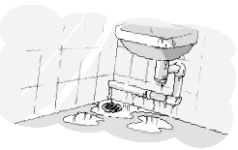
Paragraph 2: Complaints about the classrooms
        - Size
        - Cleanliness
        - Furniture
        - Teachers and classmates

Paragraph 3: Complaints about the toilets
        - Cleanliness
        - Pipes, floor, wall, sink


Paragraph 4: Complaints about the tuck shop
        - Food
        - Cleanliness
        - Staff

Paragraph 5: Ask for action
        - Improvement

Closing

Signature

Sender’s name

( )words

