C.C.C. Kwei Wah Shan College

Name: _________________________
Date: __________________________
Class: ___________________( )
Marks / Grade: ________________/10

Form Two English: Comprehension _______: City of Restaurants

Hong Kong-City of Restaurants

1 Hong Kong is famous for its restaurants.

2 It is often said that you could eat at a different restaurant every day for three years!

3 Certainly, the streets of the urban centres, and even the suburbs, are filled with restaurants both Chinese and foreign. Local people love eating out and restaurants are busy, friendly, noisy places. They also love to go for meals in large groups. It's not unusual to see 15 or even 20 people at one large round table.

4 Eating out is not very expensive, either. A typical Cantonese lunch for two doesn’t cost more than $150 – including the 10% service charge.

5 The choice of food is wide. China is a very large country and it is not surprising that there are many regional styles of cooking.

6 You will see restaurants that specialise in the cooking of Beijing, Shanghai, the Szechuan region and the Chiu Chow style as well as in the local Cantonese food.

7 Try yum cha – it means literally ‘take tea’. The local Cantonese people enjoy yum cha at any time from mid-morning to mid-afternoon. The main kind of food served is dim sum – small hot dishes of many different kinds. They are served in bamboo baskets which are pushed around on heated trolleys. Choose from beef, pork, fish, sea-food and vegetable dishes; or try one of the many types of steamed buns or a plate of braised bean- curd.

8 There are usually soups and sweets as well. But don't try Phoenix claws unless you have a strong stomach. They are chickens’ feet!

1. Where do you think you might read this king of article? (Tick the picture that shows the right kind of publication.) ( 1@ )
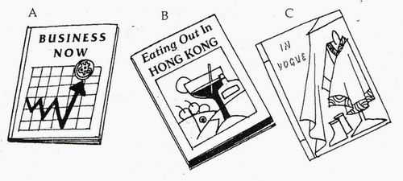
- Paragraph 2 tells us that …( 1@ )
A There are too many restaurants in Hong Kong.
B Most people only visit restaurants three times a year.
C There is a very large number of restaurants in Hong Kong.

- Find two other words in paragraph 3 which describe the restaurants in Hong Kong. Write them here: ( 2@ )
_______________________________________________________________

- ‘Eating out is not very expensive, either,’ (Choose the sentence below which could replace the underlined words and keep the same meaning.) ( 1@ )
A cheaper than either
B cheaper than eating at home

C quite cheap as well

- Read paragraph 7 again. Who do you think this is written for? ( 2@ )
_______________________________________________________________
_______________________________________________________________
Why do you think this? (Write your answers in note form.) ( 3@ )
_______________________________________________________________
_______________________________________________________________

