C.C.C. Kwei Wah Shan College

Name: _________________________
Date: __________________________
Class: ___________________( )
Marks / Grade: ________________/12

Form Two English: Comprehension _______: New Year

New Year – New Start

1 New Year is an important time for many people in many countries. But they don't all celebrate New Year in the same way. They don't all celebrate New Year on the same day, either.  2 For most people, however, New Year has always been important for one very good reason; New Year marks a new start, a new beginning.  3 For thousands of years people in China, in Scotland, in India or in Japan have seen New Year as a time to make a new start.  4 What does a new start mean exactly? It means you can forget the mistakes you have made and you can forget the bad things you have done. All tho5e mistakes and bad things have gone with the old year. Now you can start again. You can be better and wiser during the coming year.  5 In China, people have celebrated the Lunar New Year for thousands of years. They think that it is very important to pay your debts, clean your house and wear new clothes at that time. Why do they think you should do this? It's so that you can make a fresh start in the New Year and leave all the bad and unhappy things behind. | 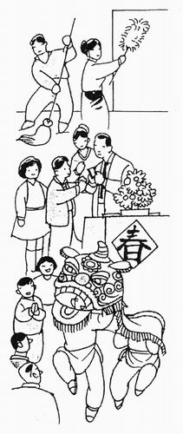

- Read paragraph 1 again and then finish this sentence: ( 2@ )
People celebrate New Year in __________________________________ ways and on ______________________________________.

- What is the ‘very good reason’ in paragraph 2? ( 2@ )
_______________________________________________________________
_______________________________________________________________
_______________________________________________________________

- Write down the name of three countries where New Year is celebrated. ( 3@ )
_______________________________________________________________
_______________________________________________________________
_______________________________________________________________

- Choose the right option to complete the sentence: ( 1@ )
You can forget your old mistakes because ……….
A you will make new ones in the New Year.
B no one remembers them for long.
C they are finished, just like the old year.

- Find a word in paragraph 5 which means almost the same as ‘new’. ( 2@ )
_______________________________________________________________
_______________________________________________________________

