C.C.C. Kwei Wah Shan College

Name: ___________________________ Class: _____________________( )

Date: ____________________________ Marks: __________________________

Form Two English: Dictation Unit 5, P.80_Famous Hong Kong Tourist Spots

Famous Hong Kong Tourist Spots
Fill in the blanks with the correct names of places.
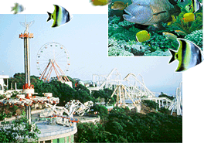
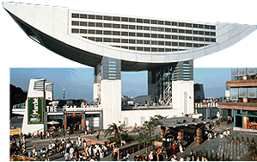
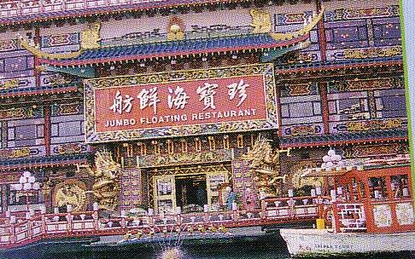

- O____________________ Park, Jumbo Floating (2) R___________________, and

The (3) P_____________________ are on Hong Kong Island.

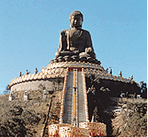
On (4) L_______________________ Island, we can visit The

Big (5) B_________________________.

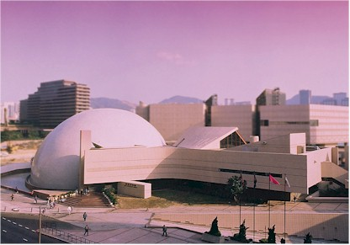
Hong Kong Space (6) M________________________

is in (7) K__________________________.

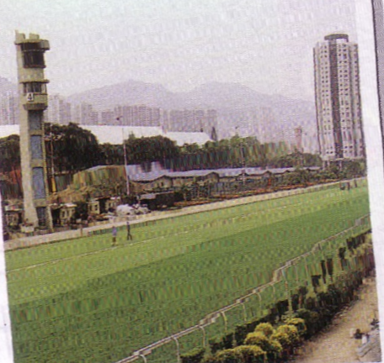
Sha Tin (8) R________________________________ is

in the New (9) T_________________________________.

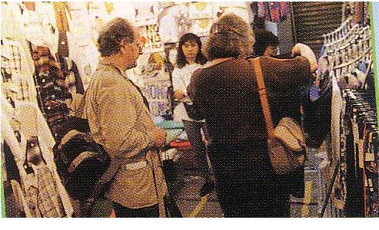
If you like shopping, you can go to Temple Street Night

(10) M_____________________ in Yau Ma Tei.

