C.C.C. Kwei Wah Shan College

Name: ___________________________ Class: _____________________( )

Date: ____________________________ Marks: __________________________

Form Two English: Dictation Unit 5, P.82_Places to Visit
Fill in the blanks with the correct vocabulary.

The Peak
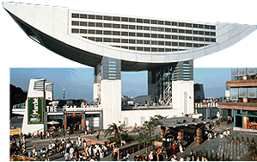
Every year, more than 6 million visitors visit The Peak. This makes it Hong Kong’s number one tourist
- _______________________ . The most enjoyable way to
(2) ______________________ The Peak is to take the Peak Tram. There are many (3) __________________________.(4) ____________ lovers can go on some great walks.

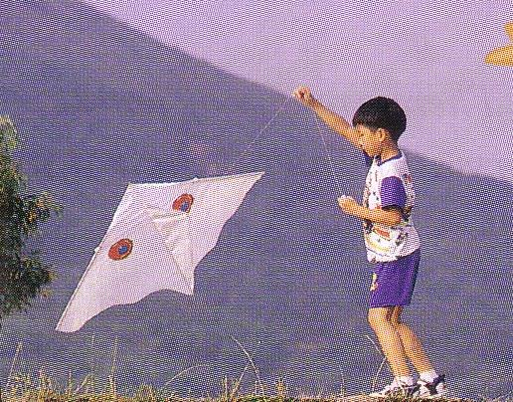
Tap Mun Island
A lot of young people come to Tap Mun to fly (5) _______________

as the island is very (6) ______________. Since the island is flat and

(7) ________________, camping is also popular.

Hong Kong Railway Museum
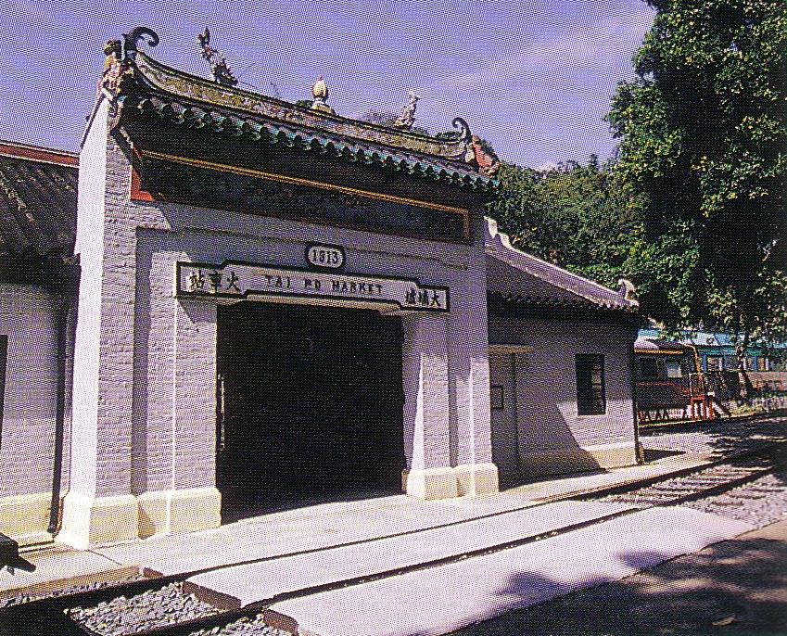
At the Hong Kong Railway Museum, visitors can look at old

photographs and read about Hong Kong in the past. There are

also some interesting old trains to (8) ________________. The

old trains are very different from the (9) ________________ ones we have today. For

example, they have (10) ________________ seats, open windows and no air

conditioning.

