C.C.C. Kwei Wah Shan College Name: _________________________
Form Two English: Unit One: At the Movies Class: ____________________( )
Activity 1: Which type of film are they? Date: ___________________________

Target: Categories of films Marks: __________________________
( horror films 恐怖片 ／ love stories ( romances ) 愛情片 ／action films 動作片／
action comedies 動作喜劇 ／ cartoons 卡通片 )
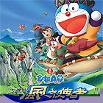
1. Doraemon - Nobita and the Wing Wizard

Type of film: ____________________________________


2. Drink, Drank, Drunk

Type of film: ____________________________________

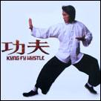
3. Kung Fu Hustle

Type of film: ____________________________________

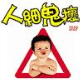
4. Mean Spirit

Type of film: ____________________________________

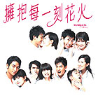
5. Moments of Love

Type of film: ____________________________________

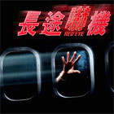
6. Red Eye

Type of film: ____________________________________

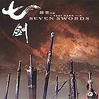
7. Seven Swords

Type of film: ____________________________________

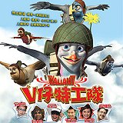
8. Valiant

Type of film: ____________________________________

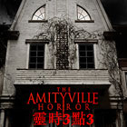
9. The Amityville Horror

Type of film: ____________________________________

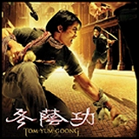
10. Tom Yum Goong

Type of film: ____________________________________

