C.C.C. Kwei Wah Shan College

Name: ___________________________ Class: _________________( )

Date: ____________________________ Marks: ______________________

Form Two English: Dictation – Vocab 4.1 ( Types of Clothing )

Complete the sentences below using vocabulary related to types of clothing.
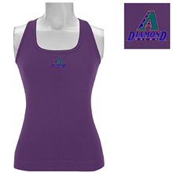

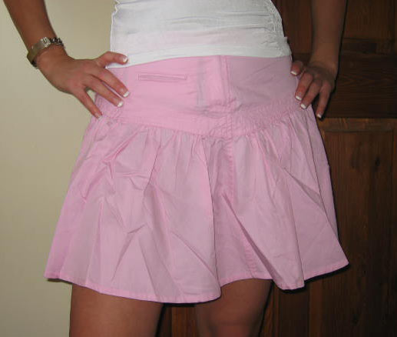
- Young girls like to wear a _______________________and a _____
________________ in summer.
- My father goes to work in an office. He usually wears a ___________.
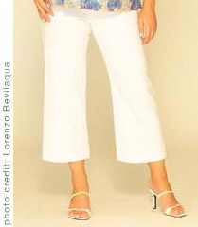
3. Mother likes to wear _____________________________ and

_______________________ in her free time.

- We usually wear a _________________ and
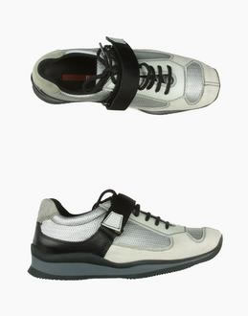
_______________________ during our PE lessons.

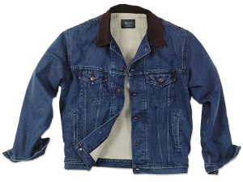
5. Cowboys like to wear a _____________ __________________
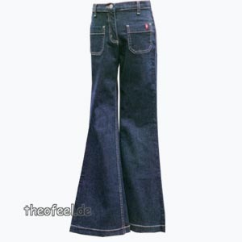

and ___________________.

