C.C.C. Kwei Wah Shan College

Name: ___________________________ Class: _____________________( )

Date: ____________________________ Marks/Grade: _____________________

Form Two English: Task Sheet 1: Reported Speech Target 2B Unit 8, p.18, 22
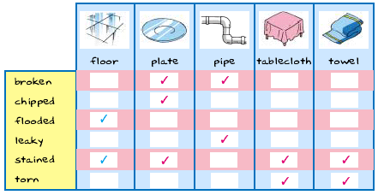(Target 2B, P.18)
Task 1(Individual Task): Sentence Making-make complaints about these five things
e.g. The floor is flooded.

1. The plate_____________________________________________________________

2. ____________________________________________________________________

3. ____________________________________________________________________

4. ____________________________________________________________________

5. ____________________________________________________________________

Task 2(Individual Task): Oral Practice

Task 3(Individual Task): Writing Task-Reported Speech
Language Structure:
(Name of student) said that the (Thing) (was / were) (Adjective)
e.g. (Johnny) said that the (floor) (was) (flooded).

1. ________________said that _____________________________________________

2. ____________________________________________________________________

3. ____________________________________________________________________

4. ____________________________________________________________________

5. ____________________________________________________________________

